17 December 2020
Dear Parents
You may be aware that the government has announced today that there will be a staggered return to secondary school in January.
In accordance with government guidance, I would like to share the arrangements for the start of term.
Monday 4th January - Year 11
Year 11 students will return to school at the usual start time of 8.35am (Breakfast available from 8am). The school day will run as normal for Year 11 students and they will attend their usual timetabled lessons every day in school.
Monday 4th January – Years 7-10
Students in Years 7–10 will not return to school in person on Monday 4th January and they will access lessons remotely from home until Friday 8th January. We know that all students now have access to a digital device and they will be expected to join all of their usual timetabled lessons every day during this week.
All students in Years 7-10 will return to school on Monday 11th January.
If your child is in Years 7-10 and is eligible to attend school from Monday 4th January – Friday 8th January (vulnerable children and children of critical workers), they should arrive on Monday 4th January at their normal start time. Your child’s Year Leader will contact you to confirm eligibility. For clarification, vulnerable children are classed as follows:
- Children with a social worker
- Looked After Children
- Children with an EHCP
Finally, please can I remind you that your child should stay at home and you should seek a test if they have COVID symptoms:
- a high temperature
- a new, continuous cough
- a loss or change to your sense of smell or taste

We will contact you again at the start of term regarding the recently announced testing arrangements in school.
Please stay safe and have an enjoyable Christmas.
Yours faithfully
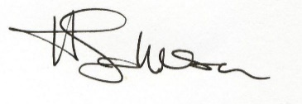
Mrs Johnson
Headteacher

