May 2022

**For the attention of Year 9 and Year 10 Parents**

Dear Parents

I hope that this letter finds you and your families safe and well.

I am writing with an update ahead of next academic year, which contains important information relating to current Year 9 and Year 10 students.

**Safeguarding and Mobile Phones**

You will be aware that we have put in place a number of measures this year to reinforce the message that bullying and harassment of any kind are not tolerated at BPS. This has included restrictions on mobile phone use during the school day. I am delighted with the way that students have responded to this campaign and we have had lots of feedback to confirm that this is making a positive difference.

To build on this success and continue to prioritise student safety and wellbeing, **mobile phones will not be permitted to be used by any year groups during the school day from September 2022**. Whilst it is understandable that students may wish to have a mobile phone to support safe travel to and from school, all students must put phones away in their school bag before they enter the building in the morning. Phones may not be used during the school day at any time, including break and lunchtime. Any phones seen during the day will be confiscated and may be collected from pastoral staff at the end of the school day, as currently.

**Year 11 uniform – current Year 10 students**

As I am sure you know, our Year 11 students now wear a professional black suit. These changes allow Year 11 students to dress as young adults rather than school students. Furthermore, our students identified an additional benefit in that they can attend Post 16 apprenticeship/college interviews during the course of the year dressed as young adults rather than school children.

For boys, the professional black suit is accompanied by a plain dark green tie. Girls wear an open neck shirt and not the current closed collar shirt and tie.

As this is professional business dress, all Year 11 students are expected to wear **plain black business shoes** and **not black trainers.**

The table below gives a summary of the exact uniform requirements for Year 11 students:

|  |  |  |
| --- | --- | --- |
|  | **Boys** | **Girls** |
| **Jacket** | Business suit/plain black | Business suit/plain black |
| **Shirt** | White/buttoned collar (same as now) | White/open (Rever Collar) neck (see image) |
| **Tie** | Plain dark green | No tie |
| **Trousers/Skirt** | Plain black | Plain black skirt |
| **Shoes** | Plain black business shoes  (no trainers) | Plain black business shoes  (no trainers) |
| **PE kit** | As now | As now |
| **Bag** | School rucksack as now *(provided)* | School rucksack as now *(provided)* |

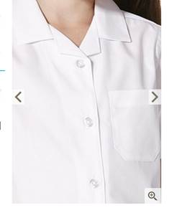

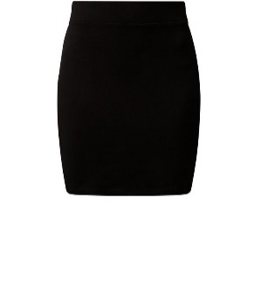

Please note that a tube or bodycon skirt, pictured to the left, is not permitted.

The school uniform for all other year groups remains unchanged. The PE kit for Year 11 also remains unchanged.

The Year 11 jacket and tie can be purchased from Wirral Uniforms.

Thank you for your continued support. If you have any further questions, please do not hesitate to contact your child’s Year Leader.

Yours faithfully

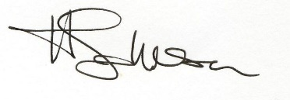

Mrs H Johnson

Headteacher