9th February 2026

Dear Parent/Carer
I am delighted to invite you to our Year 7 Parents’ Evening, which is being held on Thursday 26th February 2026, from 4.00 p.m. to 6.30 p.m.
This is a highly valued part of the school calendar, which gives you the opportunity to discuss your child’s academic progress with their subject teachers.
Similar to last year, we will be using an electronic system for booking your appointments to see your child’s teachers. We have enclosed an easy-to-follow instruction sheet on how to access this booking system, along with a list of your child's current teachers. We would encourage you to meet with as many subject teachers as possible.
There will also be available members of the Year 7 Pastoral Team and the Senior Leadership Team for you to talk to, if you wish.
We do hope that you will be able to attend this important event.
Yours Faithfully
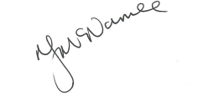
Kind regards,

Mrs N McNamee
Head of School


Year 7 Parent-teacher interviews will be held at the following time:
- 4:00pm – 6:30pm Thursday 26th February 2026
To book your interviews, go to www.schoolinterviews.co.uk/code in your browser, and enter the event code 7ga57. Then follow these three simple steps:
 | First enter your name, your child's name, and your email address.  If you need to book for more than one student, change the “Book for x students” setting, and enter the other student's name.
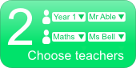 | On the next page, pick the teachers you want to meet.  First select the subject, then choose from the list of teachers.
 | Then you'll see a timetable showing when your chosen teachers are available. Simply click on the times that suit you.

When you have finished, your interview timetable will be emailed to you. You can return to the site and enter the event code 7ga57 again to change or cancel your interviews.
If you don't have internet access, please call Mrs Thomas on 0151 652 1574 at the school office. She will be able to make a booking for you.

