26th February 2021

Dear Parents/Carers

Further to Mrs Johnson’s letter you will be aware the government made announcements yesterday about assessments for those students taking GCSEs this summer. Ofqual have also releases information about this; the following information provides a helpful summary: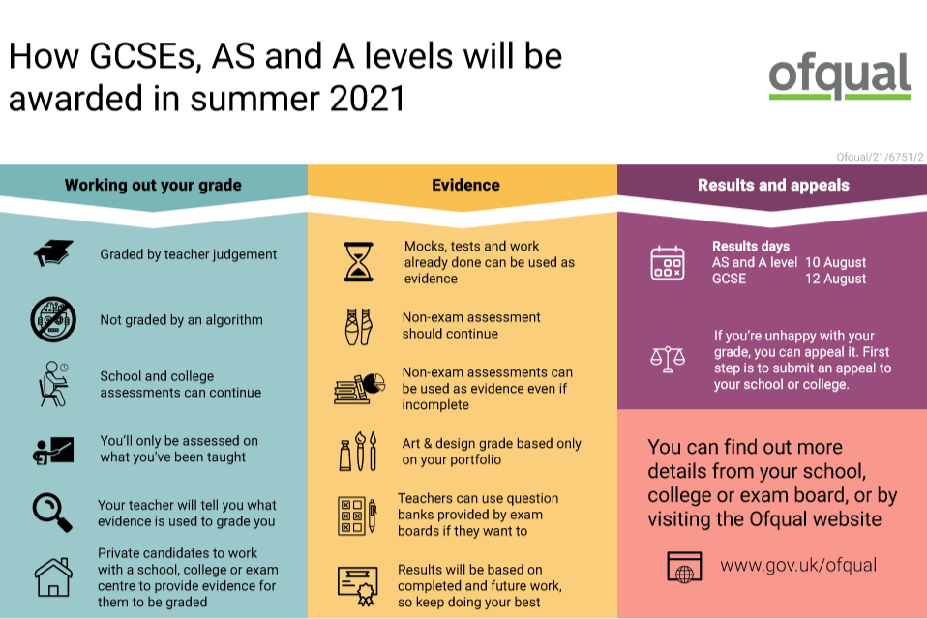

It is important to note that at this stage we are still waiting to hear from the individual examination boards about specific details of the assessment process, including what evidence should be gathered and how it should be used to generate grades. However, we have received the following guiding principles.

* Teachers must assess their students’ performance, only on what content has been delivered to them by their teachers, to determine the grade each student should receive.
* Teachers can use evidence of a student’s performance from throughout the course to inform their judgement.
* Teachers should determine the grades as late in the academic year as is practicable, to enable teaching to continue for as long as possible.
* Schools and colleges should use a broad range of evidence across the taught content to determine the grades before submitting the grades to the exam boards.
* Overall, it will be no easier or harder for a student to achieve a particular grade this year compared to previous years

We await further information from individual examination boards and we will continue to keep you informed as we receive more information. **It is crucial that all Year 11 students return to school week commencing 8th March to provide the evidence to help determine the teacher assessed grade in the summer.**

**Your Sincerely**



**Mr P Mee**

**Deputy Headteacher**