Year 7 ‘Must Know Knowledge’
Over half term make sure you revise this. Read it, summarise it, get tested on it, turn it into a poster, mindmap or revision cards. This is the knowledge you must know and remember.
Enjoy your half term break knowing that you know the important stuff!
English  Revise the following – Draw a picture make a mind-map  Soliloquy, Rhetoric, Imply  Conclude, Attribute,Plethora  Context  Recall quotes from speeches – Dual code and explain their meanings  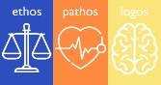 | 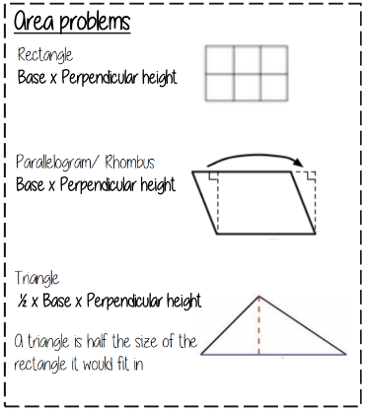  Maths | Science  Energy CANNOT be created.  The units for energy are JOULES.  Energy can be stored as chemical, kinetic, gravitational potential, nuclear, thermal or elastic potential energy  Conservation means to keep things the SAME.  A GAMETE is a sex cell (sperm or egg)  Sperm cells adapted for their function They have lots of mitochondria (to release energy) an a tail to help them move.  Egg cells adapted for their function as they have lots of cytoplasm which stores nutrients for growth
History  There was a Peasants' Revolt in 1381 because...  - in 1351 a law was passed that stopped the wages from increasing. This meant that the peasants’ pay did not increase for over 30 years.  - England had been at war with France for 50 years and there was a threat of invasion. Taxes increased to pay for this expensive war.  - King Richard II was only 14 years old and had lots of bad advisors making decisions for him. These decisions were bad for the peasants | Geography  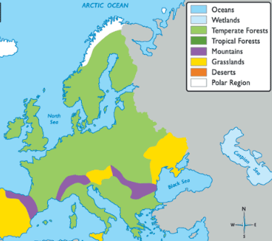  Describe the location and characteristics of the biomes in Europe | RE  Must know how Jesus influences Christians in their everyday lives: Salvation- Jesus died to save Christians from their sins Atonement- making amends when you have done something wrong. Christians believe God will forgive you for sins you have committed because of Jesus' sacrifice. Good Friday- Some Christians sacrifice eating meat on Good Friday because Jesus sacrificed his life for them and their sins. Easter Sunday- Most Christians celebrate the resurrection of Jesus on Easter Sunday- they may go to a special service in Church, they may eat Easter eggs that represent new life.
French  Verb endings for the Present Tense of ER verbs.  je joue  tu joues  il/elle joue  nous jouons  vous jouez  ils/elles jouent | 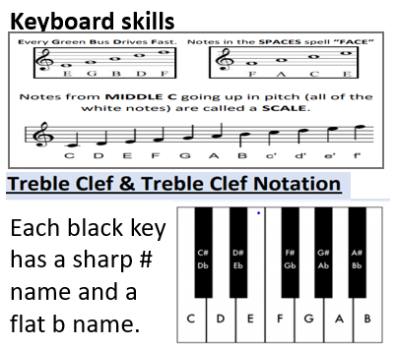  Music | Drama  Key components of Musical Theatre  - Singing  - Dancing  - Gestural movements  Sondheim’s ‘Acting through Song’  Musical Theatre has a long history and performers who are ‘triple threat’ aspire to work in the West End or Broadway.
Art  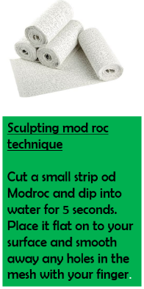  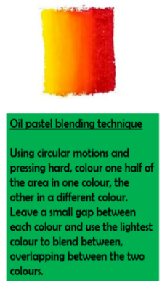 | Computing  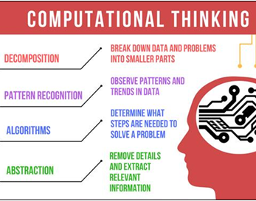 | PE CPR  Cardio-pulmonary Resuscitation.  2 rescue breaths followed by 30 chest compressions, repeat until medical assistance takes over. Know how to use a defibrillator. Know how to call an ambulance and inform the operator you have an unconscious, unresponsive casualty. If heart starts again, place in recovery position.
Return your revision of this essential knowledge to your teacher on your return for a reward for being positive, ambitious, resilient and thoughtful.

