Year 7
‘Must Know Knowledge’
Over half term make sure you revise this. Read it, summarise it, get tested on it, turn it into a poster, mindmap or revision cards. This is the knowledge you must know and remember.
Enjoy your half term break knowing that you know the important stuff!
English  Revise the following – Draw a picture make a mind-map  Globe Theatre, Elizabethan Era, Context  Fill the blanks and make a card for each  “To be or ___ to __” Who said it?  “Friends, romans, ______________” lend me your ears” What does this mean?  “All the world’s a ________” what is this speech about? | 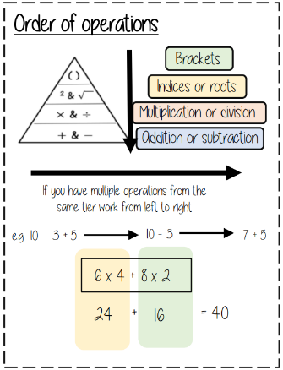  Maths | Science  Energy CANNOT be created.  The units for energy are JOULES.  Energy can be stored as chemical, kinetic, gravitational potential, nuclear, thermal or elastic potential energy  Conservation means to keep things the SAME.  A GAMETE is a sex cell (sperm or egg)
History  Henry Tudor defeated Richard III at the Battle of Bosworth in 1485 because...  -King Richard left the high ground to kill Henry this meant he was open to attack.  -Some of Richard’s men did not trust him and did not want to fight.  -Henry’s men were loyal to him and fought well.  -No noble families supported Richard but they did support Henry. | Geography  Learn all of the Western European countries and oceans.  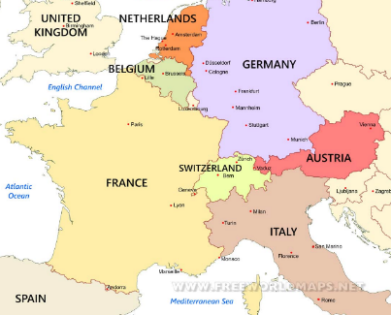 | RE  Must know why Jesus is important to Christians. The following keywords and definitions will help you: Incarnation- God in the flesh- Jesus Resurrection- Jesus rose again (came back to life) on Easter Sunday Ascension- Jesus returned to Heaven to be with God the Father.  Atonement- making amends when you have done something wrong. Christians believe God will forgive you for sins you have committed because of Jesus' sacrifice. Salvation- Jesus died to save Christians from their sins
French  Learn this key vocabulary:  I play = je joue  I watch = je regarde  I send = j'envoie  I do = je fais  I like playing = j'aime jouer | 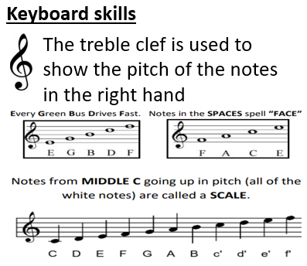  Music | Drama  Key components of Musical Theatre  - Singing  - Dancing  - Gestural movements  - Storytelling (Acting through Song)  E.g. Matilda/ West Side Story  Triple threat: A performer who excels in singing, acting & dancing.
Art  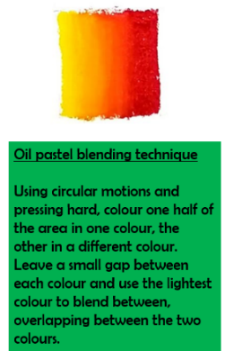  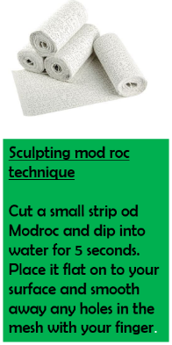 | Computing  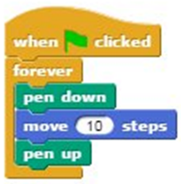  You program a sprite by joining two or more blocks together. You must make sure the order of events is correct when building  sequences. | PE CPR  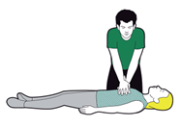  Resuscitating the heart to prolong life. 2 rescue breaths followed by 30 chest compressions, repeat until medical assistance takes over. If heart starts again, place in recovery position.
Return your revision of this essential knowledge to your teacher on your return for a reward for being positive, ambitious, resilient and thoughtful.

