Year 8 ‘Must Know Knowledge’
Over half term make sure you revise this. Read it, summarise it, get tested on it, turn it into a poster, mindmap or revision cards. This is the knowledge you must know and remember.
Enjoy your half term break knowing that you know the important stuff!
English  Recall the definitions of the following vocabulary then write a sentence using a DAFOREST technique which links to the word.  Ethos  Logical  Pathos  Rebuttal (to use in counter-argument)  Accomplish | 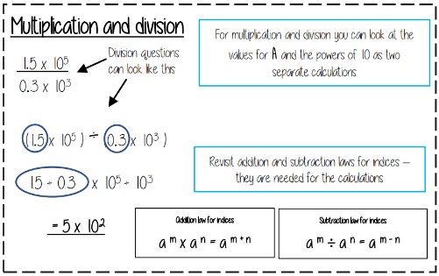  Maths | Science  Respiration and breathing are NOT the same  The word equation for aerobic respiration in animal cells is…  glucose + oxygen carbon dioxide + water (and energy released)  Inside cells respiration take place in the mitrochondria  The separation technique you would use to separate a mixture of two or more liquids is distillation In paper chromatography the mobile phase is known as the SOLVENT  Asound wave is LONGDITUDIONAL  Microwaves are TRANSVERSE waves
History  Germany lost World War One because...  - The United States entered the war on the Allies side in 1917, by mid-1918 they had over one million troops.  - German civilians were beginning to riot and strike as people became frustrated with the war and food shortages.  - German soldiers had low morale.  - The German Kaiser (monarch) had abdicated (left the throne) – the new government wanted peace.  - Germany’s allies had been defeated or had signed agreements to end their part in the war. | Geography  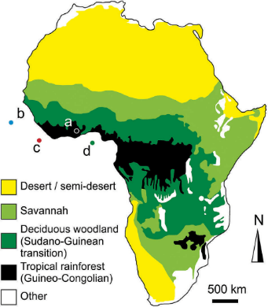  Learn the  different  Biomes that  are in Africa  and where  they are  located | RE Buddhism  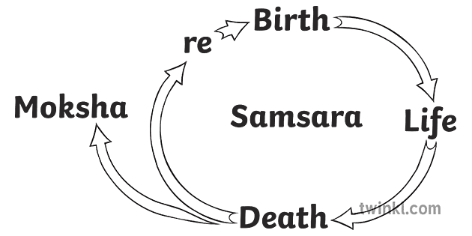  Must know how Karma influences afterlife: Samsara  Karma- the belief that actions have consequences. Enlightenment/ Nirvana- Buddhists believe the cycle of Samsara can be broken if they can achieve enlightenment/ Nirvana.
Spanish  Learn this vocabulary:  me duele (el pie) = I have a sore (foot) (singular)  me duelen (los pies) = I have sore (feet) (plural)  this = este (masc) / esta (fem)  these = estos (masc pl.)  estas (fem pl.)  hace dos años que juego = It's been 2 years since I've been playing (use present tense in Spanish) | 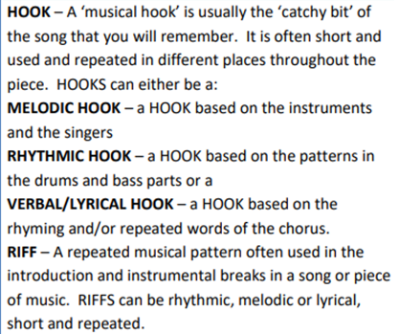  Music | Drama  Greek Theatre  - Tragedy, Comedy and Satyr  (Tormenting  those in power)  - Stories are often using Greek Myths e.g. Hercules/ Prometheus.  - Greek Chorus: Unison/ Canon/ Echo  - Huge festivals were held where thousands would be entertained.
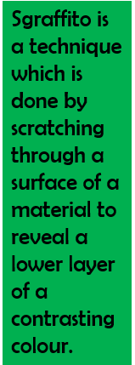  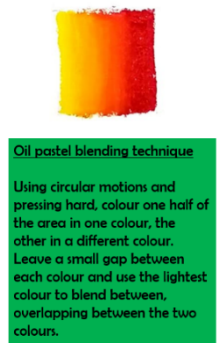  Art  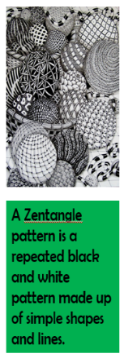 | Computing  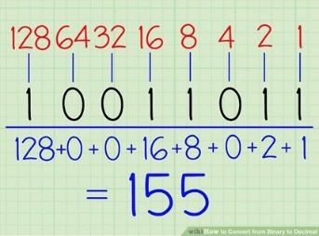  When converting Binary to Denary you use the place values. The one furthest right will be one and then each place value will times by 2. From there you can just add up the column numbers where a 1 appears below. | PE  Understand and apply the short-term health benefits of physical activity.  How to measure Resting Heart Rate - Count pulse rate for 15 seconds, multiply by 4.  How to calculate. Maximum Heart Rate – 220 minus your age.  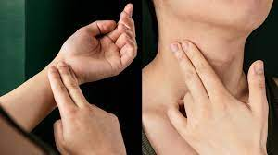  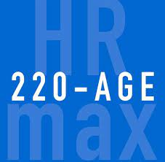  Recovery Heart Rate – the time it takes for your heart to return to resting after exercise.
Return your revision of this essential knowledge to your teacher on your return for a reward for being positive, ambitious, resilient and thoughtful.

