Year 8 ‘Must Know Knowledge’
Over half term make sure you revise this. Read it, summarise it, get tested on it, turn it into a poster, mindmap or revision cards. This is the knowledge you must know and remember.
Enjoy your half term break knowing that you know the important stuff!
English  Revise the definitions of the following vocabulary and write a sentence, for each of the words, linked to the speeches that you have studied this term.  Ethos  Logical  Pathos  Rebuttal (to use in counter-argument)  Accomplish | 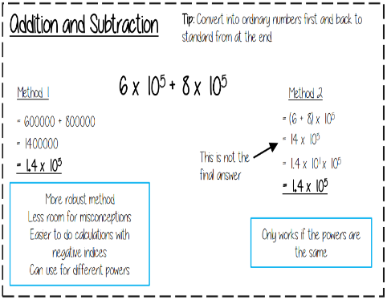  Maths | Science  Respiration and breathing are NOT the same  The word equation for aerobic respiration in animal cells is…  glucose + oxygen carbon dioxide + water (and energy released)  Inside cells respiration take place in the mitrochondria  The separation technique you would use to separate a mixture of two or more liquids is distillation  Asound wave is LONGDITUDIONAL
History  World War One started because ...  Militarism - The attempt to build up a strong army and navy gave nations the means and will to make war. Alliances - Germany, Austria-Hungary and Italy formed the Triple Alliance. France, Britain and Russia had all joined the Triple Entente.  Imperialism - The desire to conquer colonies, especially in Africa brought the powers into conflict.  Nationalism - The belief that your country is better than others. This made nations assertive and aggressive. | Geography  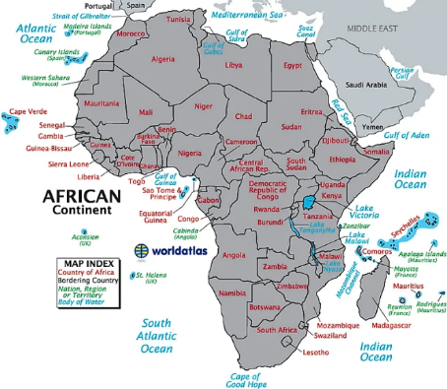  Know at least 5 countries and 5 seas and oceans. | RE  Buddhism  Must know the cycle of Samsara:  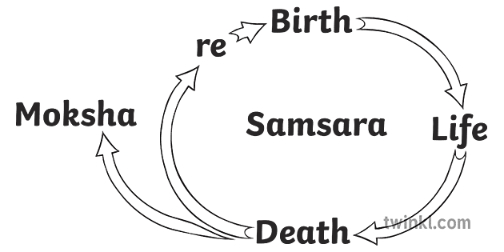
Spanish  Learn this key vocabulary:  I have a sore (head) = me duele la cabeza  I have a cough = tengo tos  give me = deme  you must/have to = debes  you must drink water = hay que beber agua | 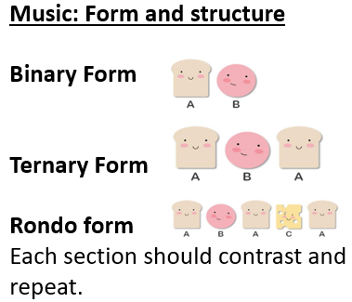  Music | Drama  Greek Theatre  - Tragedy, Comedy and Satyr  (Tormenting  those in power)  - Stories are often using Greek Myths e.g. Hercules/ Prometheus.  - Greek Chorus = Narrators  - Huge festivals were held where thousands would be entertained
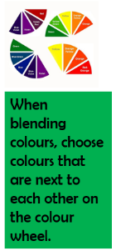  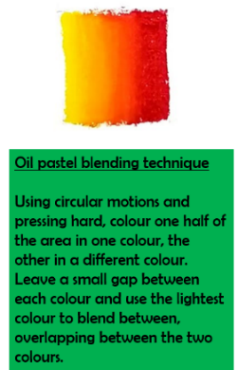  Art  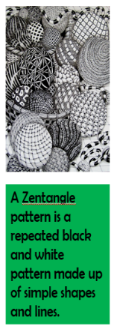 | Computing  - All computers have circuits/transistors that allow electricity to pass through them.  - A microchip is a group of tiny circuits that help a computer or other digital device to work.  - Electricity is needed for computers to work.  - Binary code tells the circuits/ transistors when to turn the different parts of a computer on or off. ‘On’ is represented by ‘1’ and ‘off’ is represented by ‘’0’. | PE  Understand and apply the short-term health benefits of physical activity.  - How to measure Resting Heart Rate - Count pulse rate for 15 seconds, multiply by 4.  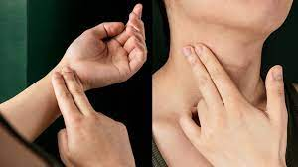  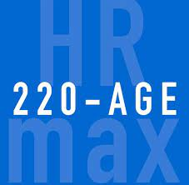  - How to calculate maximum Heart Rate – 220 minus your age.
Return your revision of this essential knowledge to your teacher on your return for a reward for being positive, ambitious, resilient and thoughtful.

