Year 8 ‘Must Know Knowledge’
Over half term make sure you revise this. Read it, summarise it, get tested on it, turn it into a poster, mindmap or revision cards. This is the knowledge you must know and remember.
Enjoy your half term break knowing that you know the important stuff!
English  Revise the definitions of the following vocabulary and practise the spellings of each WOW.  Ethos  Logical  Pathos  Rebuttal (to use in counter-argument)  Accomplish | 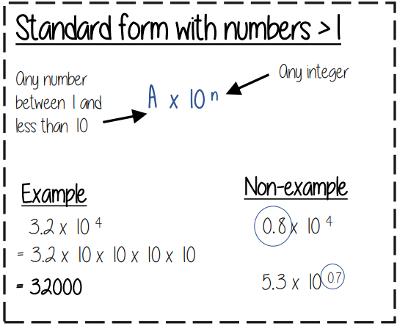  Maths | Science  Respiration and breathing are NOT the same  The word equation for aerobic respiration in animal cells is…  glucose + oxygen carbon dioxide + water (and energy released)  Inside cells respiration take place in the mitrochondria
History  World War One started because of...  Militarism- army/navy  Alliances- agreements with countries  Imperialism- take over other countries  Nationalism- proud of your country | 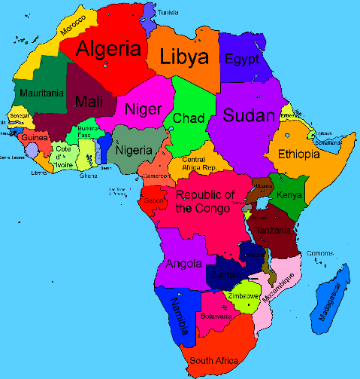  Geography  Know at  least 5  countries  in Africa | RE  Buddhism  Must know the 5 precepts-  - Do not harm living things  - Do not take what is not given  - Do not abuse relationships  - Avoid improper speech  - Avoid alcohol and drugs
Spanish  Learn this key vocabulary:  me duele (la cabeza) = I have a sore (head)  Tengo tos = I have a cough  deme = give me  debes = you must / have to  hay que beber agua = you must drink water | 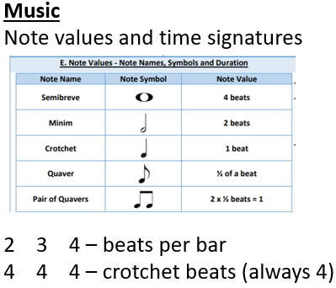  Music | Drama  Greek Theatre  - Tragedy, Comedy and Satyr  (Tormenting  those in power)  - Greek Myths and Gods e.g. Prometheus and the Theft of Fire.  - Greek Chorus = Narrators
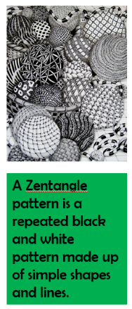  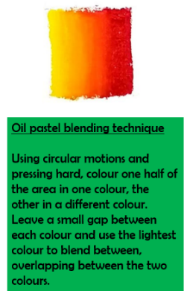  Art | Computing  Binary is a number system that contains two symbols, 0 and 1. Also known as base 2 number system.  00001111 in binary is 15 in decimal. | PE  Understand and apply the short-term health benefits of physical activity.  - How to measure Resting Heart Rate  - Count pulse rate for 15 seconds, multiply by 4.  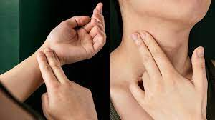
Return your revision of this essential knowledge to your teacher on your return for a reward for being positive, ambitious, resilient and thoughtful.

