Year 9 ‘Must Know Knowledge’
Over half term make sure you revise this. Read it, summarise it, get tested on it, turn it into a poster, mindmap or revision cards. This is the knowledge you must know and remember.
Enjoy your half term break knowing that you know the important stuff!
English  Revise the definitions of the following vocabulary and recall a quotation from the play which it links to.  Supernatural  Valour  Regicide  Emasculate  Hamartia  Allusion  Treachery | 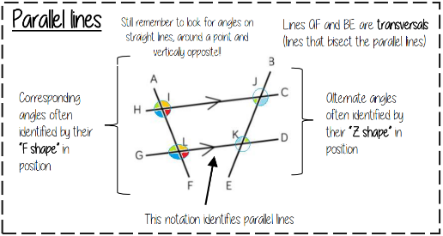  Maths | Science  The word equation for photosynthesis is  Carbon dioxide + water glucose + oxygen  Photosynthesis take place in CHLOROPLAST  The name given to energy stored in movement is called Kinetic energy  The name given to energy stored in fuels is CHEMICAL energy  The law of conservation of energy is that energy CANNOT be created or destroyed, only transferred between stores  3 examples of renewable energy resources are Wave, wind, tidal, geothermal, biomass, hydroelectric  Fossil fuels are Coal, oil and natural gas
History  Why did the Soviet Union end?  Gorbachev’s reforms spread from the Soviet Union to the satellite states.  The satellite states wanted to become independent.  Gorbachev’s glasnost policies meant people could freely disagree with the state, but perestroika only made the Soviet economy worse.  Living conditions for everyone got even worse.  The SU would not intervene in Eastern Europe to support communism, this  resulted in many peaceful revolutions. | Geography  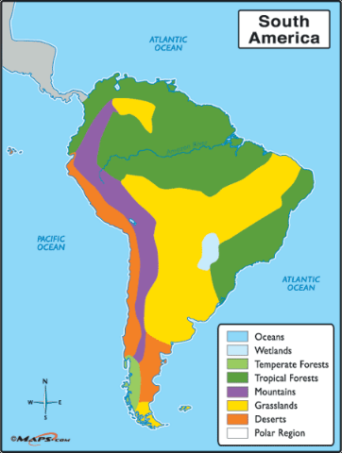  Learn the biomes in South America and where they are. | RE Ethics  Must know the importance of human life and animals in the world today: Sanctity of life- all life is special and given by God. Only he can take it away. Quality of life- the idea that somebody's quality of life should be considered when solving ethical dilemmas  Key questions to consider: Why are humans valuable?: they protect the earth? they protect animals? they create new life? Why are humans NOT valuable?: are they destroying the world? are they using animals for their own entertainment and survival? Why are animals valuable?: food? clothing? transport? companionship? services?
French  Learn this vocabulary:  I go = je vais  I went = je suis allé(e)  I stayed = j'ai logé  I'm going to travel = je vais voyager  I will swim = je nagerai  I would visit = je visiterais | 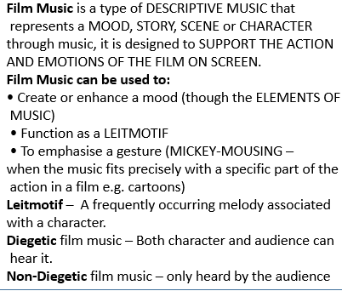  Music | Drama  Technical Theatre  Costume designer- clothes, wigs, makeup, prosthetics (injuries)  Sound designer- makes original sounds and microphones/ music.  Set designer- stage furniture and props- smoke/ rain/ snow.  Technical Theatre help to elevate a performance into a polished performance.  Career opportunities in various aspects of technical theatre.
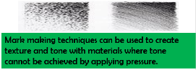  Art  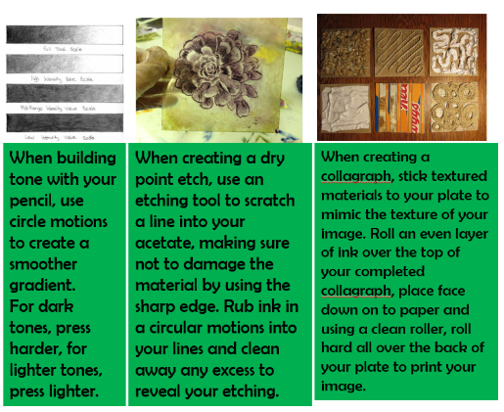 | Computing  PAN Stands for "Personal Area Network." A PAN is network of connected devices used by one person. It allows devices such as computers, tablets, smartphones and smartwatches to communicate with each other. A PAN may incorporate a number of different connections, including Ethernet, Wi-Fi, and Bluetooth. A desktop computer may connect to a personal router via Ethernet and a tablet may connect via Wi-Fi. A smartphone may communicate with a computer via Wi-Fi and a smartwatch via Bluetooth. | PE  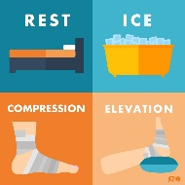  How common sporting injuries occur.E.g sprained ankle when landing in trampoline. Concussion when banging heads during a rugby. How to respond to these injuries. E.g bandage, hospital treatment, ice pack. Know sporting injuries acronyms such as RICE and how to apply it.
Return your revision of this essential knowledge to your teacher on your return for a reward for being positive, ambitious, resilient and thoughtful.

