Year 9 ‘Must Know Knowledge’
Over half term make sure you revise this. Read it, summarise it, get tested on it, turn it into a poster, mindmap or revision cards. This is the knowledge you must know and remember.
Enjoy your half term break knowing that you know the important stuff!
English  Revise the definitions of the following vocabulary and write a sentence linked to the play.  Supernatural  Valour  Regicide  Emasculate  Hamartia  Allusion  Treachery | 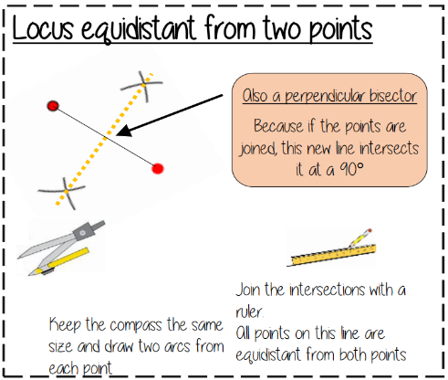  Maths | Science  The word equation for photosynthesis is  Carbon dioxide + water glucose + oxygen  Photosynthesis take place in CHLOROPLAST  The name given to energy stored in movement is called Kinetic energy  3 examples of renewable energy resources are Wave, wind, tidal, geothermal, biomass, hydroelectric  Fossil fuels are Coal, oil and natural gas
History  The Brown Vs Topeka Case was significant because...  - Overturned Plessy v Ferguson ‘Separate but equal’.  - Led to the desegregation of schools.  - Moral victory.  - Demonstrated importance of support at federal level.  - Showed legal processes could achieve changes | Geography  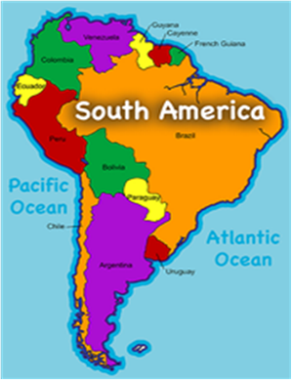  Learn the location of all 13 countries and both oceans in South America. | RE Ethics  Must know the importance of human life: Sanctity of life- all life is special and given by God. Only he can take it away. Contraception- something artificial that is used to stop the sperm meeting the egg.  Key questions to consider: When does life begin?: Conception? When a heart beat is formed? When a soul is created? After birth? Why are humans valuable?: they protect the earth? they protect animals? they create new life?
French  Learn this vocabulary:  I go = je vais  I stay = je loge  I travel = je voyage  I do = je fais  I swim = je nage  I would like = je voudrais | Music  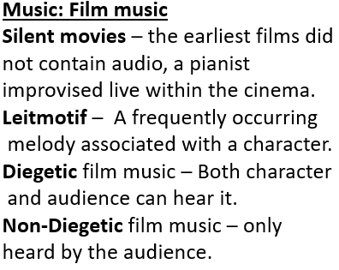 | Drama  Technical Theatre  Costume designer- clothes, wigs, makeup  Sound designer- makes original sounds / music.  Set designer- stage furniture and props  Technical Theatre help to elevate a performance into a polished performance.
Art  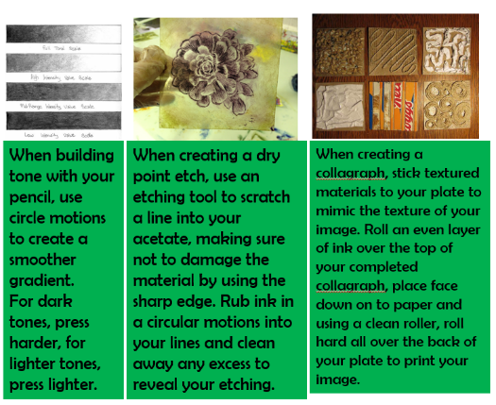 | Computing  Cloud computing is storing and using services online, rather than on a hard drive. Cloud computing is becoming more popular. It is increasingly easy to use cloud services using web apps on smartphones, tablets and desktop machines – as long as there is a web connection in range.  Cloud storage is used to store files such as documents and photos. The files are stored on a server owned by the service provider. | PE  How common sporting injuries occur  E.g sprained ankle when landing in trampoline. Concussion when banging heads during a rugby.  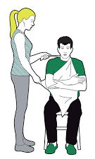  How to respond to these injuries. E.g bandage, hospital treatment, ice pack.
Return your revision of this essential knowledge to your teacher on your return for a reward for being positive, ambitious, resilient and thoughtful.

