Happiness at Upton Infants
At our school we use the term happiness instead of well-being as we want our children to be happy, to know what makes them happy and to develop resilience against unhappiness.
We see ourselves and our children as being on the happiness road but sometimes we can get stuck or something can happen where we get knocked off the road. That something is called life! We want to help those children to get back on the happiness road but more importantly we want to teach children strategies so they can get themselves back on the happiness road.
To do this we teach children that it is okay not to be okay, that it is alright not to be alright as long as you talk about it and don’t stay not okay or not alright. Bad days are okay but bad weeks and even months are not.
Even though all of our staff are friendly, smiley and very approachable we know that schools are very busy places and some children may not feel comfortable telling us that they are not okay. That is why all of our classrooms have our okay/not signs up where children can let us know how they are feeling.

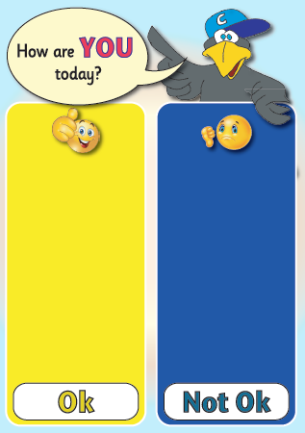

We are well aware that most people and children will bounce back quickly from not being okay however some children won’t. If children do not then that is where our graduated response for Social Emotional Mental Health comes in. This is clear pathway for children to access more specialised help, from in school specialists and external experts with the aim that they will, over time, bounce back.
Additionally all of our children and parents have access to free mental health support by texting SHOUT to 85258. This is supplied by Hamwic our multi academy trust.

