Knowledge and Skills Organiser: Year Two Literacy | How do | 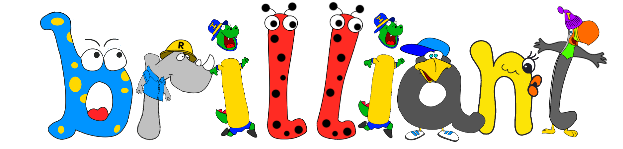 | writers write a narrative? | 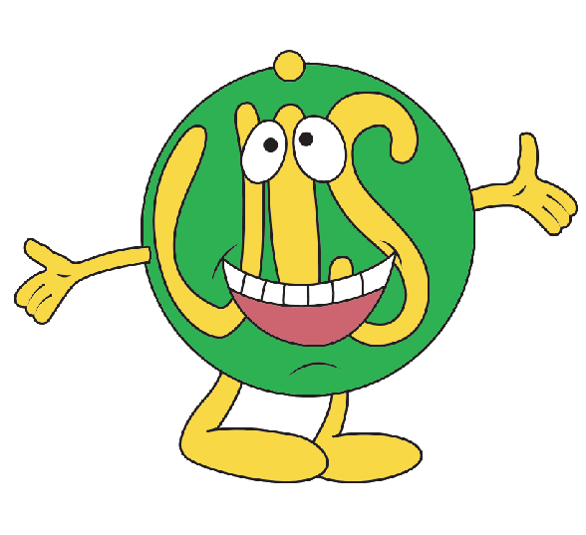

 | Meet our brilliant author and illustrator… |  |  |  |  |  |  |  |  |   How do brilliant writers use possessive apostrophes?
 | 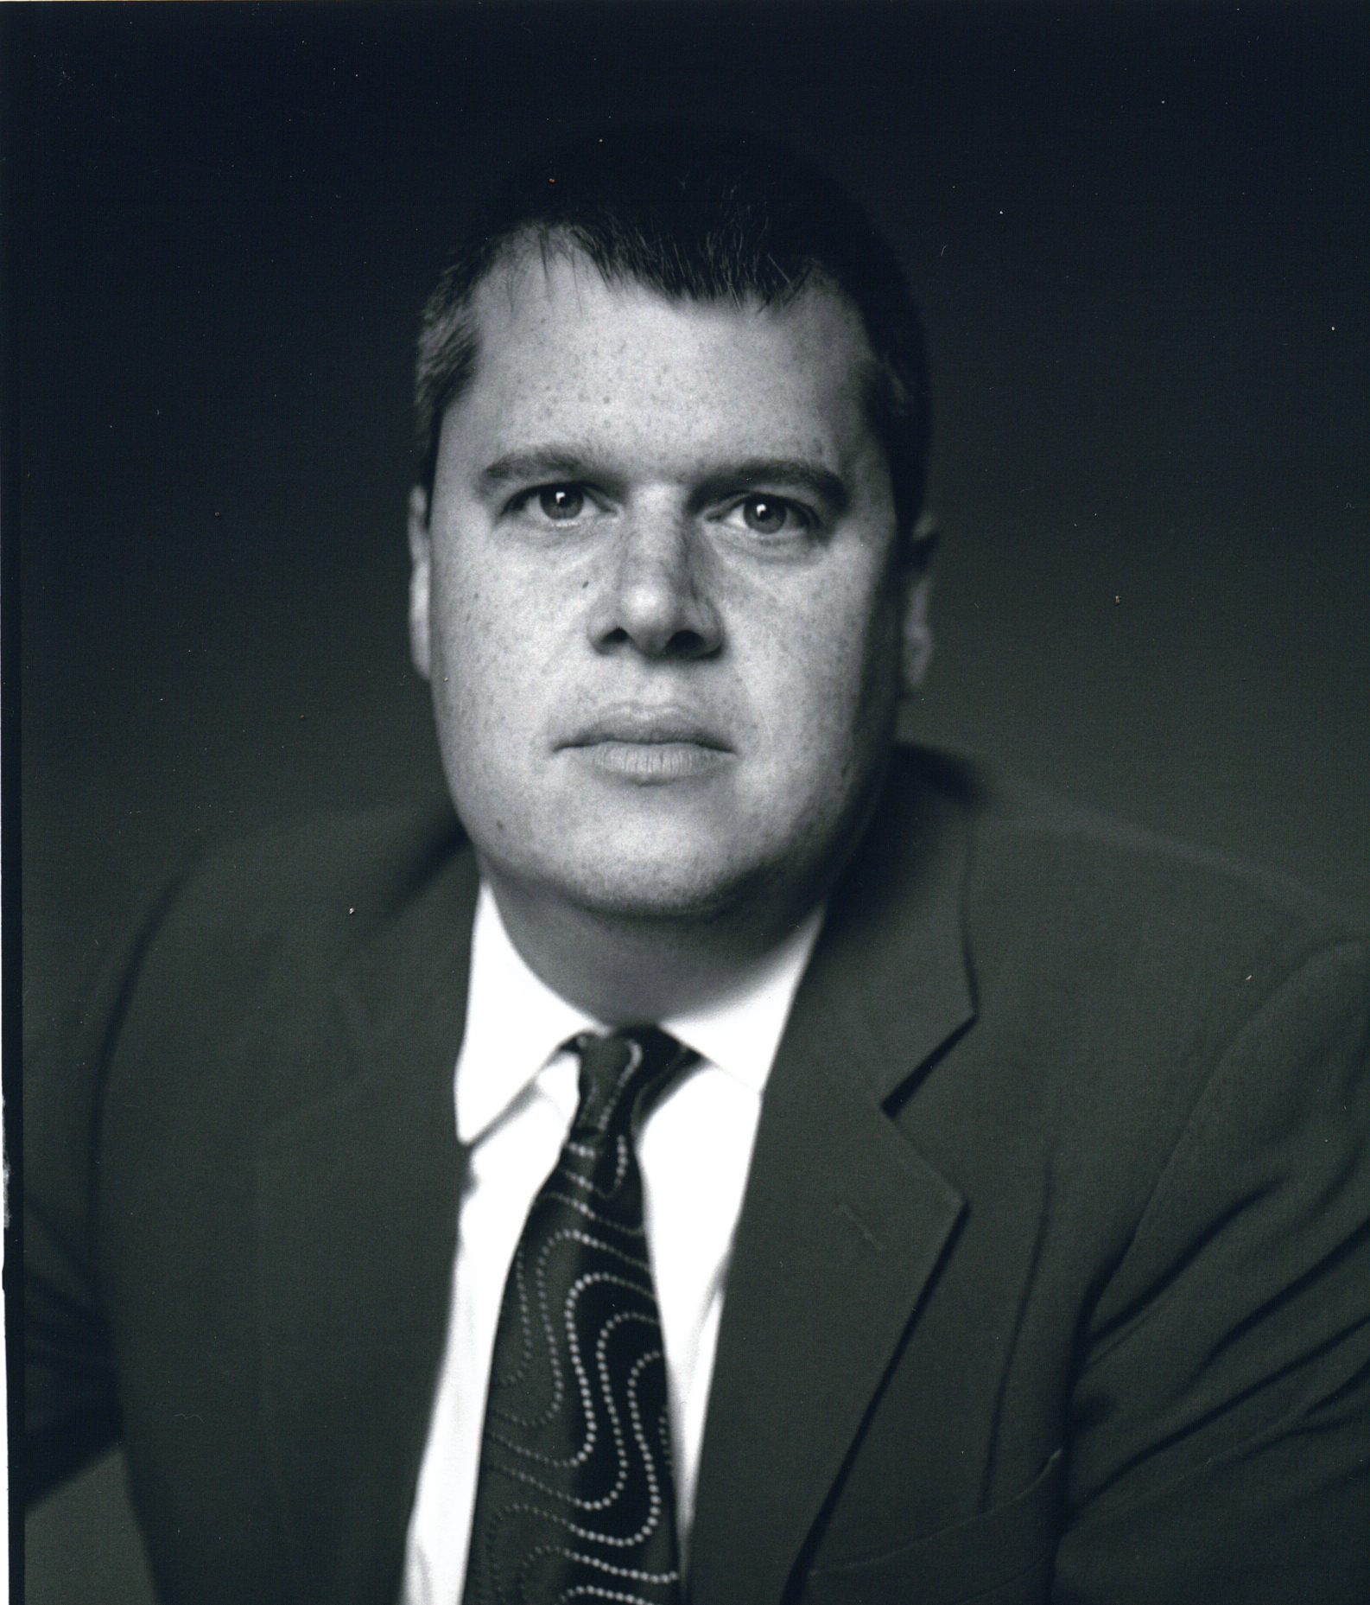 | Lemony Snicket is the pen name of an American author called Daniel Handler. He has published several children’s books and wrote the book we are looking at called ‘The Dark’. |  |  | 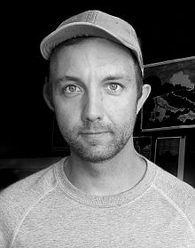 | Jon Klassen is a Canadian writer and illustrator. He has won many awards and drew the illustrations for ‘The Dark’. You may remember reading his book ‘I want my hat back’ in Year One. |  |  |  | We will be hunting for possessive apostrophes in the text and learning to use them in our own writing. | 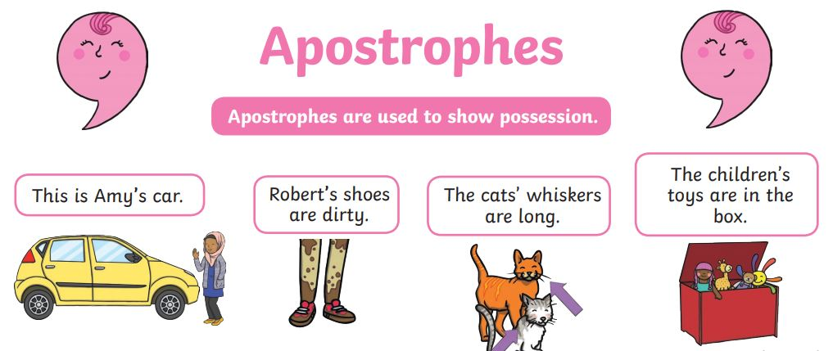
 |   How do brilliant writers use expanded noun phrases to describe and specify? |  |  |  |  |  |  |  |  | How do brilliant writers write in the first person?
 | We will be looking at the text for vocabulary that makes the writing interesting. We will practise using adjectives with nouns to create expanded noun phrases. When using a list of adjectives, we will use commas. |  |  | 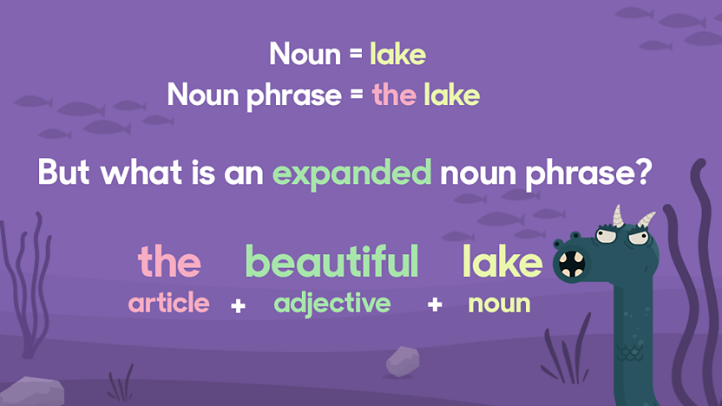 |  |  |  | You can learn more at  https://www.bbc.co.uk/bitesize/topics/zwwp8mn/articles/z3nfw6f |  | A first-person narrative is a way of storytelling through the narrator’s point of view. It uses first-person pronouns such as 'I', 'me' and 'we'.
 |  |  |  |  |  |  |  |  |  | We will use drama techniques such as ‘hot seating’ to explore how the dark may act and feel in the story. This will help us prepare for our writing.
 | 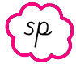 How do brilliant writers add suffixes to spell longer words? |  |  |  |  |  |  |  |  | Our narrative written in the first person
 | CHOP  Remove the ‘e’ |  |  | CHANGE  Change the ‘y’ to an ‘i’ |  |  | DOUBLE  Double the final consonant |  |  | 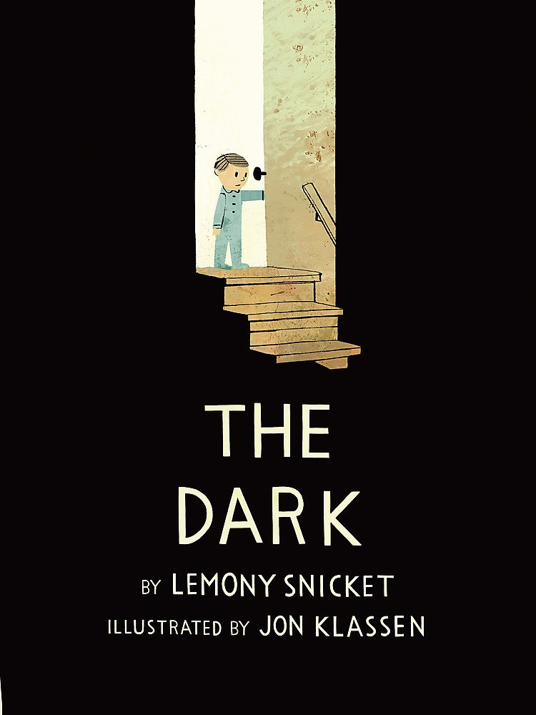 |  | We will be pretending that we are the dark and writing the story from the dark’s perspective. We will use:  - interesting story language  - possessive apostrophes  - expanded noun phrases  - suffixes  in our writing.  Finally, we will edit, revise and correct our writing.
 | When the root word ends in an 'e', chop off the 'e' then add the vowel suffix.  E.g. huge + est = hugest |  |  | The basic change rule is, for any word that ends in a consonant plus “-y,” change the “y” to “i” if adding a suffix  E.g. creaky + er = creakier |  |  | The doubling rule states that if a one syllable word ends with a vowel and a consonant, double the consonant before adding the ending  E.g. big + est = biggest
Key vocabulary: Glossary |  |  |  |  |  |  |  |  |  |  | This half term’s common exception words
adverb |  |  | A word that describes a verb (an action or a doing word). E.g. He ate his breakfast quickly. Adverbs can come before or after a verb. E.g. He 'quickly' ate his lunch or he ate his lunch 'quickly'. |  |  |  |  |  |  |  | behind |  | busy |  | Mr
expanded noun phrase |  |  | Expanded noun phrases add more detail to the noun by adding one or more adjectives. An adjective is a word that describes a noun. For example: a huge tree, some colourful sweets, the large, royal castle |  |  |  |  |  |  |  | only |  | money |  | Mrs
possessive apostrophe |  |  | An apostrophe can be used to show that one thing belongs to or is connected to something. |  |  |  |  |  |  |  | sugar |  | plant |  | clothes
suffix |  |  | A suffix is a letter or group of letters that goes on the end of a word and changes the word's meaning. |  |  |  |  |  |  |  | father |  | parents |  | water

