SEND in a nutshell –
Identification  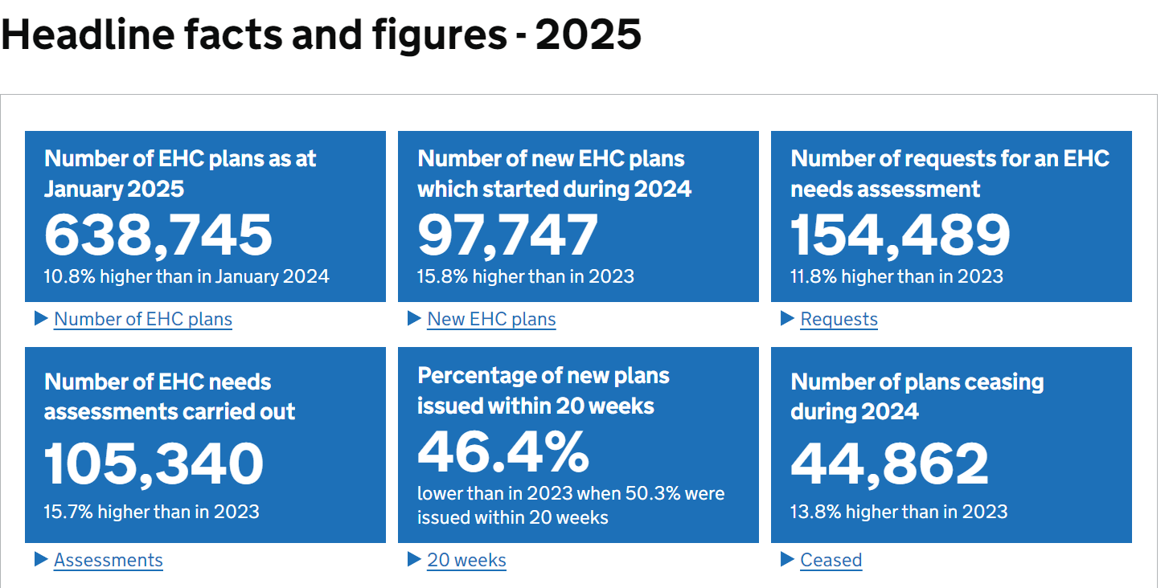 | High Quality Teaching and Intervention  Strengths and Areas for Development  Our key strengths in SEND:  - Joint working with the lower school and resource sharing  - Secure graduated response – system in place to share responsibility od SEND (every teacher is a teacher of SEND)  - Reduced classroom - smaller, structured classroom environment designed to provide personalised learning and targeted support for identified pupils.  - Robust monitoring and evaluation cycle  Our key areas for development for SEND:  - To create a positive and supportive environment for all SEND pupils  - Ensure that all SEND pupils have access to high quality teaching.  - Analysis ensures that teachers are making the necessary adaptations for SEND pupils  - Provide advice, guidance and CPD opportunities to support the work of teaching assistants.  - Develop a stronger evidence trail around coaching
  Year group | Total no. of children | No. of SEN pupils
  EHCPs | 16 (4.4%)
  Year 3 | 83 | 18 (21.7%)
  Year 4 | 88 | 25 (30.1%)
  Year 5 | 87 | 16 (18.4%)
  Year 6 | 92 | 12 (13.0%)
  Total | 350 | 71 (20.3%)
  Categories of SEN | Upton Junior
  Communication and interaction | 31.0% (22)
  Cognition and Learning | 17.0% (12)
  Social, mental and emotional health | 46.5% (33)
  Sensory and/or physical | 5.6% (4)
  SEND Attendance
  Non-SEND | 94.44%
  SEND | 89.09%
  EHCP | 80.82%
  High Quality Teaching for All
  Graduated response  - Joint CPD with the infants: Aligning teaching and learning and SEND approaches  - Establish a transparent system for identifying pupils requiring additional support and accurately mapping their position within the graduated response framework | Establishing Flamingos class  - Support from RG (Hamwic)  - Embedding zones of regulation  - Introducing skills based curriculum  - Personalised planning for pupils
  Universal Adaptive and Responsive Teaching for SEN  - Upton staff personalised working document | Learning walks across lower and upper school  Strengths  Professional development and coaching
  CPD
  Graduated response – joint CPD with infants
  SEND drop in sessions

