Our Vision | ‘Growing Together, Learning Together, Achieving Together’
Our Values | Aspirational, Resilient, Curious

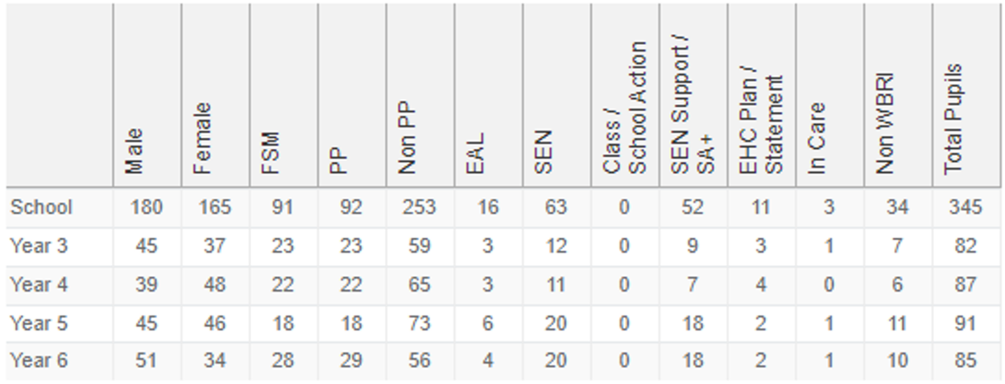
School Context & Background

Upton Junior School is a large Key Stage 2 school on the south coast of the UK with average numbers of disadvantaged pupils (26%) and pupils with Special educational needs (14%). It has been supported by a large educational trust since 2018 and had undergone some turbulence in the leadership of the school.

When the current headteacher arrived, the school was judged to ‘Require Improvement’ by Ofsted twice over eight years. Following 18 months of embedding GOOD provision, it was recognised that a different approach was required to move the school to greater success.

The challenge for Upton Juniors is to sustain and build on the rapid improvement journey that was made in the last two years. Working with stakeholders, including staff, governors and the trust, a purposeful reflection and collaboration on internal and external factors which contribute to the school’s success has been undertaken and using the findings of the analyses, leaders have identified an over-arching strategic intent, and the specific areas for development to deliver it. We recognise that by ensuring excellence for the most vulnerable pupils, we will raise attainment for all and ensure that we become a top 5% school.

Aim |  | Success Criteria | RAG Status >> | 2023-2024 |  |  | 2024-2025 |  |  | 2025-2026
 |  | Success Criteria | RAG Status >> | Aut | Spr | Sum | Aut | Spr | Sum | Aut | Spr | Sum
A | To improve mental health and wellbeing of all pupils and staff | - Percentage of pupils who say that the school encourages them to talk about feelings and emotions: Increase from 58% (Spring 24) to 85%.  - Reduced numbers of pupils using the pastoral team.  - Ratio of positive to negative behaviour increases from 9:1 (Summer 23) to 12:1.  - Average number of days sickness absence per member of staff reduces from 3.95 days to 2 days.  - Number of staff on long-term sick leave relating to mental health concerns reduces from 2 (Autumn 23).
B | To reduce the absence of the disadvantaged / bottom 20% children. | - Attendance for disadvantaged pupils is at least 95% (91.4% 21/22)  - Persistent absenteeism is significantly reduced by the end of KS2 (29.6% 21/22)
C | To improve standards so that we become an FFT top 5% school | - 2023-24: Top 50%  - 2024-25: Top 20%  - 2025-26: Top 20%  - 2026-27: Top 5%

Key Milestones |  | Expected Outcomes | Costs | Owner | Progress Monitoring
 |  |  |  |  | How | When | By Whom
To improve mental health and wellbeing of all pupils and staff
A1 | Develop a Trauma Informed approach | Warm welcome observed at the start of day in every classroom | £3,000 | GM  JF | Observation | Termly | SLT
A2 | Ensure a consistent approach to behaviour. |  | £3,000 | GM  JF | Observation | Termly | SLT
A3 | Develop and promote strategies and support for staff and pupil mental health and wellbeing. | Stormbreak is used in all classes appropriately in line with expectations | £3,000 | GM  JF | MH champion report to Govs | Spring / Summer | Govs
A3 |  | Staff survey indicates increasing number of staff feel their MH and WB is considered by SLT | £3,000 | GM  JF | Survey outcomes | Spring / Summer | Govs
A4 | Develop pupil voice and pupil leadership responsibilities across the school | Pupil representatives on LGB | £3,000 | GM  JF | Meeting notes | Termly | School council
A4 |  | Pupil leadership roles expanded
A5 | PP children showing confidence and resilience in approaching all aspects of learning. | Reduced numbers of pupils using the pastoral team. | £3,000 | GM  JF |  | Termly | SLT
A5 |  | Boxall profiles indicating higher levels of resilience and confidence in school.
To reduce the absence of the disadvantaged / bottom 20% children
B1 | Policy & procedures in line with latest guidance |  | 1 hour cover / walk | KS | HT report | Termly | HT / Govs
B2 | Develop relationship between the SEND team, teachers and parents.
B3 | Identifying patterns and trends.
To improve standards so that we become an FFT top 5% school
C1 | Develop mathematical fluency in times tables and number bonds | See Maths Plan |  | ON | Governor Monitoring | Termly | Govs
C2 | Improve Maths teaching and learning | See Maths Plan |  | ON | Governor Monitoring | Termly | Govs
C3 | Improve Writing teaching and learning |  |  | LL | Governor Monitoring | Termly | Govs
C4 | Ensure wider curriculum builds knowledge over time |  |  | ES | Governor Monitoring | Termly | Govs
C5 | Develop the teaching of reading |  |  | LL | Governor Monitoring | Termly | Govs
C6 | Improve the quality of feedback |  |  | LL | Governor Monitoring | Termly | Govs

2023-2024 Actions |  | Owner | Due Date | Updates
A1.1 | TIS training for all staff |  | Jul-24
A1.2 | TIS Practitioner training for 3 members of staff |  | Jul-24
A1.3 | TIS Empathy training for all staff |  | Jul-24
A2.1 | All staff read When the Adults Change |  | Jul-24
A2.2 | Staff meeting to discuss behaviour policy and possible changes following reading. |  | Jul-24
A2.3 | Develop 30 second script |  | Jul-24
A3.1 | Mental health Champion in place |  | Jul-24
A3.2 | Introduce Stormbreak to develop whole class response to MH and WB |  | Jul-24
A3.3 | Promotion of staff MH and WB strategies and support available through Hamwic Trust |  | Jul-24
A4.1 | Appoint Pupil voice lead |  | Jul-24
A4.2 | Develop clear rationale and success criteria to introduce pupil participation |  | Jul-24
A4.3 | Survey pupils on aspects of school |  | Jul-24
A4.4 | Gather pupil voice on aspects of school |  | Jul-24
A4.5 | Develop working partnerships between Governors and pupils |  | Jul-24
B1.1 | Implement policy and procedures in line with September 2023 expectations |  | Jul-24
B1.2 | Share expectations with Parents and local community |  | Jul-24
B1.3 | Introduce first day home visits for PA pupils |  | Jul-24
B1.4 | Build on Attendance procedures at UIS |  | Jul-24
B2.1 | Review morning arrival arrangements |  | Jul-24
B2.2 | SEN open events |  | Jul-24
B2.3 | Formal reporting arrangements |  | Jul-24
B3.1 | 6 weekly reviews of attendance data |  | Jul-24
B3.2 | LA attendance officer meetings |  | Jul-24
C1.1 | Set children according to tables / number facts knowledge across the school |  | Jul-24
C1.2 | Purchase Number sense to provide structured approach to the teaching of |  | Jul-24
C2.1 | Redesign maths programme of study so that pupils build and remember knowledge, concepts and skills. |  | Jul-24
C2.2 | Improve the quality of modelling |  | Jul-24
C2.3 | Improve AfL so that teachers know when to adapt teaching and when to move children on. |  | Jul-24
C2.4 | Use targeted interventions to ensure children catch up |  | Jul-24
C2.5 | Ensure appropriate pupils have access tutoring program |  | Jul-24
C3.1 | Assess writing across the school with Hamwic consultant |  | Jul-24
C3.2 | Develop an action plan to address identified areas for development |  | Jul-24
C4.1 | Staff CPD programme for effective modelling |  | Jul-24

2024-2025 Actions |  | Owner | Due Date | Updates
A1.4 | Develop a Relationship Policy |  | Jul-25
A1.5 | TIS practical approaches developed in line with relationship policy |  | Jul-25
A2.4 | Whole school behaviour policy introduced across the school with 30 second script in line with PD approach |  | Jul-25
A2.5 | Training with PD associates |  | Jul-25
A2.6 | Behaviour at unstructured times is addressed following pupil voice |  | Jul-25
A3.4 | Stormbreak is used in all classes appropriately in line with expectations |  | Jul-25
A3.5 | Staff and pupil survey undertaken twice a year. |  | Jul-25
A4.6 | Pupil participation in development of school vision and values. |  | Jul-25
B1.5 | Share expectations with Parents and local community |  | Jul-25
B1.6 | Ensure first day home visits for PA pupils |  | Jul-25
B1.7 | Build on Attendance procedures from UIS |  | Jul-25
B2.4 | Review morning arrival arrangements |  | Jul-25
B2.5 | SEN open events |  | Jul-25
B2.6 | Formal reporting arrangements |  | Jul-25
B2.7 | Monthly coffee morning sessions for PA / disadvantaged pupils |  | Jul-25
B3.3 | 6 weekly reviews of attendance data |  | Jul-25
B3.4 | LA attendance officer meetings |  | Jul-25
C3.3 | Complete action plan for writing |  | Jul-25
C3.4 | Moderation of writing |  | Jul-25
C3.5 | CPD on effective modelling of writing following EEF guidance |  | Jul-25
C4.2 | Review Art / DT / History / Geography |  | Jul-25
C4.3 | Develop strategies to enable children to remember more |  | Jul-25
C5.1 | Identify changes to Reading in the new Framework. |  | Jul-25
C5.2 | Share exemplar planning and evidence from Year 4 |  | Jul-25
C6.1 | Follow the EEF guidance on Feedback. |  | Jul-25
C6.2 | Staff CPD focussing on effective feedback |  | Jul-25
C6.3 | Share examples from Maths and writing of effective feedback and response |  | Jul-25

Appendix

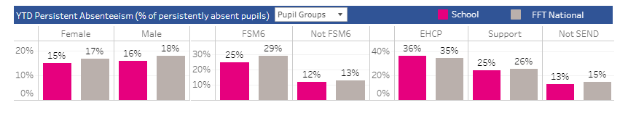
Attendance
Disadvantaged Pupils | 2021/2022 | 2022/2023 | 2023/2024
Attendance | 91.4% | 93.4%
Persistent Absenteeism | 29.6% | 16.7%
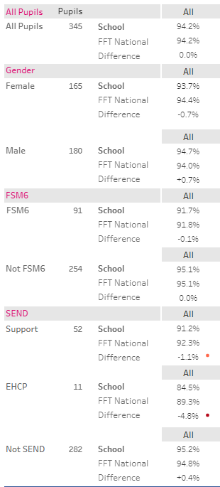

Standards – Key Stage 2 SATs

2023 Outcomes
% of Pupils | National Standards |  |  |  | Upton Junior School
% of Pupils | Reading | Writing | Maths | Combined | Reading | Writing | Maths | Combined
At National Standard | 73 | 71 | 73 | 60 | 75 | 67 | 63 | 55
Above National Standard | 29 | 13 | 24 | 8 | 33 | 7 | 14 | 4
Average Points Score | 105.1 |  | 104.2 |  | 105.7 |  | 102.3

Targets to attain FFT Top 5%

2024 Targets (Top 50%) | % of Pupils
2024 Targets (Top 50%) | Reading | Writing | Maths | Combined
At National Standard | 79 | 87 | 81 | 69
Above National Standard | 22 | 12 | 13 | 3

2025 Targets (Top 50%) | % of Pupils
2025 Targets (Top 50%) | Reading | Writing | Maths | Combined
At National Standard | 69 | 75 | 74 | 59
Above National Standard | 18 | 9 | 24 | 3

2026 Targets (Top 20%) | % of Pupils
2026 Targets (Top 20%) | Reading | Writing | Maths | Combined
At National Standard | 83 | 86 | 87 | 76
Above National Standard | 37 | 30 | 35 | 17

2027 Targets (Top 5%) | % of Pupils
2027 Targets (Top 5%) | Reading | Writing | Maths | Combined
At National Standard | 86 | 87 | 90 | 80
Above National Standard | 45 | 38 | 46 | 24

