ART Year group: 3 Term: 1 Unit: Drawing
Key question: How can I use line and tone to draw what I can see?
Vocabulary I need to know |  |  | Things I already know before I start the journey |  | Things I need to know by the end of the journey
Sketch  Sketch lightly | A quick, free hand drawing, usually not intended as a finished piece of work.  Draw using pencil very lightly.
Sketch  Sketch lightly |  |  | I know about the work of artists and can describe the differences and similarities between different practic- es.  I know how to use some shading techniques  I know how to draw carefully from observation.  I can make links from the work of well known artists to my own work.
I know about and can describe the drawings of Wassily Kandinsky.
I know that the pencil grade describes how hard or soft the lead is, extending my knowledge to 3B.
I know how to use different hardness of pencils and different pressure to show different lines.
I know how to use a wide range of shading tech-
Tone | The tone of something refers to how  light or dark it is. Areas with lots of light are called highlights and darker areas are called shadows.
Shading  Linear Shading | Shading can be used to create different tones in a drawing. This makes a 2D  drawing (flat) look 3D (solid). See diagram
Shading  Linear Shading |  | 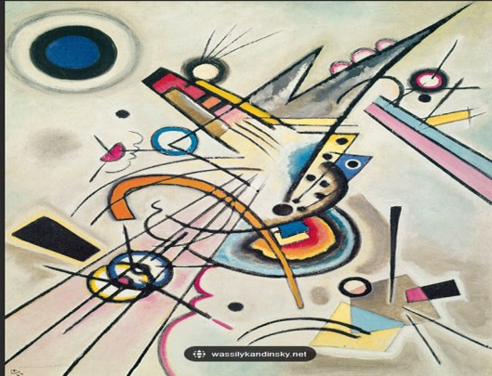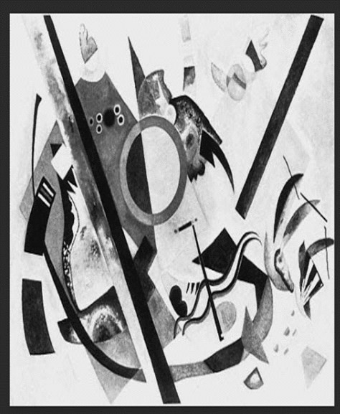 |  |  | niques in my drawings to create tone.  I know how to use a wide range of shading tech- niques in my drawings to show texture.  I know how to sketch lightly (no need to use a rubber to correct mistakes.)
Line weight | The heaviness or darkness of a line,  created by the pressure on your draw- ing as you make your line.
Texture | Describes how a surface feels or may feel if you touch it. (actual/visual)


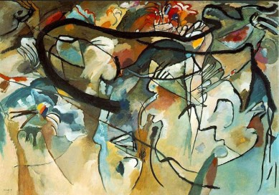
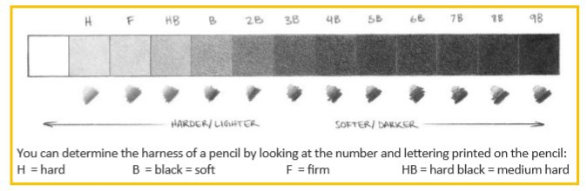
Introduce Elements of Art LO: I know about and can describe the drawings of Wassily Kandinsky.  Focus: Line, Tone, Texture, Shape | LO: I know how to use shad- ing techniques to show tone in my drawings: line weight and linear shading. | LO: I know how to use shad- ing techniques to show tone in my drawings: hatching and cross hatching. | LO: I know how to use a  range of techniques to show texture in my drawings. | LO: I know how to create my own abstract artwork, using Kandinsky's drawings as my  inspiration. | LO: I know how to add tone and texture to my drawings, using pastels.  Evaluation of finished work.

