ART Year group: 4 Term: 1 Unit: Drawing
Key Question: How can I use different kinds of shading to show light and shadow?
Vocabulary I need to know |  |  | Things I already know before I start |  | Things I need to know by the end of
 |  |  | the journey |  | the journey
Pencil hardness | How hard or soft the lead is.
 | H = Hard /lighter B= Soft/blackness |  | I know that the pencil grade describes how hard or soft the lead is, extending my knowledge to 3B.  I know that tone is how light or dark something is  I know that artists can use a wide range of shading techniques in their drawings to create tone.  I know that artists can use a wide range of shading techniques in their drawings to show texture.  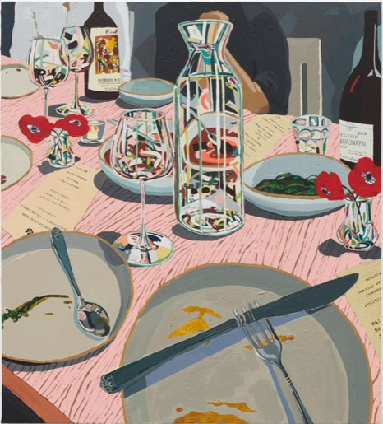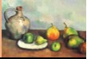 |  | I know about and describe key ideas and tech-  niques of a variety of still life artists. (Cezanne and Hilary Pecis/Nicole Dyer)  I know that the pencil grade of a pencil describes how hard or soft the lead is, extending my  knowledge to 4B  I know how to create tone in my artwork by using a range of shading techniques (contour hatching, contour shading, scumbling), changing my pencil grip if needed.  I know how to use these shading techniques to show light and shadow in a still life drawing.  I know how to use my own and other’s opinions of my work to identify areas of improvement.
Tone | The tone of something refers to how
 | light or dark it is. Areas with lots of light
 | are called highlights and darker areas
 | are called shadows.
Shading | Shading can be used to create different
 | tones in a drawing. This makes a 2D
 | drawing (flat) look 3D (solid).
Line weight | The heaviness or darkness of a line,
 | created by the pressure on your draw-
 | ing as you make your line.
Still Life | Collection of objects, often fruits, flow-
 | ers, glasses (anything that is still!)

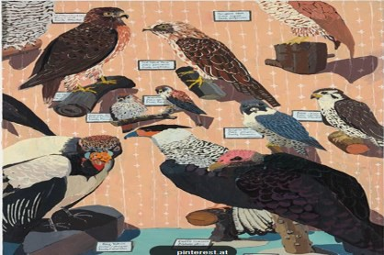
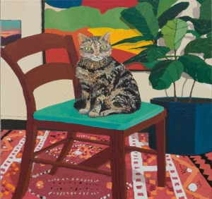
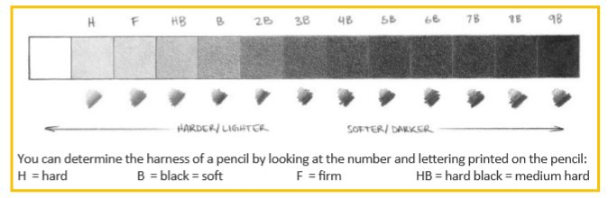
LO: I know about and can describe key ideas and tech- niques of different still life artists (traditional and con- temporary) | LO: I can create tone I my artwork, but using a range of  shading techniques. (Contour hatching, stippling, scum-  bling) | LO: I know how to use these shading techniques to show light and shadow in still life drawings. | LO: I can choose a style of still life drawing to use as an inspiration for my own draw- ings. | LO: I know how to use a  range of shading techniques to show light and shadow my own drawings. | LO: I know how to use my own and other’s opinions of my work to identify areas of improvement.

