ART Year group: 5 Term: 1 Unit: Drawing

Key Question: What techniques should I use to show movement in my drawings?

Vocabulary I need to know
Pencil hardness How hard or soft the lead is.
H = Hard /lighter B= Soft/blackness

Tone The tone of something refers to how
light or dark it is. Areas with lots of light are called highlights and darker areas are called shadows.
Shading Shading can be used to create different tones in a drawing. This makes a 2D
drawing (flat) look 3D (solid).

Movement techniques Speed of the line—fast marks look fast!
Fusion of subject and background. Smooth ,flowing lines

Line weight The heaviness or darkness of a line,
created by the pressure on your draw- ing as you make your line.

Things I already know before I start the journey
Things I need to know by the end of the journey

I know how to research and discuss ideas and ap- proaches/styles of various ‘movement’ artists.
Know about and describe key ideas and techniques of
a variety of still life artists.
I can create tone in my artwork by using a range of mark making techniques, changing my pencil grip if needed.
I know how to use these shading techniques to show light and shadow in a still life drawing.
I know that the pencil grade of a pencil describes how hard or soft the lead is, extending my
knowledge to 5B.
I know how to create tone in my drawings, using a range of shading techniques. (Recap from Yr 3/ 4)
I know how to use speed of line and fusion of sub- ject and background in my drawings, to portray movement.
I know how to use smooth, flowing lines and re- peated still images in my drawings, to show movement.
I know how to create a montage with shading to portray movement.

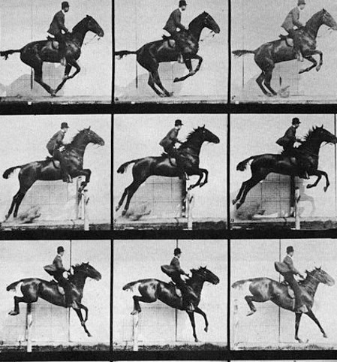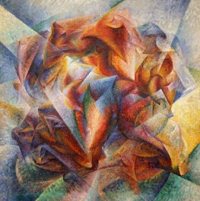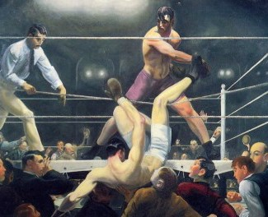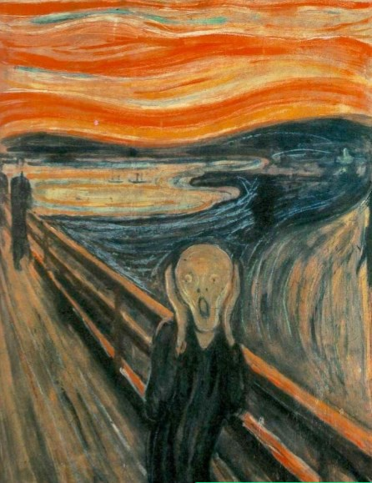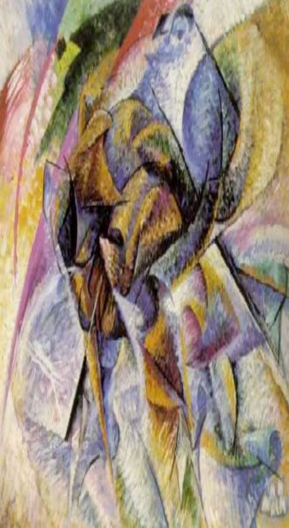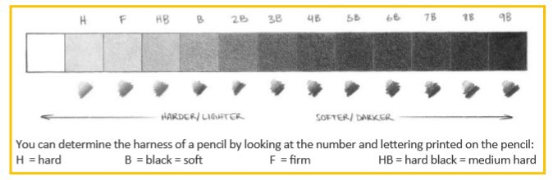LO: I know how to record
from first hand observation, using different shading tech- niques, including facial ex- pressions—expressive art.
LO: I know about the ideas and approached of various ‘movement’ artists—speed of the line, fusion of subject and background.
LO: I know about the ideas and approaches ‘movement ‘artists—smooth flowing
lines, repetition of images.
LO: I know how to create a montage with shading to portray movement—
overlapping similar shapes.
LO: I I know how to use a
range of chosen techniques to show movement in my own drawing.
LO: I know how to use a
range of chosen techniques to show movement in my own drawing.

Evaluation of finished work.

