ART Year group: 6 Term: 1 Unit: Drawing
Key question: How can I use a range of techniques to show depth and perspective?
Vocabulary I need to know |  |  | Things I already know before I start the journey |  | Things I need to know by the end of the journey
Pencil Hardness | How hard or soft the lead is. H = Hard B= Soft/blackness
Pencil Hardness | How hard or soft the lead is. H = Hard B= Soft/blackness | I know how to research and discuss ideas and I know how to describe and interpret the work, ideas  approaches/styles of various ‘movement’ artists. and techniques of Henry Moore. (Including historical,  cultural and social context—WW2 The Blitz)  I know how to use speed of line and fusion of  subject and background in my drawings, to por- II know that the pencil grade describes how hard  tray movement. or soft the lead is, extending my knowledge to 6B.  I know how to use smooth, flowing lines and re- I know that in a flat piece of artwork, artists need to peated still images in my drawings, to show use a range of techniques tell the viewer where things movement. are in space.  I know how to use linear perspective (one and two point) in my drawings.  I know how to draw people suing simple shapes.  I know how to create tone and texture in my drawings, using a range of shading techniques. (Recap from Yr 3 and 4)
Line weight | The heaviness or darkness of a line,  created by the pressure on your draw-
Shading | Shading can be used to create different tones in a drawing. This makes a 2D  drawing (flat) look 3D (solid).
Linear perspective  Vanishing point | This is where the composition creates space by creating imaginary lines which disappear to a point on the horizon
Foreground, middle ground, background. | 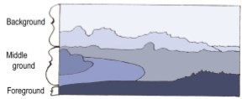


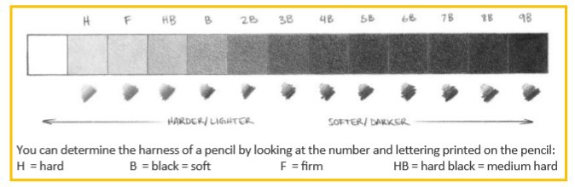
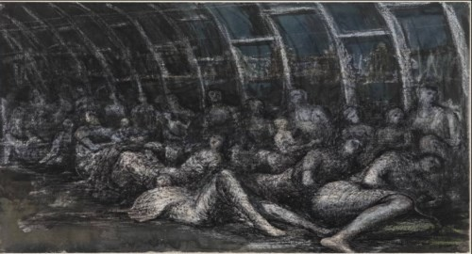
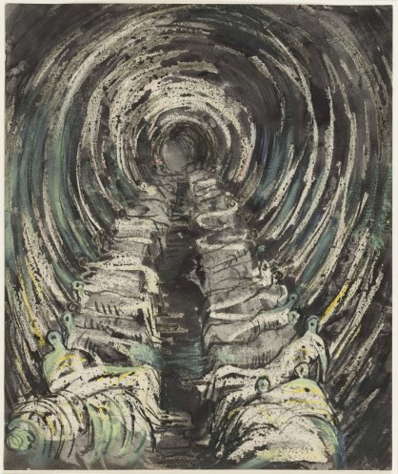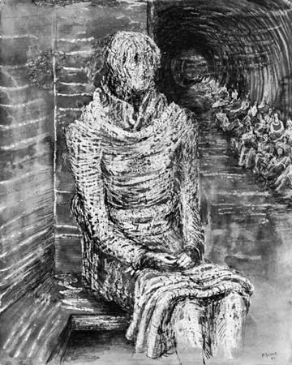
LO: I know how to describe and interpret the  work ,ideas and techniques of Henry Moore. (WW2 Un- derground drawings)  Focus: Line, Shape, Tone, | LO: I know how to use  linear perspective (one point) in my drawings. | LO: I know how to use linear perspective (two point) in my drawings. Trip to UCP | LO: I know how to draw people using simple shape and use these to show depth and perspective. | LO: I know how to use  different media (pencil and charcoal) to create different tones and texture. | LO: I know how to choose certain artists as inspiration for my own original style of artwork—WW2 theme.

