
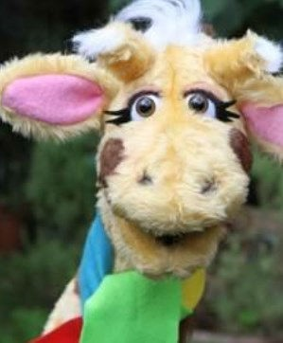

I know what is meant by the term ’being responsible’. I know the reason we have rules.
I know what the word influence means. I know what a bystander is.
I know the names of some national and international environmental organisations.
I know what the term income and expenditure mean.
I know what the term income tax, national insurance and VAT mean.
I can explain why people volunteer.
I can suggest ways to help keep people safe. I can write a recount.
I can evaluate different ways of looking after the school envi- ronment.
I can explain how common household items cost money.

I can explain the factors which affect how much you earn.
Things I need to know by the end of the journey
Things I already know before I start the journey
PSHE Year group: 4 Term: Autumn 1
Unit: Rights and Respect
PSHE Association Link: Living in the wider world

Vocabulary I need to know
Volunteer | A person who offers to work or help without pay.
Fact | A statement which is true.
Opinion | A statement which someone thinks of feels.
Environment | The surroundings all around us.
Income | The money people get for working.
Wage | Money people are paid by their em- ployer.
Salary | Money paid for a fixed period of time  e.g. one month.

Lesson One | Lesson Two | Lesson Three | Lesson Four | Lesson Five | Lesson Six | Lesson Seven
(It’s your right)  LO: I can explain my responsibilities in school  (incl. class charter/ school council) | (Who helps us stay healthy and safe?)  LO: I know what is meant by the term re- sponsible | (How do we make a difference?)  LO: I know the reason we have rules. | (In the news!)  LO: I know what the word influence means. | (Safety in numbers)  LO: I know what a by- stander is. | (Harold’s expenses)  LO: I know what the terms income and ex- penditure mean. | (Why pay taxes?)  LO: I know what taxes are and what they go towards.

