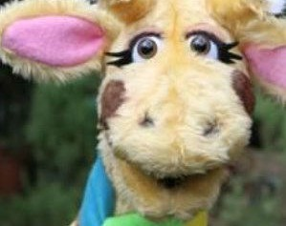
I know strategies for dealing with friendship issues I can recognise peer influence and pressure
I can suggest strategies to act assertively when someone pressures me to do something
I know of ways in which people can respond more positively to one another
I know that people have the right to be free an choose whether to marry or not
I know that some types of physical contact can
evoke negative feelings
I know of safe and respectful behaviours online
.I know of strategies for dealing with difficult situations I know of some key qualities of friendships
I know who to talk to if I need help
I know and can demonstrate assertive skills
I know risk factors in given situations including emo- tional risks
I known that respectful behaviour is acceptable when dealing with others
Things I need to know by the end of the journey
Things I already know before I start the journey
PSHE Year group: 6 Term: Autumn 2 Unit: Me and My Relationships
PSHE Association Link: Relationships/Living in the wider world

Vocabulary I need to know
assertive | Having a confident or forceful personality
peer influence | influence from members of your peer group (friends or people the same age)
peer pressure | Pressure from member of  your peer group
consequence | A result which is usually un- pleasant based on another action
commitment | Being dedicated to doing something
Inappropriate | Not suitable or proper in the situation
illegal | An action not allowed by law

Lesson One | Lesson Two | Lesson Three | Lesson Four | Lesson Five | Lesson Six | Lesson Seven
(Working together)  LO: I know how to im- prove collaboration with others. | (Solve the friendship  problem)  LO: I know some of the challenges which arise from friendships | (Dan’s day)  LO: I know the conse- quences of reacting to someone in a positive or negative way | (Behave yourself)  LO: I know some basic emotional needs and know that they change according to circumstances | (Assertive skills)  LO: I know of some asser- tive behaviours | (Don’t force me)  LO: I know ways which people show their com- mitment to others | (Acting appropriately)  LO: I know that some inap- propriate touch is illegal

