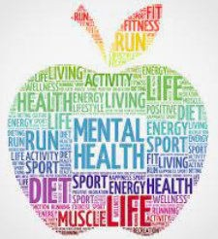
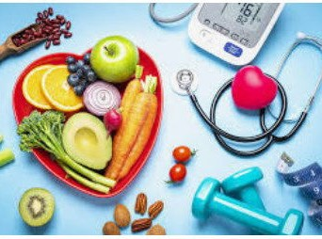
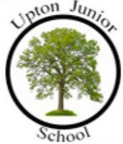
•
I can give a few examples of different
things I do to keep healthy.
•
I can different examples of some of the
things I do to look after my environ-
ment.
•
I can explain the benefits of looking
after myself both now and in the fu- ture.
•
I can explain the benefits of looking
after my environment both now and in
the future.
I know what the term balanced diet means
I know that some infectious illnesses are spread from one person to another
I know what issues can affect my health and well
being
I know that people may say kind things to help us feel good about ourselves
I know how to be successful
I know the names of major internal body parts.
Things I need to know by the end of the journey
Things I already know before I start the journey
PSHE Year group: 4 Term: Spring 2
Unit: Being My Best
PSHE Association Link: Health & Well Being

Vocabulary I need to know
individual | A single human being
unique | Not being like others, being one of a kind
balanced diet | A diet consisting of a variety of different types of foods
well-being | The state of being comfortable, healthy and happy
community | A group of people living in thr dsame place or sharing interests
first aid | Giving help to someone until they can access full medical support
unresponsive | Not being responsive when someone talks to you

Lesson One | Lesson Two | Lesson Three | Lesson Four | Lesson Five | Lesson Six
(What makes me ME!)  LO: To know that my friends and I will sometimes make the same choices but some- times not. | (Making choices)  LO: I know of choices that I make for myself and choices made for me | SCARF HOTEL  LO: I know that the body gets energy from food, water and oxygen and that exercise and sleep are important to health. | Harold’s seven R’s  LO: I know what the seven R’s are. | My school community  LO: I know what is meant by the word community. | SCARF: Basic first aid / British  Red Cross  LO: I have an understanding of basic first aid (choking and burns).

