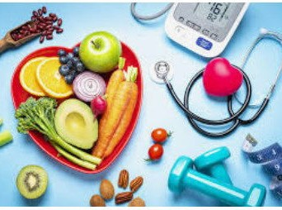
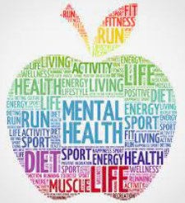
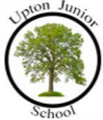
•
I can give an example of when I have had
increased independence and how that has also helped me to show responsibility.
•
I can name several qualities that make peo-
ple attractive that are nothing to do with how they look, but about how they be- have.
•
I can predict the increasing levels of inde-
pendence and responsibilities I will have as I grow older by giving some examples of
this from teenage to adult years.
•
I can also explain how media images of ce-
lebrities can make some people feel
I know that sometimes my friends and I will make similae choices but sometimes not
I know that the body gets energy from food, water and oxy- gen and that exercise and sleep are important to health.
I know whart the seven R’s are.—refuse, re-use, reduce, rot, recycle, repair, re-think
I know what is meant by the word community.

I know how to make a call to the emergency ser- vices if needed.
Things I need to know by the end of the journey
Things I already know before I start the journey
PSHE Year group: 5 Term: Spring 2
Unit: Being My Best
PSHE Association Link: Health & Well Being

Vocabulary I need to know
organs | Body tissues grouped together to form different functions
perseverance | Keeping trying at something even when you find it difficult
Interpersonal skills | Skills needed to community and build relationships with others
independence | Being able to do something by your- self
responsibility | Being in control of dealing with
patience | Being able to tolerate delays without getting angry or upset
resilience | Recovering quickly from things that you have found challenging

Lesson One  (It all adds up!)  LO: I know the basic functions of the four (body) systems cov- ered and know they are inter- related. | Lesson Two  (Different skills)  LO: I can identify my own strengths and talents as well as identify areas that need im- provement. | Lesson Three  (My school community 2)  LO: I know what is meant by the term community. | Lesson Four  (Independence and responsi-  bility)  LO: I know that some people are responsible for helping me stay safe and healthy. | Lesson Five  (Star qualities?)  LO: I know that the way people are portrayed in the media isn’t always an accurate reflection of them in real life. | Lesson Six  SCARF: Basic first aid /  British Red Cross  LO: I have an understanding of basic first aid (unresponsiveness).

