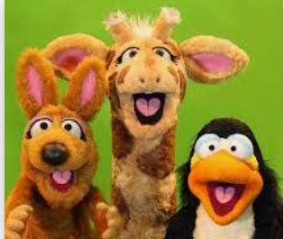
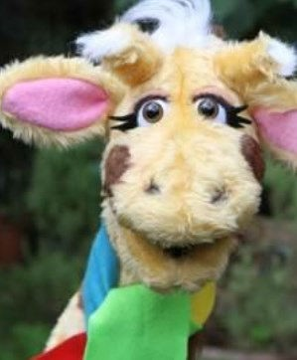

I can explain strategies to help me cope with feelings of loss.
I can demonstrate collaborative working skills.
I can suggest strategies for maintaining rela-
tionships with special people. I can explain what a dare is.
I know of strategies to use when I don’t want to do a dare.
I can express opinions and listen to others.
I can suggest reasons why friends fall out and ways to resolve conflict.
I understand we have different ways to express our feel- ings.
I can express my feelings in a safe, controlled way.

I can tell you some ways that I can get help if I am being bullied and what I can do if someone teases me.
I can tell someone how they are making me feel.

I can give you lots of ideas about being what makes a good friend and also tell you how I try to be a good friend.
Things I need to know by the end of the journey
Things I already know before I start the journey
PSHE Year group: 3 Term: Autumn 2 Unit: Me and My Relationships
PSHE Association Link: Relationships/Living in the wider world

Vocabulary I need to know
Loss | The fact or process of losing
Collaboration | Working with others to achieve a
Dare | Being challenged to do some- thing which you may not want to do
Conflict | A serious disagreement
Relationships | The way in which two or more
Solution | Finding a way to deal with a diffi-
Qualities | Characteristics other people have

Lesson One | Lesson Two | Lesson Three | Lesson Four | Lesson Five | Lesson Six | Lesson Seven
(Looking after our spe-  cial people)  LO: I know people who I have a special relation- | (How can we solve this  problem?)  LO: I know that no one has the right to force me | (Tangram team chal-  lenge)  LO: I know the different skills which people bring | (Friends are special)  LO: I know the qualities of what makes a good friend | (Thunks)  LO: I know how to con- sider other people’s points of view | (Dan’s dare)  LO: I know what a con- flict is | (My special pet)  LO: I know that feelings of loss are normal and can explain how to cope

