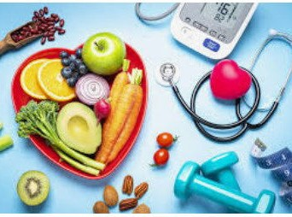
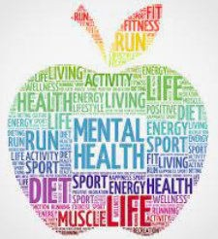

(
I can give a few examples of things that I can take responsibility for in relation to my health.
I can explain and give an example of a skill that I have developed and the goal-setting that I’ve already done (or plan to do) in order to improve it.
I can give several examples of things that I do to take responsibility for my health and can explain the benefits of this.
I can tell you about aspirations I have for when I’m older and give examples of the goals I need to set in order to achieve these.
I can explain what happens when I learn something new.
I can explain how setting a goal or goals will help me to achieve what I want to be able to do.
I can explain how hand hygiene stops virus’ and germs from spreading/
I can give examples of what I can do and give my body to stay healthy.
I can name different parts of my body that are inside me and help to turn food into energy.
Things I need to know by the end of the journey
Things I already know before I start the journey
PSHE Year group: 3 Term: Spring 2
Unit: Being My Best
PSHE Association Link: Health & Well Being

Vocabulary I need to know
Balanced diet | Eating a broad range of different foods.
Food groups | The five groups that have different nutritional values.
Infectious | Passing germs from one to another.
Hygiene | Staying clean and healthy.
Well being | The state of being happy, comforta- ble, healthy and safe.
Achievements | Something that you are proud of  that you have completed.
Development | Improving at something.

Lesson One | Lesson Two | Lesson Three | Lesson Four | Lesson Five | Lesson Six
(Derek cooks dinner) | (Poorly Harold) | (Body Team Work) | (For or against) | (I am fantastic) | (Top talents)
LO: To know what the term balanced diet means | LO: To know how some in- fectious illnesses are spread from one person to another. | LO: To know the names of major internal body parts. | LO: To know what issues can affect my health and well being. | LO: To know that people may say kind things to help us feel good about ourselves. | LO: To recognise my own talents and skills as well as that of others.

