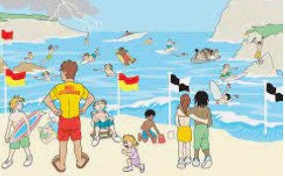
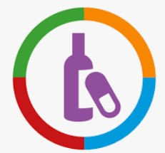

I can say what I can do to make a situation less risky or not risky at all.
I can say why medicines can be safe or harmful.

I can say why some people might take risks and why others choose to avoid risky situations.
I can explain why things other than drugs can be helpful and harmful to a person’s health and what can influence a per- son.
I can say why some people might take risks and why others choose to avoid risky situations.
I can explain why things other than drugs can be helpful and harmful to a person’s health, and what can influence a per- son to take risks.
I can give examples of how sometimes people try to find out personal information through online communication and the problems this can lead to.
I can keep myself safe around medicines. I can explain that they can be helpful or harmful, and say how they can be used safely.
I can respond appropriately in relation to keeping myself and others safe.
I can say what I do and don’t like and who to ask for help.

I can give some examples of safe and unsafe secrets and I can think of safe people who can help if something feels wrong.
I can give examples of touches that are ok or not ok and can identify a safe person to tell if I didn’t feel okay about some- thing.
Things I need to know by the end of the journey
Things I already know before I start the journey
PSHE Year group: 3 Term: Summer 1
Unit: Keeping Myself Safe
PSHE Association Link: Health & Well Being/Relationships/Living in the wider world

Vocabulary I need to know
trust | Firmly believing what somebody says
safe | Being free harm or danger
unsafe | Being at risk of harm or danger
risk | Someone or something that could cause a problem
strategy | A carefully developed plan for achieving something
alcohol | A drug harmful to especially your liver
cigarettes | Contain a drug harmful to especially your lungs

Lesson One | Lesson Two | Lesson Three | Lesson Four | Lesson Five | Lesson Six
(Safe or Unsafe)  LO: I know people who can help if a situation is unsafe. I know people who can help if a situation is unsafe. | (Danger or risk and Risk ro-  bot)  LO: I know the difference between danger and risk. | (Help or harm?)  LO: I know that medicines are drugs that can be helpful and harmful. | (Super searcher)  LO: I know how to keep my- self safe online. | (Alcohol and cigarettes)  LO: I know what the word drug means. | RNLI Website for 7—11 year  olds—Is This Safe activity?  LO: I know how to stay safe near the water.

