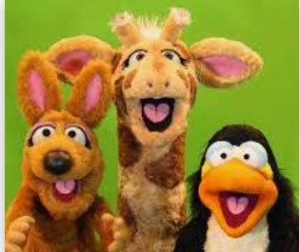
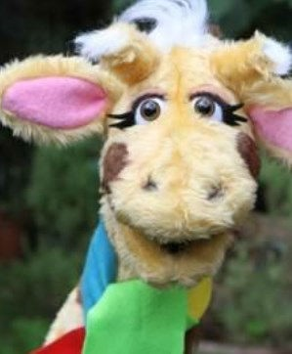

I can give examples of different community groups and what is good about having different groups.
I can talk about examples in our classroom where respect and tolerance have helped to make it a happier, safer place.
I can explain how different families and communi- ties can experience prejudice and why this can happen.
I can give examples of when I have helped people to be more respectful and tolerant by setting a good
example.
I can be respectful of those who are different to me.
I can describe how someone can change someone’s feelings.
I can tell you why it is important to show good listening to people who think differently to me.
I can name and suggest strategies to someone who feels left out.
I can be kind and use kind words to my friends.
Things I need to know by the end of the journey
Things I already know before I start the journey
PSHE Year group: 3
Term: Spring 1
Unit: Valuing differences
PSHE Association Link: Living in the wider world and Relationships

Vocabulary I need to know
Adoption | This means to accept a person,  pet or object as your own.
Community | A group of people living in a par- ticular area.
Origins | The background of people, plac- es or objects.
Tolerance | Willing to accept respect what is different in others
Differences | Things not the same between people.
Similarities | Having things in common.
Prejudice | A liking or dislike for one rather  than another especially without good reason.

Lesson One | Lesson Two | Lesson Three | Lesson Four | Lesson Five | Lesson Six
(Respect and challenge)  LO: To know examples of respectful language. | (Family and friends)  LO: To know that there are many different types of fami- ly. | (My community)  LO: To know what the term community means. | (Our friends and neighbours)  LO: To know that people that live in the UK have different origins. | (Lets Celebrate our differ-  ences)  LO: To know what name- calling is. | (Zeb)  LO: To know the reaons why different people are bullied and what the term prejudice means.

