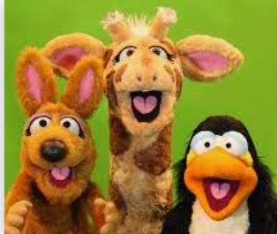
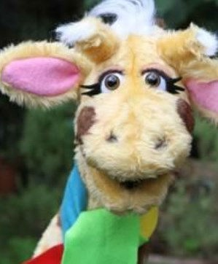

I know what the term feelings mean
I know and can name feelings which make us feel good I know and can name feelings which make us feel bad
I know of qualities which I admire in others
I know of situations when I might need to say no to a friend
I know successful qualities of teamwork and collabora- tion
I know of situations where my feelings towards others change
I know that I can be influenced to behave in an unac- ceptable way
I can suggest strategies for maintaining rela- tionships with special people.
I can explain what a dare is and know of strat- egies to use when I don’t want to do a dare.
I can suggest reasons why friends fall out and
ways to resolve conflict.
I can explain strategies to help me cope with feelings of loss.
Things I need to know by the end of the journey
Things I already know before I start the journey
PSHE Year group: 4 Term: Autumn 2 Unit: Me and My Relationships
PSHE Association Link: Relationships/Living in the wider world

Vocabulary I need to know
Bullying | Seeking to harm or upset some-
Collaboration | The action of working with some-
Teamwork | Working with people to achieve a
Relationships | The way in which two or more
Feelings | An emotional state
Physical state | The way which someone appears
Assertive | Having or showing a confident or

Lesson One | Lesson Two | Lesson Three | Lesson Four | Lesson Five | Lesson Six | Lesson Seven
(Human machine) | (Ok or not Ok? Part 1) | (Ok or not ok? Part 2) | (An email from Harold) | (Different feelings) | (When Feelings Change) | (Under Pressure)
LO: I know successful qualities of teamwork and collaboration | LO: I know some of the qualities which I admire in others | LO: I know that there are times when I might need to say no to a friend | LO: I know good and not so good feelings and can explain how feelings can affect us | LO: I know how others might show different feelings. | LO: I know that feelings can change towards people in different situa- tions | LO: I know how I can be influenced to behave in an unacceptable way

