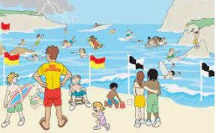
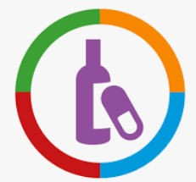

•
I know people who can help if a situation is un-
safe. I know people who can help if a situation is unsafe.
•
•
•
I know what the word drug means.
I know risk factors in different situations.
I can understand where to get help from when making decisions.
•
I know how to stay safe near the water.
I can say what I can do to make a situation less risky or not risky at all.
I can say why medicines can be safe or harmful.
I can say why some people might take risks and
why others choose to avoid risky situations.
I can explain why things other than drugs can be helpful and harmful to a person’s health and what can influence a person.
I can say why some people might take risks and why others choose to avoid risky situations.
I can explain why things other than drugs can be helpful and harmful to a person’s health, and hat can influence a person to take risks.
Things I need to know by the end of the journey
Things I already know before I start the journey
PSHE Year group: 4 Term: Summer 1
Unit: Keeping Myself Safe
PSHE Association Link: Health & Well Being/Relationships/Living in the wider world

Vocabulary I need to know
danger | Something or someone that puts  you at risk of harm
risk | Someone or something that could cause a risk
consequences | The result of doing something , this is usually not nice
drug | A substance that changes the way our body works
medicine | Medicine is the science of keeping people healthy
social norms | An accepted behaviour that people are expected to follow in certain  groups, communities and cultures
influence | Where someone attempts to change your actions, emotions or beliefs

Lesson One | Lesson Two | Lesson Three | Lesson Four | Lesson Five | Lesson Six
(Danger, risk and hazard) | (How dare you) | (Keeping Ourselves Safe) | (Raisin challenge 2) | (Picture wise and Traffic | (Medicine, check the labels)
LO: I know the term danger, | LO: I know how to be asser- | LO: I know the stages of | LO: I know how I can be in- | lights) | LO: I know that medicine is
risk and hazard and explain | tive and manage dares. | identifying and managing | fluenced both positively and | LO: I know the risks involved | a drug.
the difference between them. | (incl. water safety with swimming from Swim England)) | risk. | negatively. | with online sharing and how to stay safe online.

