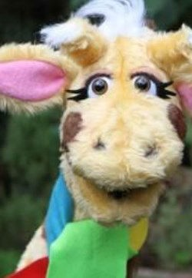
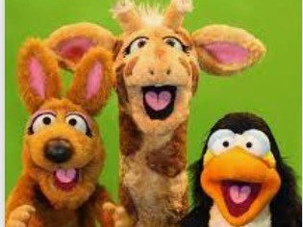

I can say a lot of ways that people are different including religious or cultural differences.
I can explain why it is important to challenge ste- reotypes that might be applied to me or others.
I can say how differences sometimes cause con-
flict but can also be something to celebrate.
I can explain how stereotyping can limit some people’s thinking about what they can do or be- come and why it’s important for me and others to challenge this.
I know that there are many different types of family. I know what the term community means.
I know examples of respectful language.
I know that people who live in the UK have different origins.
I know what name calling is.
I know the reasons why different people are bullied and what the term prejudice means.
Things I need to know by the end of the journey
Things I already know before I start the journey
PSHE Year group: 4
Term: Spring 1
Unit: Valuing differences
PSHE Association Link: Living in the wider world and Relationships

Vocabulary I need to know
Conflict | A struggle between people which may be physical.
Uncomfortable | Not feeling content or relaxed.
Relationships | A connection that we have with others.
Aggressive | Angry behaviour or feelings.
Respect | Acting in a way that shows that you care about people’s feelings.
Stereotype | An idea that people have about a thing or group that may be nega- tive or untrue.
Compromise | To settle by agreeing.

Lesson One | Lesson Two | Lesson Three | Lesson Four | Lesson Five | Lesson Six
(Can you sort it?)  LO: To know how to manage  conflict and differences. | (What would I do?)  LO: To suggest strategies for dealing with aggressive be- haviour | (The People We Share Our World With)  LO: To know the word re- spect and respect towards other demonstrate ways of  showing | (That is such a stereotype) LO: To identify stereotypes | (Friend or acquaintance)  LO: To know how to give examples of features of different types of relation- ships | (Islands)  LO: To know people that we can talk to if we feel uncom- fortable.

