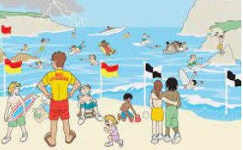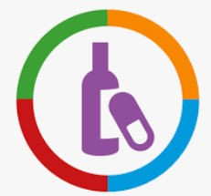
Vocabulary I need to know
habits | A behaviour repeated regularly
pros | The positive reasons in favour of something
cons | The negative reasons against some- thing
drugs | A substance that changes the way our body works
norms | Something that is usual or standard
perceptions | The way that people view things in their own way
assertive | Being confident and forceful in your personality

PSHE Year group: 5 Term: Summer 1
Unit: Keeping Myself Safe
PSHE Association Link: Health & Well Being/Relationships/Living in the wider world
Things I already know before I start the journey
Things I need to know by the end of the journey

I know the term danger, risk and hazard and explain the difference between them.  I know the stages of identifying and managing risk.  I know some of the key risks of smoking and drinking alcohol.  I know that medicine is a drug  I know strategies for keeping safe near water. |  |  |  |  | - I can say the percentage of people aged 11-15 years old that smoke in the UK (3%) and I can give rea- sons why some people think it’s a lot more than this.  - I can explain how knowing the real norms about smoking can influ- ence people to choose not to smoke. I can express how this might be the case for other drugs, including alcohol and illegal  drugs.
Lesson One (Spot bullying)  LO: to demonstrate strate- gies for dealing with bully- ing. | Lesson Two (Play, like, share)  L0: to recognise the dangers with being online and how to stay safe online. | Lesson Three  (Decision dilemmas and Ella’s diary dilemma)  LO: to identify risky situa- tions and explore decision making. | Lesson Four  (Vaping: health or un-  healthy )  LO: I know some health risks of vaping. | Lesson Five  (Would you risk it? )  LO: I can identify risk factors of situations involving smok- ing. |  | Lesson Six  (RNLI 7 – 11 year olds – Fly The Flag ) LO: I know what a rip current is and how these can be dangerous when swimming.

