PSHE Year group: 5 Term: Spring 1 Unit: Valuing differences
PSHE Association Link: Living in the wider world and Relationships
 | Vocabulary I need to know |  | Things I already know before I start the journey  I know how to manage conflict and differences.  I know people that we can talk to if we feel uncomfortable.  I know how to give example of features of different types of relationships.  I can suggest strategies for dealing with aggressive behav- iour.  I know the word respect and demonstrate ways of showing respect towards others.  To know how to identify stereotypes. | Things I need to know by the end of the journey  I can give examples of different faiths and cultures and positive things about having these differences.  I can explain how people sometimes aim to create an impression of themselves in what they post online that is not real and what might make them do this.  I can describe how religious and cultural differences can be a source of conflict and explain some of the reasons for this (fear, ignorance, misunderstanding etc.)  I can give examples of why posting an inaccurate (or selective) impression of themselves could be harmful for people that do it (trying to live up to their image, taking risks etc.)
 | Friendship | A friend is a person that someone
 |  | likes or knows
 | Appropriate | It is right or suited for some purpose
 |  | or situation.
 | Discriminatory | When a person is treated differently
 |  | (not in a good way), because of an
 |  | aspect of their identity.
 | Community | A group of people living in a
 |  | particular area.
 | Accurate | Acting in a way that shows that you
 |  | care about people’s feelings.
 | Consequences | Something that happens as a result
 |  | of certain behaviours.
 | Positive/ negative | Bringing something good or not
 |  | good.
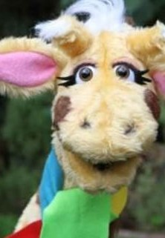
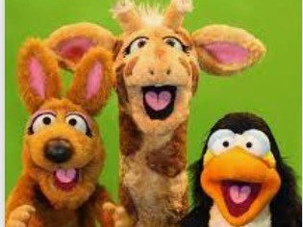

Lesson One | Lesson Two | Lesson Three | Lesson Four | Lesson Five | Lesson Six
(Qualities of Friendships) | (Kind conversations) | (Happy Being Me) | (The Land of The Red People) | (Is it true?) | (Stop, start, stereotypes)
LO: To know how to de- scribe ways of making a friendship last | LO: To know how to respond  appropriately to others | LO: To know how discrimi- natory behaviour can be challenged | LO: To know the different groups that make up their school/wider community/ other parts of the UK. | O: To know that information that we see online isn’t al- ways true or accurate | LO: To recognise that some people can get bullied be- cause of how they express their gender.

