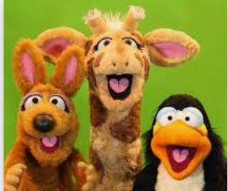
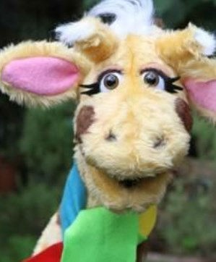

I can reflect on and give reasons for why some people show prejudice behaviour and sometimes bully for this reason.
I can explain the difference between a passive bystand- er and an active bystander and give an example of how active bystanders can help in bullying situations.
I can explain how different families and communities can experience prejudice and why this can happen
I can give examples of when I have helped people to be more respectful and tolerant by setting a good example.
I know how to describe ways of making a friendship last. I know how to respond appropriately to others.
I know how discriminatory behaviour can be challenged.
I know the different groups that make up my school and wid- er community.
I know that information that we see online is not always true
or accurate.

I know the consequences of positive and negative behaviour on myself and others.
Things I need to know by the end of the journey
Things I already know before I start the journey
PSHE Year group: 6 Term: Spring 1
Unit: Valuing differences
PSHE Association Link: Living in the wider world and Relationships

Vocabulary I need to know
Attributes | A quality or characteristic of a per- son, place or thing.
Bullying | Continuous unwanted behaviour.
Non verbal communi- cation | Communicating using body language
Tolerance | Willing to accept respect what is different in others
Acquaintance | Someone that you have met but do not know well.
Gender | Gender means type, it is commonly used to describe whether a person is a girl or a boy.
Prejudice | A liking or dislike for one rather than  another especially without good

Lesson One | Lesson Two | Lesson Three | Lesson Four | Lesson Five | Lesson Six
(Okay to be different)  LO: To know strategies for dealing with bullying | (We have more in common than not)  LO: To know ways of sup- porting someone being bul- lied | (Respecting differences)  LO: To know ways of show- ing respect towards others. | (Tolerance and respect for others)  LO: To know the importance of mutual respect for differ- ent faiths and beliefs. | (Advertising friendships)  LO: To know the qualities of a strong, positive friendship. | (Boys will be boys)  LO: To know that the media can sometimes reinforce gender stereotypes.

