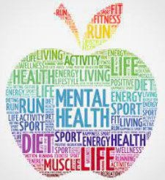
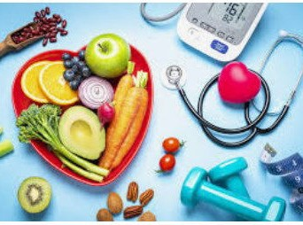
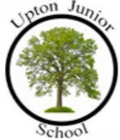
I know the importance of food, water and oxygen, sleep and exercise for the human body and its health.
I know the actual norms around smoking.
I know the basic functions of the four body systems.
I know what is meant by the term community.
I know that some people are responsible for helping me stay safe and healthy.
I know that the way people are portrayed in the media isn’t always accurate.
I know the concepts of basic first aid and know how to
make a clear and efficient call to emergency services.
I can tell you how I can overcome problems and challenges on the way to achieving my goals.
I can give examples of an emotional risk and a
physical risk.
I can give examples of ways that I’ve over- come challenges and barriers to achieving my goals.
I can tell you about the things I (and others) can do to reduce or remove risk in different situations.
PSHE Year group: 6 Term: Spring 2
Unit: Being My Best
PSHE Association Link: Health and Wellbeing
Vocabulary I need to know
Wellbeing | The state of being comfortable, healthy or happy.
Health | The state of being free from illness or injury.
Lifestyle | The way in which a person lives.
Aspiration | A hope or ambition of achieving something.
Risk | A situation involving exposure to danger.

Things I already know before I start the journey
Things I need to know by the end of the journey

Lesson One | Lesson Two | Lesson Three | Lesson Four | Lesson Five | Lesson Six
(Five Ways to Wellbeing  project)  LO: To know what the five ways to wellbeing are. | (This will be your life!)  LO: To know what my aspirational goals are. | (Our recommendations)  LO: To know what health and wellbeing issues are. | (What’s the risk? (1))  LO: To know the risk factors of given situations. | (What’s the risk? (2))  LO: To know what risk is. | SCARF: Basic first aid, including  Sepsis / British Red Cross  LO: I have an understanding of basic first aid (bleeding and broken bone).

