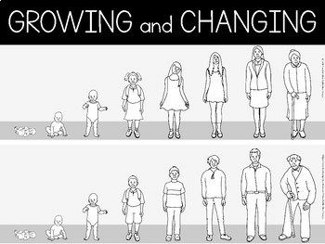
2024
I can name a few things that make a positive relation ships and some things that make a negative relationship.
I can explain things I have done to help keep/make a healthy relationship (e.g. with a friend or another special person).
I can identify when someone hasn’t been invited into my body space and show how I can be assertive in asking them to leave it if I feel uncomfortable.
I can tell you what happens to the woman’s body when the egg isn’t fertilised, recognising that it is the lining of the womb that comes away.
I can tell you some of the correct words for the parts of the woman’s body that are involved in menstruation.
I can identify unsafe secrets that make me feel uncom- fortable and who I can talk to about it.
I can give support to a friend.
I can describe feelings of loss and suggest what some- one can do if a friend moves away.
I can describe the stages of growth I have been through and what I look forward to in my future.
I can name the human private parts that are used to make a baby.
I can talk about keeping private parts private.
Things I need to know by the end of the journey
Things I already know before I start the journey


PSHE Year group: 3 Term: Summer 2
Unit: Growing and Changing
PSHE Association Link: Health & Well Being/Relationships

Vocabulary I need to know
Relationships | Two way in which two or more peo- ple are connected
Personal space | The physical space immediately sur- rounding someone
Respect | Thinking about other’s feeling and emotions
Invade | Entering somewhere without per-  mission
Puberty | A time in which teenagers go through physical and emotional changes
Uncomfortable | Feeling uneasy or awkward
Secret | Something someone tells you which they don’t’ want others to know
Suprise | An unexpected event
Humanitarian aid | Help offered to those in need

Lesson One | Lesson Two | Lesson Three | Lesson Four | Lesson Five | Lesson Six
(SCARF: Relationship tree)  LO: I know who I have rela- tionships with. | (SCARF: Body space)  LO: I know what the term body space means. | (SCARF: None of your busi- ness!)  LO: I know how to keep myself safe on the internet. | (SCARF: Secret or surprise?)  LO: I know what the terms secret and surprise mean. | (SCARF: My changing body)  LO: I know that babies come from the joining of an egg and sperm. | (SCARF: Basic first aid)  LO: I have an understanding of basic first aid (asthma attacks and head injuries).

