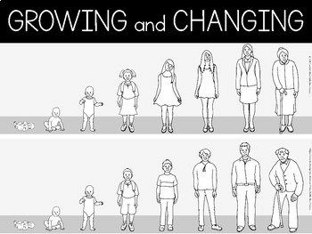
2024
•
I can label some parts of the body that only
boys or girls have.
•
I can list some of the reasons why an adoles-
cent might have difficult feelings.
•
I can reflect on how changes in family dy-
namics can cause difficult feelings.
•
I can tell you why people get married and why
some get divorced.
•
I can talk about how some of the body parts
change during puberty.
•
I can explain what the LGBTQ+ community is.
I know who I have different relationships with. I know what the term body space means.
I know what the terms secret and surprise mean.
I know that babies come from the joining of an
egg and sperm.
Things I need to know by the end of the journey
Things I already know before I start the journey

PSHE Year group: 4
Term: Summer 2
Unit: Growing and Changing
PSHE Association Link: Health & Well Being/Relationships

Vocabulary I need to know
Hormones | Puberty hormones trigger physical  and emotional changes in puberty.
Puberty | Your body begins to develop and change ready to become an adult.
Compromise | An agreement that is made by both sides.
Menstruation | The time in which a woman dis- charges blood from the lining of her uterus.
Marriage | A ceremony which legally bounds two people together as partners.
LGBTQ+ | An umbrella term to describe someone’s sexual orientation.
Divorce | A legal separation following a mar-  riage.

Lesson One | Lesson Two | Lesson Three | Lesson Four | Lesson Five | Lesson Six
(Moving House)  Starter: secret/surprise  LO: I know some of the changes that happen within the family. | (My Feelings Are All Over The Place)  LO: I know some of the changes that happen to my body during puberty. | (All Change—part 1)  LO: I know the correct terminology for body parts and I can identify these in boys and girls. | (Preparing for changes at Puberty)  LO: I know the key facts of the menstrual cycle | (Together)  LO: I know that there are a variety of different rela- tionships that people can have. | (All Change—part 2)  LO: To understand different ways of bringing children into a family.

