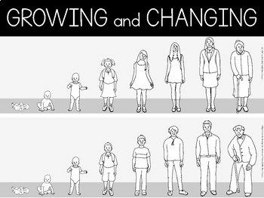
2024
I can suggest ways to cope with strong emotions in response to change.
I can list ways that I can prepare for changes (e.g. to get the facts, talk to someone) .
I can give a few examples of how I can develop my re-
silience, confidence and self-esteem.
I can label male and female body parts and name their sexual organs.
I can recognise when others may need to get help and can advise them to talk to a trusted adult.
I am able to recognise kinds of touch and what to do if
I feel uncomfortable.
I know some of the changes that happen to people during their life.
I know some positive and negative feelings.
I know the correct terminology for body parts and I can identify these in boys and girls.
I know the key facts of the menstrual cycle.
I know the term and surprise and the difference be- tween a safe and unsafe secret.
Things I need to know by the end of the journey
Things I already know before I start the journey


PSHE Year group: 5 Term: Summer 2
Unit: Growing and Changing
PSHE Association Link: Health & Well Being/Relationships

Vocabulary I need to know
Hormones | Puberty hormones trigger physical and emo- tional changes in puberty.
Resilience | The ability to bounce back from difficult events
Unwanted touch | When somebody is touching you without you allowing them to
Menstruation | The time in which a woman discharges blood from the lining of her uterus.
Self-esteem | Confidence in your own worth and abilities.
Genitalia | The reproductive organs
Confidential | Telling somebody something and trusting them not to share that information
Consent | Giving permission.

Lesson One  (SCARF: Dear Ash/Dear Hetty)  LO: I know who I can trust and the difference between a safe and unsafe secret. | Lesson Two  (SCARF: Help! I’m a teenag- er– get me out of here!)  LO: I know how my body feels when relaxed. | Lesson Three/Four  (SCARF: Changing bodies and feelings; Growing up and changing bodies)  LO: I know the correct terminology for sexual organs.  LO: I know what menstruation is and why it happens. | Lesson Five  (SCARF: Taking notice of our feelings)  LO: I know what kinds of touch are appropriate and inappropriate. | Lesson 6 *chosen depending on class  needs in relation to L3/L4  (Dove Self-esteem: Confident Me Lessons*)  LO: I know how to build my self-esteem and body confi- dence during puberty.

