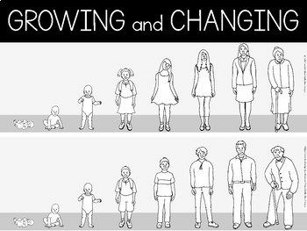
2024
•
I can suggest ways in which a person can feel
better about their body changing and see it in a positive way.
•
I can explain that the media can have a
negative impact on someone’s mental and
physical health.
•
I know what periods are and why they happen
as well as how females can cope better with having them.
•
I know how a baby can be conceived in
different ways.
•
I know how to stay safe online and understand
the implications of sharing images online.
I know a range of words and phrases to describe the intensity of feelings.
I know what kinds of touch are appropriate and inappropriate.
I know the correct terminology for sexual organs.
I know what menstruation is and why it happens. I know the consequences of negative behaviour.


PSHE Year group: 6 Term: Summer 2
Unit: Growing and Changing
PSHE Association Link: Health & Well Being/Relationships
Vocabulary I need to know
Puberty | Changes that you go through to become an  adult.
Stereotypes | A fixed image or thought about a particular type of person or thing.
HIV | Human immunodeficiency virus that causes a weakened immune system.
Menstruation | The time in which a woman discharges blood from the lining of her uterus.
Peer influence | The power to make other people agree with your opinions or do what you want.
Consent | Giving permission.

Things I already know before I start the journey
Things I need to know by the end of the journey

Lesson 1 | Lesson 2 | Lesson 3 | Lesson 4 (Boys/Girls) | Lesson 5 (R2W)
(SCARF: I look great/media manipulation)  LO: I know how the media can influence my thoughts and feelings. | (SCARF: Pressure online)  LO: I know the risks of sharing images online and how these are hard to control, once  shared. | (SCARF: Helpful or unhelp- ful? Managing change)  LO: I know ways to manage my emotions when dealing with change. | (SCARF: Is this normal?)  LO: I know some of the phys- ical and emotional changes during puberty. | (SCARF: Making Babies)  LO: I know the legal age for consent, the range of ways to  make a baby and how to look after my sexual health.

