

Nursery Update
14th October 2022

Hello,
Hope you are all ok.
We’re really looking forward to our Nursery Open Day next Tuesday and we hope that lots of you will be able to come and join in the fun. There will be two sessions- 9.30-10.30am and 1.40-2.40pm. Any 2 adults are welcome to attend but please only come to one session. There is no need to let us know which. Access will be via the Main School Gate and then across the playground to our red gate. No doubt there will be a few tears when you leave but please be reassured, your child will be looked after.
We also have a Coffee and Curriculum Morning on Thursday in the Junior Hall at 9am-10am. It will be a chance for us to meet up and go through how the Nursery works and the skills we are fostering. We understand that lots of you are busy and so, if you can’t make it, the presentation screens will be put on the school website for you to look at. Any questions, please let me know.
This week we have been very busy learning the story of the Gingerbread man and learning lots of new signs to help us act out the story for our Harvest Festival for Key Stage 1 next week. On Wednesday we helped Mrs Steele to write a shopping so she could buy the ingredients for some soup and we have also been watching some vegetables in our Curiosity Box as they changed in both sight and smell over the last couple of weeks.  In maths, Kipper the dog has been helping us to count carefully by lining things up and pointing as we count and we have also been creating repeating patterns all around Nursery.  Some of us chose to make Autumn crowns and leaf prints that we have found around outside and we are still loving our conker shutes.  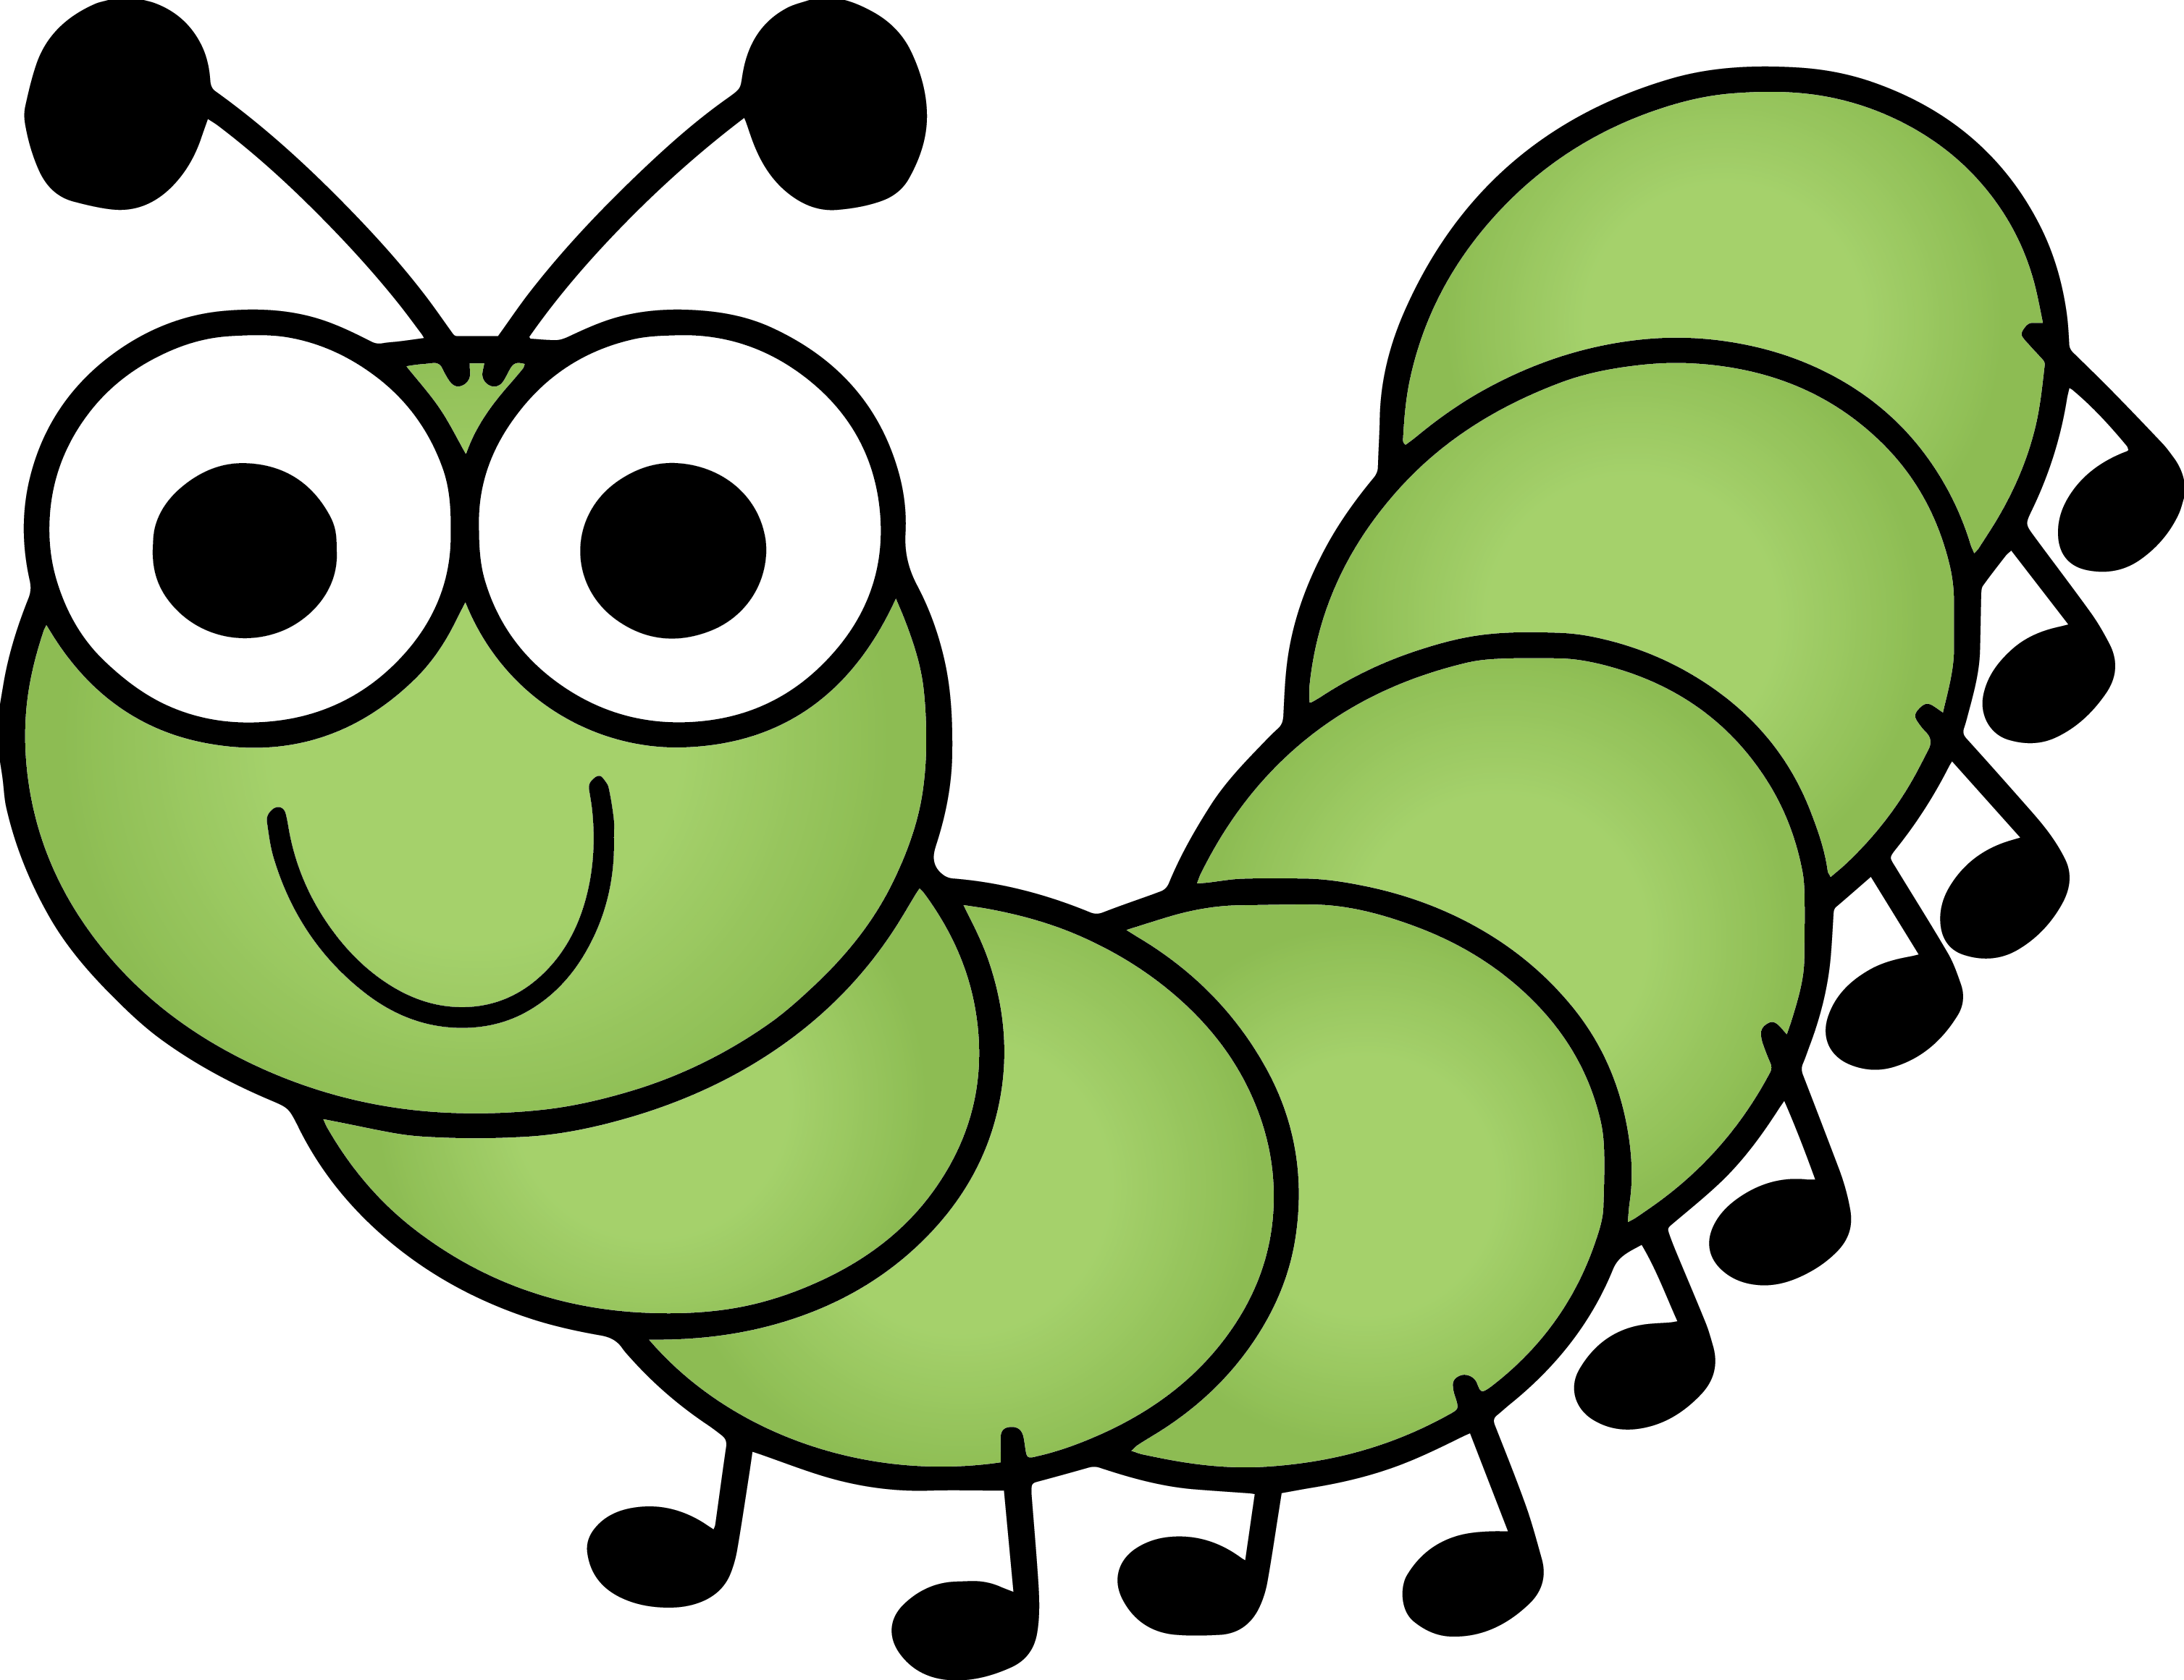  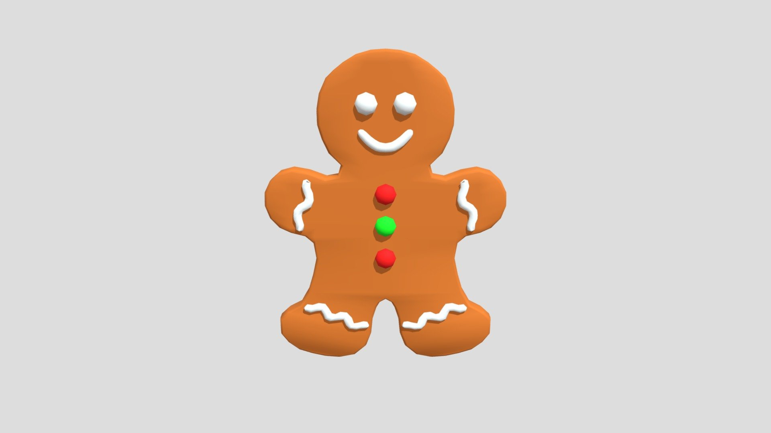 | Next week, we will be starting to think about Halloween, making potions and making up spells, reading some Meg and Mog stories along the way.  We will be making gingerbread men in the playdough area and decorating real ones for us to have as a treat at snacktime. We will be also be making Gingerbread man hats to wear for our Harvest performance.  In maths we will be thinking about more and less and the language of comparison- big and little, long and short and doing some sorting challenges.  On Friday it’s Diwali day in school so come to Nursery in extra bright colours. Diwali is the Hindu and Sikh Festival of Light and it’s happening over the holiday so on Friday we will learn a little about it before celebrating it properly after the holiday with some fun activities, dancing and craft.  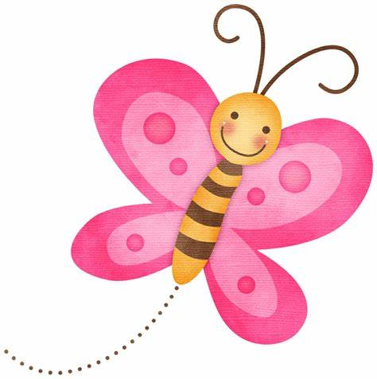  
The children are doing so well at becoming more independent. Please continue to encourage them to put on their own coats and shoes. Thank you.

