*Wycliffe Road*

*Urmston M41 5AH*

*Tel: 0161 748 4362*

*Email: admin@urmstonprimaryschool.com*

*urmstonprimary.com*

*Headteacher: Mr S Parker* ***‘Growing Together. Empowered to be more’***

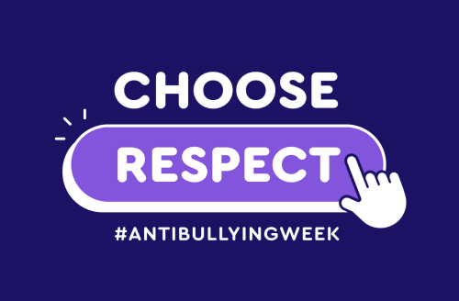***Anti–Bullying Week 11th-15th November and Children In Need – Friday 15th!***

Dear Parents and Carers,

Anti-Bullying Week is next week and this year’s theme is: ***Choose Respect***

As usual, it will include an ***Odd Socks Day on Tuesday 12th*** - to remind our children (and all of us!) that we should celebrate our uniqueness, and to CHOOSE RESPECT with every interaction that we have - even if we disagree we can disagree well and with kindness and respect.

**We’ve said that with a continued focus on our school values of respect, responsibility and kindness, bullying doesn’t happen often at UPS but when it does, it has a long lasting effect on those who experience and witness it. However, whilst bullying in the narrowest, definitive sense of the term doesn’t happen often, a lot of work can still be done on supporting our children socially and how to be respectful in their relationships with others, especially regarding their pro-activity in being kind and responsible, which for young people in particular, sometimes means being brave and doing what they know is right, and standing up for others’ rights. The children will participate in assemblies and activities during the week, with a view to seeking how to eradicate all forms of bullying within our society (including online!) and how we can be active in doing so.**

**We’re all a piece in the puzzle, and together, we’re united against bullying.**

On the Friday we have Children In Need. We have decided this year to link it with World Kindness Day, which is on the Wednesday. Children can wear their own clothes on Friday and bring in £1 for Children In Need (the buckets will be on the gates) and we will be keeping a tally of how many random acts of kindness we can achieve as individuals, class teams, and as a whole school team! Of course, we’ll be putting across the message that no one needs to keep a tally of their kindness, but it can certainly be a habit and something that stays with us. Indeed, ‘The fragrance always remains on the hand that gives the rose.’

Thank you so much for all your support and for the discussions you’ll no doubt have with your children.

Many thanks,

***From us all at UPS***

PS – Of course, we’ll be marking Remembrance Day on Monday through observing the Last Post at 11, standing together to think of those who have shown such incredible courage and resilience, and those who have been affected by war not only in the past, but in the present too.