*Wycliffe Road*

*Urmston M41 5AH*

*Tel: 0161 748 4362*

*Email:* [*admin.urmstonprimary@trafford.gov.uk*](mailto:admin.urmstonprimary@trafford.gov.uk)

*urmstonprimaryschool.com*

*Headteacher: Mr S Parker* ***‘Growing Together. Empowered to be more’***

***Anti – Bullying and Road Safety***

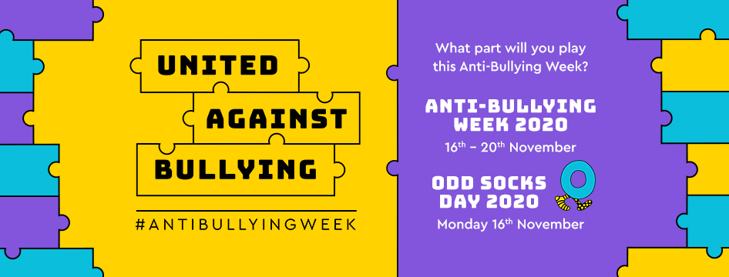

Dear Parents and Carers,

The theme for Anti-Bullying Week 2020 is: United Against Bullying.

Anti-Bullying Week will happen from Monday 16th - Friday 20th November and will start with Odd Socks Day to mark the first day of Anti-Bullying Week.

**This year, more than ever, we’ve witnessed the positive power that society can have when we come together to tackle a common challenge.**

**Anti-Bullying Week is no different. Bullying has a long lasting effect on those who experience and witness it. But by channelling our collective power, through shared efforts and shared ambitions, we can reduce bullying together. From parents and carers, to teachers and politicians, to children and young people, we all have a part to play in coming together to make a difference.  The children will participate in lessons all week**

**We’re all a piece in the puzzle, and together, we’re united against bullying.**

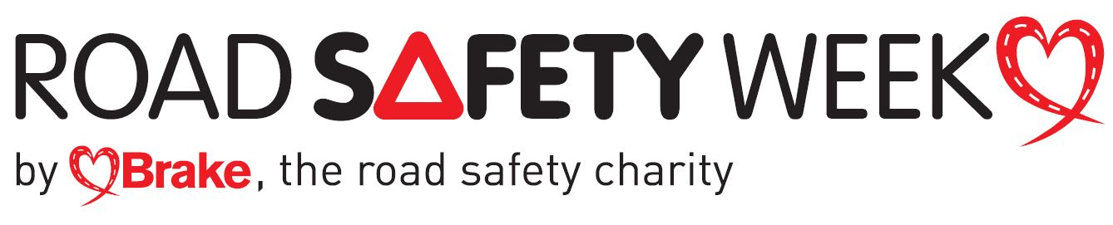**It is also Road Safety Week!** Road safety education plays an important role in shaping the attitudes and behaviours of children and young people – ensuring they become responsible drivers, passengers, pedestrians and cyclists. As the old saying goes; you are never too young to learn. Your children will also have the opportunity to discuss these important points in class.

Thank you so much for all your support,

Mrs Tuckey