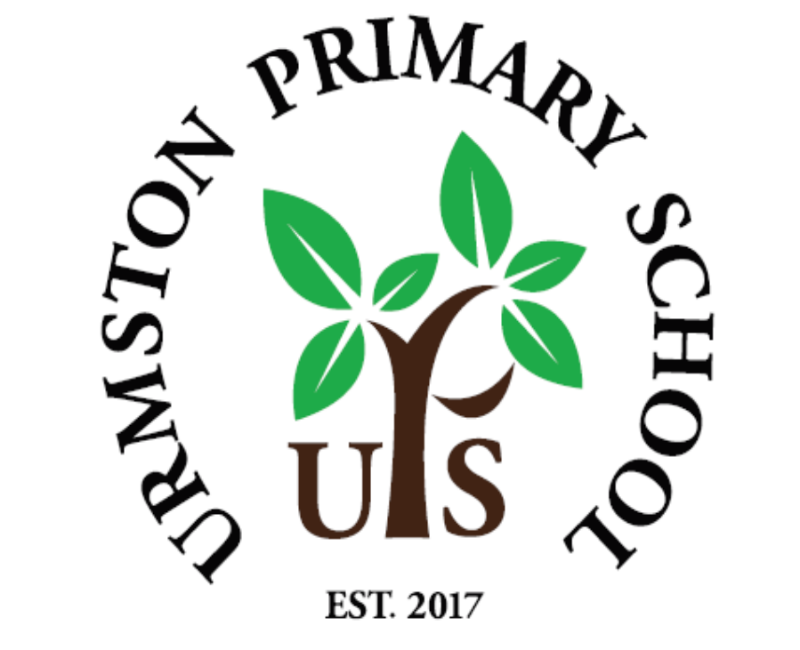

UPS Values-led
‘Being More’ Curriculum
Nurturing active learners
to ‘be more’
2026

Contents
 | Page
Vision | 3
Aims | 5
Themes | 6
Planning | 10
The Balance of knowledge and Skills | 10
Teaching and Learning | 13
Beyond the Curriculum | 13
SMSC and our UPS values | 13
Recording | 14
Progression, support and challenge (and avoiding ceilings to learning) | 14
From EYFS to Y6... | 15
Monitoring impact and outcomes  - The Teachers’ Role  - The Subject Leader’s Role | 15
Appendix 1: Curriculum Overviews | 19
Appendix 2: Subject Skill-sets | 25
Appendix 3: Class Charities | 25
Appendix 4: Rationale | 26

VISION
The amalgamation of Urmston Infant and Junior Schools in 2017 began a passionate journey into curriculum development. Urmston Primary’s school values of resilience, responsibility, respect, happiness, kindness and pride, like our motto of ‘Growing Together. Empowered to Be More’, has become engrained into the fabric of school life and also weaved into every context and every topic that the children learn about. It continues to evolve so that it incorporates local, national and global contexts and enables our pupils to become knowledgeable young citizens who want to actively make a difference and make the world a better place. This is all the more important in the midst of a pandemic, and the aftermath, and so this curriculum – along with other initiatives based upon wellbeing and character education, particularly looking at meta-cognition and being a ‘Thinking School’ - will continue to develop and evolve in order to inspire our children to be reflective, positive, independent and pro-active young people who gain strength and identity from following our values.

Underpinning our curriculum is the fostering of character and learning behaviours and this draws upon Maslow’s Hierarchy of Needs – our children must feel safe and secure in ‘growing together’ before being ‘empowered to be more’. This recognition allows our staff to gauge our children’s social and emotional needs and appropriately guide them to develop their knowledge, skills and behaviours, offering our support and challenge when we see fit.
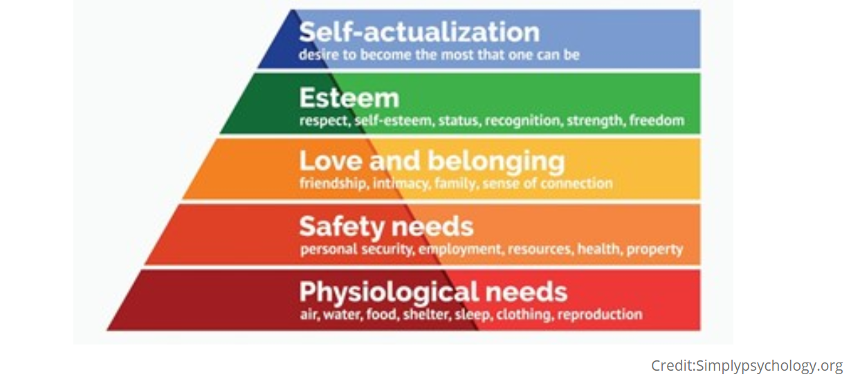
Although a previous document, Development Matters in the Early Years Foundation Stage states, ‘Children are born ready, able and eager to learn. They actively reach out to interact with other people, and in the world around them. Development is not an automatic process, however. It depends on each unique child having opportunities to interact in positive relationships and enabling environments.’ This is a premise that is maintained throughout Early Years, KS1 and KS2. Indeed, the principles below could almost just as well be applicable to our eldest children as to our youngest, and the practices used by our Year 6 teachers just as they are by our Nursery and Reception staff.
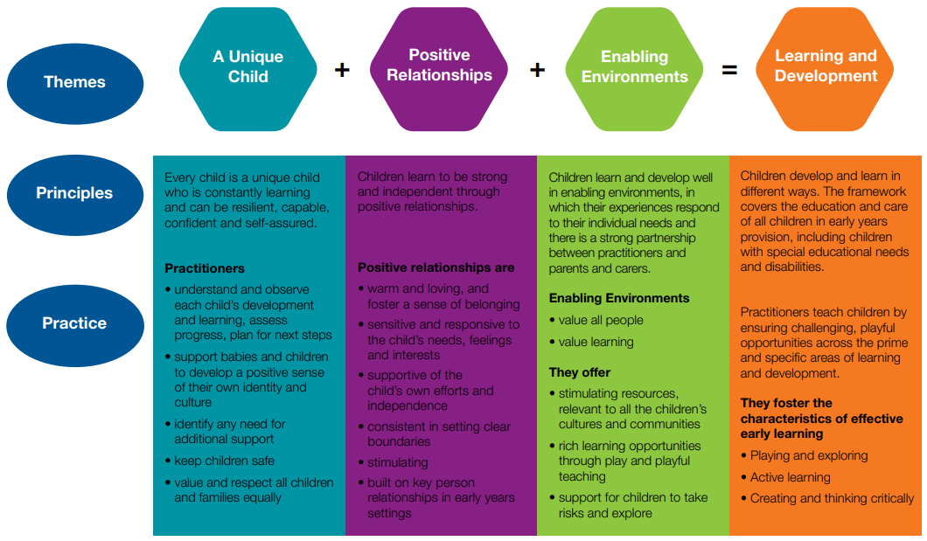

It is imperative for children to have an appropriate balance between focused learning - to develop their substantive knowledge - and investigation and exploration - to enhance their skills and disciplinary knowledge in using and applying what they know, developing their independence, inter-dependence and self-confidence in wanting to ‘be more’. Along with a focus on enhancing an awareness of our children’s place in our society and the impact that their actions can have on others, this ensures our curriculum develops happy, kind and well-rounded young people.
Our curriculum will enable this balance. All learning, in every area of our curriculum, provides pupils with context, providing memorable learning experiences, giving learning relevance, and ensuring that our pupils are engaged, enthused and inspired by their education. This leads to a lifelong love of learning that our children carry with them as they move on to secondary education and beyond.
The combination of acquiring knowledge, enhancing vocabulary, applying knowledge and skills practically through enquiry and first-hand experience, including school trips, will all add to our pupils’ broad cultural capital whilst nurturing inquiring minds and a love of learning.
In order to achieve our vision, there are a number of things that our children need from us: key principles that we must agree with; key aims that we need to achieve; and key themes that we want to address, so that our young people are ready and confident in ‘being more’.

AIMS
Aim | We do this by...
For our children to be active in their learning and behaviours and nurture a desire to make a positive difference to the world around them. | - Relentlessly promoting a shared vision of ‘being more’ amongst all of our school community - from staff, to children, to parents  - Always being aware of the importance of children’s character building and the impact this has on their learning
For our children to learn in an environment that is relevant, engaging, and challenging and encourages them to reflect upon their learning and upon the societal issues that they are exposed to. For them to understand how our values are important in today’s societies and cultures and how they might differ depending on belief systems, geographical location or historical era. | - Providing opportunities for children to empathise with others locally, nationally and globally, the use of topical links with year group and whole school charities, community care home links and other community activities  - Staff being part of the life of the curriculum, their shared vision and value system meaning that our children are exposed to a truthful, accurate and thorough learning experience which promotes equality and diversity and celebrates achievements of all backgrounds  - Ensuring pupils know why they are learning to develop certain skills and acquiring certain substantive and disciplinary knowledge, which is linked, useful and purposeful  - Ensuring links with the R.E. curriculum so that a broad and balanced picture of faith and belief is given to our children
For our pupils to be supported, challenged and nurtured in developing their knowledge (and thirst for knowledge), skills and understanding. | - Staff being aware of pupils’ abilities, and planning, assessing and delivering lessons and programs appropriately, ensuring coverage of all objectives set out in the Primary National Curriculum  - Having a clear understanding of all children’s needs, especially SEND and disadvantaged.  - Ensuring that children’s knowledge and skill progresses as they move through the school and builds on prior learning, and that there is a good balance between the substantive knowledge and disciplinary knowledge and skills that are developed.  - Pupils learning core literacy and maths skills and using and applying these skills, transferring them across the curriculum where appropriate.
For our children’s learning experiences to be fun, evoking intrigue and inquisitiveness. | - Higher-order questioning and critical thinking  - Providing creative and inspiring topics that our children are engaged in and enthused about, through giving learning context and meaning  - Offering memorable learning experiences that stick with our children, providing opportunities for them to use their imaginations, explore and investigate  - Nurturing a love of the arts, ensuring they are embedded into our curriculum and that knowledge and skill in Music, Art and DT are given relevant context
For our children to be confident and independent learners. | - Encouraging resilience and positivity in all areas of the curriculum.  - Giving opportunities for learning to be child-led, giving children the licence to question the world and find out the answers.  - Developing children’s awareness of how they learn and retain knowledge, becoming ‘meta-learners’.

THEMES
Although some topics straddle both science and humanities disciplines (Year 3’s topic on Rocks - Respecting nature’s power: ‘What Makes The Earth Angry?’, and Year 4’s ‘Water: Nature’s Driving Force’ - for example) many of them are either science-based or humanities-based.
Our vision and aims for Science are set out in our Science Policy and topics are themed on the areas of Biology, Chemistry and Physics. Importantly, where possible, a diverse array of inspirational scientists or inventors provide a stimulating springboard for learning, which fits in with our school value of resilience – making mistakes, being prepared to fail, and trying again. Our values of respect and responsibility also play a significant part in how science is taught (responsibility for our environment and sustainability linking in with a core geographical concept) and weave throughout our primary science curriculum, with teachers using their skill and our common vision and values to maintain this important thread.
When it comes to our other humanities-based topics, key themes arise and these are weaved throughout. Despite sometimes being inextricably linked, substantive knowledge and disciplinary knowledge and skills in History and Geography are made explicit and in addition to our key themes, our Geography and History policies highlight areas of substantive and disciplinary knowledge (in looking at concepts and what Geographers and Historians do) that our children learn about. This is based on what is outlined in the National Curriculum, as well as what we feel are key to children’s overall understanding, with particular geographical and historical concepts being fundamental to our humanities topics.
The themes of our ‘Being More’ Curriculum, including our school values, are a key vessel through which our children’s knowledge, skill and cultural capital grows, which lead to a readiness for wider society as well as a broader range of thinking and open-mindedness as they move up to secondary school.
UPS VALUES
As mentioned, our school values of resilience, responsibility, respect, happiness, kindness and pride, play an integral part of life at Urmston Primary. However, although these are referenced in this document, it is the staff that truly bring this element to life within our curriculum and even though there are other themes present, our values form our most common thread. Our shared vision for our children’s learning and outcomes form part of our staff’s outlook and so every opportunity is taken to remind the children of the importance of each one and how these have been used positively both throughout history and across the world geographically. The value of resilience is particularly important due to the challenging times in which our children live and this core value is frequently elaborated on to aid in our children’s development of their self-esteem and confidence.
Resilience | Showing ‘grit’ and determination to succeed; making mistakes, being prepared to make more, and growing from them; being brave and bold and willing to take on challenges.
Responsibility | Leading by example and doing what it right; always recognising the part we play; being honest and worthy of trust.
Respect | Empathising with others and accepting their views on life, even if different from our own; acknowledging our differences and similarities.
Happiness | Realising all we have to be grateful for; bringing joy into our own and others’ lives brings us joy ourselves.
Kindness | Again, empathising, treating others as we’d like to be treated; wanting to make others happy.
Pride | Having a passion to do our best; recognising and celebrating our own and others’ achievements.
POWER AND LEADERSHIP (political, economic, social, cultural)
Fu Hao, Alexander The Great, Caesar, Boudicca, Alfred the Great, King Cnut, Henry VIII, Chamberlain, Churchill, Hitler, Mussolini...the list of historical leaders is endless and provides our children with the opportunity to look why these people and the events they led are so significant. They look at the choices that those leaders have made, what the causes and consequences of those choices were, how other leaders acted similarly and differently and to think critically about what they would have done differently. The desire for power has provoked invasions and conquests and shaped dynasties and empires and our pupils will look at how the decisions made affect the lives of those who look to their leaders for courage, goodness and inspiration. Looking at power and leadership also allows a greater depth of understanding of civilisations, empires and dynasties and the differences between them, considering continuity and change and particularly legacy. Our children come to learn that leaders are not only those in positions of power but those who inspire others in doing what is morally right, regardless of the consequences and the opposition, just like our Year 2s learn when studying Parks and Pankhurst, who is elaborated on in Year 4.

INVASION, WAR AND CONFLICT (military, political, economic)
Throughout history, war and conflict, particularly through invasion, has shaped our world and the consequences have been huge. We see this in our own British history from Romans to Normans to Saxons to Vikings to the impact of WW2; and across the world in civilisations of Ancient China, Maya and Greece and how some civilisations grew into vast empires. The ideologies followed, the decisions made, and the actions taken have led to societies rising and falling and new ones taking their place, significant events causing vast political, social and cultural changes to the places affected. People have had to endure tremendous hardships throughout history, and still do today, and have shown incredible resilience, despite getting caught up in the crossfire of war, not always on the battlefield but due to what damage war can do to everyone. Looking at the history of invasion, war and conflict allows our children to empathise and consider what that must have been like and how respect, responsibility and pride can impact on our views and our actions, whether that be in war, or in seemingly small conflicts that we have in everyday life! Although this theme is predominantly in KS2, conflict and resolving conflict is very much about looking at our values of respect and responsibility, no matter what the scale, and so is something that is looked at throughout the school.
EQUALITY AND DIVERSITY (social, cultural, political)
A lack of equality and equity, both historically and presently across the world, has meant that we have much to do...and it will be down to our children and generations to come to put it right. Throughout history, there have been examples of oppression and prejudice, imperialism, colonisation and slavery, with inequality around gender, race and social standing being prevalent. Addressing these inequalities and allowing our children to learn about a lack of fairness and examples of exploitation and subjugation in eras and civilisations from the Ancient Egyptians, the Roman and Greek empires, to the Mayans, to the Shang Dynasty, to the Saxons, Vikings, throughout WW2, within our own United Kingdom and former British Empire and even today (Year 5’s geography topic on the Amazon magnifies this), will mean that our children can see the responsible role that they may play in ensuring these inequalities are not repeated and that we not only learn from the lessons that history teaches us all, but that we act. One of these lessons is to ensure that we celebrate the achievements of Black, Asian and Minority Ethnic role models within our curriculum and do so through learning about diverse literature, music, art, religion and leadership. This starts early on and the first significant learning about the importance of equality is in Year 2 when the children learn about Emmeline Pankhurst and Rosa Parks and the desire to do what is right! Work on equality is present in many areas of our school community and this theme links in with our work on our Equity and Equality Policy and Scheme and our development on the theme of belonging.

CULTURE, ARTS, RELIGION, FAITH AND BELIEF (spiritual, social, cultural)
Another key theme that weaves throughout our curriculum is culture, including arts and music, and belief. A society’s faith and belief system has a great deal to do with their own values and way of life and studying this - and our children frequently revisiting how important belief is to people - will enable them to empathise and grow their respect for everyone, seeing how important this particular British Value is, especially in today’s richly diverse Great Britain. Studying historical belief systems, such as those of the Mayans, which may seem obscure to us, enables our children to reflect upon the respect that they should have for people’s views. Links are made here with our school’s RE curriculum, which is in line with Trafford’s syllabus.
Art, music and dance form part of every culture and in order for our children to grasp a greater understanding of what life was/is like in those cultures, the arts must be explored, understood and enjoyed. These form part of every one of our topics...both planned and unplanned!

Planning
Teachers use the UPS ‘Being More’ Curriculum to inform their medium and shorter term plans and will consider the most effective ways of linking learning and giving it context and relevance for our pupils. Although much of what is taught may be through topics, discreet lessons will also be taught to supplement these, where necessary. Teachers follow the UPS Curriculum, where each topic is structured through the following:
- a clear topic rationale (explaining what is taught and why);
- year group knowledge and skills progressions;
- year group core and additional knowledge acquirement;
- key Tier 2 (technical) and Tier 3 (specific subject/topic) based vocabulary;
- possible ‘enrichment’ activities;
- possible ‘critical’ and ‘higher order’ (‘Being More’) questioning (based on Blooms Taxonomy and highlighting the importance of deepening understanding and thinking process)
- Urmston Primary’s core values (emphasising its vision of developing active young citizens of the local, national and global community, and making use of its historical and geographical context)

The balance of knowledge and skills
SUBSTANTIVE KNOWLEDGE
The balance of knowledge and skills is key to the curriculum at Urmston Primary. Our children learn through two types of knowledge. Firstly, they learn substantive, factual knowledge about the topics studied. Secondly, they learn disciplinary knowledge and skills that are needed to be a good historian, geographer, scientist, etc. Teachers and subject leaders have planned extensively and set out their vision to ensure that children’s cultural capital is developed by the acquirement of both substantive and disciplinary knowledge that sticks with the children through engagement and excitement for the topics and use and application of the subject matter. Knowledge will be acquired not only to accumulate facts but to engage, excite and enhance enquiring minds and it is important to note that the specific knowledge acquired is not always the most important thing – the thirst for that knowledge is. Resources such as topic mats and glossaries may offer pupils some key factual knowledge and vocabulary which will provide a stimulus and starting point to learn and want to find out more. Acknowledging the need for breadth is important here, but so is setting out some key, concise expectations for children’s acquirement of knowledge in each specific subject and this knowledge ‘sticking’ with them. Topic-based homework projects support this endeavour to engage children in their knowledge acquirement and growing their brains!
There are three degrees of substantive knowledge (outcomes) that we want our children to acquire. These are split into the following areas:
Core: knowledge that ALL pupils will acquire and hold
Additional: knowledge that MOST pupils will acquire and hold
Further: knowledge that SOME children will acquire and hold (this may be teacher or child led – sometimes through homework projects)
The rationale for our teachers choosing this substantive knowledge is based upon considering the key elements of the National Curriculum for each subject as well as some factual information that teachers believe will nurture that thirst for knowledge.
The ‘core’ and ‘additional’ knowledge is also chosen in taking account of the school’s thematic approach to its curriculum, themes which are embedded throughout and mentioned at the fore of this policy.

DISCIPLINARY KNOWLEDGE AND SKILLS
Skills development is also paramount and its importance is emphasised not only within the UPS Curriculum document but within subject policies, which highlight the importance of, for example, scientific enquiry, geographical fieldwork and research, and historical source analysis, evidence and interpretation. It is through learning disciplinary knowledge and skills and using and applying these that our children will acquire knowledge that sticks with them and which will enable them to build on in subsequent topics. It can be noted that many of the disciplinary knowledge and skills in each year group topic will be repeated. This is intentional so that these concepts are weaved through and embedded within varying contexts. In Primary History, for example, Tim Lomas from the Historical Association states, ‘What is vital...is the recognition that a concept is not a ‘one off’ – taught for one topic and then left...they need to be planned for and taught time and time again. The understanding needs to be weaved through different content.’ (p9, 2019)

The Arts in the UPS Curriculum

Although our topics are either humanities or science-based, Art and DT are weaved throughout, with music complimenting this (although we utilise the Charanga scheme of work to ensure thorough knowledge and skills are sequenced across the phases. Subject leaders have ensured a breadth of musicians, genres and artists from a wealth of backgrounds are studied by the children and it is through these that they develop their knowledge and skills in these subjects, and therefore enhance their cultural capital. The Arts is a theme within our curriculum and through this our children gain a greater contextual understanding of the importance of art and music in numerous eras and through various cultures across the world.
We work with the Trafford Music Service to deliver wider opportunities in learning musical instruments in Years 1, 2 and 5.
Religious Education
It is of great importance that our children have a deeper understanding of faith and belief. This is a key theme in our curriculum as it shapes every culture throughout history and today. Respect is one of Urmston Primary School’s most important school values and we believe that it is incredibly important for our pupils to not only show understanding of a variety of faiths and beliefs but to have respect for every single one, even if we don’t quite understand them. RE in our UPS curriculum works in tandem with Trafford’s RE syllabus – as well as our religious calendar - and encourages children to think critically about their own faith and beliefs and to empathise with others.

Computing
Although links to our curriculum are made where possible, Computing is largely taught and assessed discreetly, using the ‘MGL’ scheme and resources. Our Computing Policy outlines the importance of nurturing and empowering our children to be responsible digital citizens in an increasingly digital world. There are also numerous opportunities for children to use the internet safely throughout the broader curriculum where children can demonstrate their aptitude and enhance their computing knowledge and skills. We are supported in our delivery of this curriculum by MGL, who work with teachers on a rota to offer expert guidance, enhance CPD, and ensure good practice.

P.E., Sport and Physical Health
Our P.E., Sport and Physical Health Policies stress the importance that we place on physical wellbeing and outlines how we address and promote this in school. Support from the PE and Sports Hub and the PE Passport aids this.

MFL
Our MFL policy addresses the hows and whys of teaching and learning modern foreign languages, with the support of the Kapow scheme of work we use…to ensure appropriate sequencing of children’s learning and that their knowledge builds year on year.

Teaching and Learning
Topics will be engaging and exciting for pupils, who will always be given meaning for learning that will be relevant and increasingly refer to, and build on, prior learning of other topics. This will, more often than not, include a ‘hook’, ensuring that learners always have a point of context. Teachers will deliver lessons and programs of study in line with our Teaching and Learning Policy (stemming from our T&L tree), catering for all types of learning styles and incorporating all manner of activities; visual, auditory, kinaesthetic, investigatory and exploratory – with an appropriate balance between child and teacher-led learning. An approach of ‘adaptive teaching’ will be used to ensure all pupils can access learning and achieve. The combination of acquiring knowledge, enhancing vocabulary, applying knowledge and disciplinary skills practically through enquiry and first-hand experience, including school trips, will all add to our pupils’ cultural capital whilst nurturing inquiring minds and a love of learning.

SMSC and our UPS values
Social, Moral, Spiritual and Cultural aspects will be woven through life at UPS, through PSHCE lessons, our curriculum and through avenues such as assemblies, friendship groups, school council, etc. along with the implementation of our behaviour policy, among others. Such ideals are further embedded through our school values of happiness, kindness, pride, respect, resilience and responsibility and the immersive culture of our school. As mentioned, resilience will form a significant part of our focus moving forward with the aim of enhancing their motivation, confidence and self-esteem both during and after the pandemic.

Enrichment beyond the curriculum
To supplement our curriculum, we incorporate whole school events and awareness days/weeks - some relating to the curriculum and some not - to offer different learning experiences for our children. These will be planned for on a yearly or termly basis or perhaps more ad-hoc, depending on the circumstances. Such events may include Black History Month, British Values Week (linked to our school values), Diversity Week, Children’s Mental Health Week, Diwali, Eid al-Fitr among others. Community links such as with Urmston Manor Retirement Home and year group charities (see Appendix 2) add to this wholesome approach.

Recording
Pupils’ learning will be recorded in a number of ways. Much of this may be by video, voice recordings or photographs (uploaded onto our online Seesaw platform) in order to evidence learning but, more importantly, to offer opportunities for pupils to reflect on that learning. This will be alongside written work in books (with ‘double page spreads’ forming an expression of pupils’ learning) on paper or card, and on display to celebrate learning, with a key focus on children taking ownership on how they present their learning. All staff account for SEND pupils who may find written recording more challenging and so technologies such as iPads and dictophones support this.

Progression, Support and Challenge (and avoiding ceilings to learning)
Our Teaching and Learning Policy and Tree makes clear the expectation that ALL pupils are both supported and challenged appropriately, with them accessing learning through teachers utilising certain principles of adaptive teaching. Teachers will use a range of age-appropriate models and activities to engage all learners and ensure progression year on year, with work set appropriate to the needs of the children. Strategies such as listening checklists, plenty of spoken language and peer support, further help to scaffold learning.
Well thought-out knowledge and skills progressions are clear from year group plans and curriculum subject overviews. The sequencing of knowledge is at first quite structured with regard to the teacher-led ‘core’ and ‘additional’ knowledge expectations mentioned above, but the element of ‘further’ knowledge develops through the inquisitiveness of the children and can offer an avenue for our young learners to explore their interests in the topic, and thus enhance their love of learning, which can often be evidenced through their homework topics.
Importantly, a culture of resilience is developed where children thrive on challenge - they desire to be challenged and to challenge themselves. Children are frequently reminded of the importance of our school value of resilience, to keep trying, and to be prepared to fail and make mistakes, just like some of the key inspirational figures that we are inspired by in our topics (See Appendix 1 and 4).
Deepening Understanding through questioning
All staff are clear that all children, including SEND and disadvantaged pupils, should have opportunities to not only access quality first teaching and learning through numerous resources to aid their learning, but have opportunities to deepen their understanding (regardless of their ‘ability’) through critical and higher order questioning, like our ‘Be more’ questions. Examples of these are given in each topic overview and teachers use their judgements and knowledge of their pupils to expose them to higher-order thinking, enabling them to present this as they feel fit, through either verbalising in discussion or debate, or through work presented in writing or pictorially. This open-ended questioning is a key tool for teachers to engage our young learners and encourage them to apply their knowledge and to analyse, evaluate, create and ultimately reflect on their understanding. The rationale here is that we are looking for breadth of understanding rather than simply more difficult concepts – this is how we help to avoid those ceilings to learning!

From EYFS to Year 6...
The fore of this policy states the importance of the principles laid out in Development Matters and how they are relevant throughout Primary School. What is also critical is the fluid nature of learning from the Early Years to Key Stage 1 and then on to Key Stage 2. Staff realise the importance of recognising how learning develops from the Early Years and all subject leaders have a clear picture of what learning looks like in their subject in Nursery and Reception. Our EY Lead, our EY/Primary Curriculum Link Lead and our Primary Curriculum Lead work closely to ensure that this is the case and that our children are given a progressive, holistic education which runs throughout their time here at Urmston Primary School, from the Early Years Curriculum, all the way through to what it is taught and learnt in our Year 6 Curriculum. This is made all the clearer by EYFS knowledge and skills organisers for each subject.

Assessment and Monitoring impact and outcomes
Reading, Writing, Maths and Science
Core literacy and maths knowledge and skills will be formally assessed on a termly basis, with ongoing assessment being more robust than other curriculum subjects. The purpose here is to ensure that pupils are developing key skills in order to access all areas of the curriculum and beyond. How this is done is outlined in our English, Maths and Assessment Policies, with the use of more summative assessment playing a useful role towards teachers’ judgements in every year group and particularly at the end of each key stage.
Science is assessed in a number of ways. Firstly, through teachers using their formative assessments and judgements based upon work in books, and ongoing discussion with pupils to gauge understanding. Here they will assess the substantive knowledge outlined in the National Curriculum. Secondly, they will assess children’s disciplinary knowledge and how well the children work scientifically; this is done in two ways – by formatively assessing the learning that the children do in each of the five enquiry types, and also by undergoing a TAPS assessment two thirds of the way through a unit, giving time to address any misconceptions after. This is outlined further in our Science policy.

‘Foundation’ Subjects
There are a number of different methods that we use to gauge how well our children are learning across the curriculum and the impact of our practice. These depend on the monitoring method and may be at the end of a unit of work or at the end of a term. It will also depend on whether it is the teacher or the subject leader who is doing the monitoring...
The teacher’s role: Teachers will assess ‘foundation’ subjects by looking at pupils’ learning in each year group and gauging a sense of achievement at each unit of work and then at the end of each term. This will be partly based on ongoing formative assessment in books and pupil discussion, but also through the following:
- Firstly, the first lesson of each topic will involve harvesting prior knowledge and recapping what has been learnt in previous linked topics and subjects. This will take different forms based upon the subject but teachers provide the children with prompts and reminders of previous learning, linked to key subject concepts as well as curriculum themes and school values where possible. Resources in the children’s books such as timelines, maps, enquiry types, key learning and inspirational character threads will aid this. Here, children will be encouraged to share these key themes and ideas that they have learnt prior to beginning this new topic. This will ensure that they can use their prior learning and build on it within a new context.

- Secondly, in some subjects pupils will complete their own topic-based glossaries, acquiring new knowledge and Tier 3 topic-specific vocabulary as they learn. By the end of the topic, they’ll have this new knowledge that they can take with them to the next topic and build upon, either later in the academic year, or in the following one.

- Thirdly, (unless stated in the subject policies) teachers will use assessment grids during and at the end of the unit to gauge children’s understanding of the substantive National Curriculum objectives as well as the disciplinary knowledge and skills studied. Different subjects will have different means of assessing dependent on their make-up, but will always come back to achievement of NC objectives. For example, History assessment uses historical concepts as a means to assess substantive knowledge, and vice versa to assess disciplinary knowledge, whereas Computing assessment is based upon each unit within Information Technology, Digital Literacy or Computer Science and whether children have met the NC objectives, knowledge and skills set out in the MGL curriculum. As mentioned these will be set out in each subject policy. Teachers will keep an assessment folder that can be handed up to the next teacher.

- Finally, teachers will input termly data into our online tracking system, Insight. Here, they will input the children’s substantive knowledge in one strand and their disciplinary knowledge/skills in another. Assessments will state whether children are Developing or On track in their substantive knowledge and disciplinary knowledge/skills of the topic studied in that term. It should be pointed out that not every skill and piece of knowledge in our curriculum will be assessed specifically at the end of each term as this is unmanageable and not purposeful. It will, as mentioned, always come back to the National Curriculum.
The subject leader’s role: Monitoring, Evaluation and Review: the bigger picture
Subject Leaders will use a number of monitoring procedures to gauge how pupils are performing in their subject areas and may use this as an indicator of areas for development in that subject across the school. With the use of knowledge and skills progressions within the curriculum, embedded into year group topics where appropriate, they will be able to clearly see how pupils develop year on year and the expectations set by each year group. The most effective way for subject leaders to monitor the children’s acquirement of subject knowledge is through pupil discussion with their books, and here, they not only get a sense of how well the knowledge has stuck with the children, but also, in more open-ended questions, gain a deeper understanding of how the children feel about the topics and subjects studied and their engagement levels.
Subject Leaders will monitor their subject’s success and the impact of our teaching and learning through the following monitoring strategies and these should be considered alongside this policy:
- Pupil discussions;
- Learning walks;
- Pupil work reviews (books and Seesaw);
- Discussions with teachers;
- Teacher assessment in their assessment folders and set out in Insight.
Our Curriculum Lead oversees the Subject Leaders’ practice and monitors this to ensure consistency and effectiveness, with ‘deep dives’ with the subject leaders taking place at various points in the school year.
Along with an awareness of the topics and objectives covered in each year group (as set out in the UPS ‘Being More’ Curriculum), using the strategies above will enable leaders to have a clear idea of pupil standards, how the children are enjoying and engaging in their subject area and what areas for development might be.
Subject leaders will have an action plan at the start of each academic year, including actions that are based on their knowledge of their subject and the subsequent needs of our school and our pupils. This may include additional resources for pupils of varying abilities or, indeed, highlight those pupils who may be ‘gifted’ or ‘talented’, who can then be provided for, and opportunities to hone these skills further can be looked into. They will again use all of this analysis as a platform for implementing improvement and enhancing our pupils’ experiences in that area of the curriculum.
To note: Development of our Curriculum is ongoing. We continue to improve and fine tune our procedures to ensure not only a thorough coverage of knowledge and skills, but a clear thread throughout, making clear to our children that their ‘soft’ skills and their character education are just as important as their academic ones, particularly in the current global situation.
Date agreed by Governors: September 2026
Reviewed and updated: September 2027
Signed: S Parker (Head) A Wilson (Chair of S&C Governors committee)

Appendix 1:
UPS Values-led Curriculum topics:
Nurturing active learners to ‘be more’
2024

YEAR 1
Term | Topic | Main subject focus | Additional cross curricular subjects | Key figures (where appropriate)
Autumn | We were young once too, you know! | History | Geography, Science, PSHE, Literacy, Art, Music, PE
Autumn | Can we build it? Tamacadam can! | Science | History, Geography, Literacy, Art, Maths | John McAdam, Charles MacIntosh
Spring | We are Explorers! | Geography | Science, History, Literacy | Christopher Columbus, Amelia Earhart
Summer | Beautiful Bodies: Happy Humans and Amazing Animals! | Science | Art and Design, DT, Literacy, Maths
Summer | How can I look after my garden? (Plants) | Science | Geography, Maths, Music
Summer | Why are we so proud of Lowry? | Geography | History, Art | Lowry

YEAR 2
Term | Topic | Main subject focus | Additional cross curricular subjects | Key figures (where appropriate)
Autumn | The Stuarts: Choice and Responsibility for fires that happened...and those that didn’t! | History | Geography, Art, Music, Literacy | Robert Catesby,  Guy Fawkes,  Samuel Pepys
Autumn | John Boyd Dunlop and his stretchy, bendy invention!  (Uses of everyday materials) | Science | History, DT, Music, Maths | John Boyd Dunlop
Spring | Malawi to Manchester: Understanding different places, respecting different lives | Geography | Art, Music, Literacy | UNICEF
Spring | Do plants need resilience too? | Science | Geography, Art, Music
Summer | Two Ps and the three Rs: Rosa Parks and Emmeline Pankhurst | History | DT, Music, Literacy, Geography | Rosa Parkes,  Emmeline Pankhurst
Summer | Happy and Larry: a world of animals and the WWF | Science | Art, Music, Geography Maths | WWF

YEAR 3
Term | Topic | Main subject focus | Additional cross curricular subjects | Key figures (where appropriate)
Autumn | Resilience and Respect: Who first lived in Britain? | History | Geography, Art, Literacy, Music
Autumn | Respecting Nature’s Power: What makes the Earth angry sometimes? | Science, Geography | History, , Literacy, Art, Music, Maths | Red Cross
Autumn | Rest and be thankful: gratitude and respect in Ancient Egypt | History | Geography, Art, Literacy, Music | Howard Carter
Spring | Eratosthenes, light and the absence of light! | Science | Art, History, Maths | Eratosthenes
Spring | William Gilbert: the world is a magnet!? | Science | DT, Maths, Music | William Gilbert
Summer | Janaki Ammal: pioneering R and R for the environment (Plants) | Science | Literacy, Maths, Art, Geography | Janaki Ammal
Summer | How does Dina Asher-Smith run so fast? | Science | Maths, PSHE, P.E. | Dina Asher-Smith
Summer | North West is Best! | Geography | History, Art, DT, Literacy
Summer | Cote d’azur...C’est Magnifique! | Geography | French
YEAR 4
Term | Topic | Main subject focus | Additional cross curricular subjects | Key figures (where appropriate)
Autumn | Music: Ears, brains and da Vinci’s sound waves | Science | Music, Art, Maths | Leonardo da Vinci
Autumn | Roman life: leadership and the 3 Rs in the Empire! | History | Geography, Literacy, P.E. – Dance, Maths, Art, Music | Boudicca, Caesar
Autumn | Water: Nature’s driving force | Science, Geography | Art, Literacy, Music | Water Aid
Spring | Mr Latimer...what would we do without you? | Science | Art, DT, Music | Lewis Latimer
Spring | Wangari Maathai: Planting, Peace and Park Life | Science | Geography, Maths, Art | Wangari Maathai
Summer | Respect the bod! What happens to the food we eat? | Science | Literacy
Summer | Early Law Makers: Equality and Power in the Shang Dynasty | History | Geography, Literacy, Art | Fu Hao
Summer | Manchester Pride | Geography | History, Art, Music, Literacy
Summer | Paris je t’aime! | Geography | French

YEAR 5
Term | Topic | Main subject focus | Additional cross curricular subjects | Key figures (where appropriate)
Autumn | Invited Immigrants to Raiders and Traders: Anglo-Saxons and the Vikings | History | Geography, Literacy, Art, DT, Music | Alfred The Great, King Cnut, Edward the Confessor
Autumn | Newton, an apple, and a world of forces! | Science | Literacy, Maths | Isaac Newton
Autumn | Stephanie Kwolek: Changing states and Kevlar | Science | Literacy, Maths, DT | Stephanie Kwolek
Spring | Respect and Ritualism: Ancient Mayans and their beliefs | History | Geography, Literacy, Music, Art, RE | Frieda Carlo
Spring | Copernicus, Galileo and the Solar System | Science | Maths, Art, Literacy | Copernicus, Galileo
Summer | Brazil And The Amazon: Respect, Responsibility, Rivers and Rainforests | Geography | History, Literacy, Art, Science, Music | David Attenborough, The Woodland Trust
Summer | Respecting the circle of life | Science | Art, PSHE/RSE
Summer | Mont Blanc et l’ alpes | Geography | French

YEAR 6
Term | Topic | Main subject focus | Additional cross curricular subjects | Key figures (where appropriate)
Autumn | Urmston Pride! | Geography | History, Literacy
Autumn | Ibn Al-Haytham: the father of optics (Light) | Science | Literacy, Art, DT | Ibn Al-Haytham
Autumn | Power and leadership in WW2: impact and consequence...the good, the bad and the unjust | History | Geography, Music, Art, DT, Literacy | Winston Churchill, Neville Chamberlain, Hitler, Mussolini, Alan Turing,  ‘Women warriors of WW2’,
Autumn | Marie M. Daly, the Circulatory System, and Healthy Lifestyles | Science | PSHE, Maths | Marie M. Daly, Place2Be
Spring | Wisdom and War in  Ancient Greece | History | Geography, Art, Literacy | Alexander The Great, Aristotle, Agnodice
Spring | Who on Earth is Mrs GREN? (Variation and Classification) | Science | Literacy, Art | Carl Linnaeus
Summer | Electricity’s Current War | Science | Music, Maths | Benjamin Franklin, Thomas Edison, Nicola Tesla, Michael Faraday
Summer | Darwin, Evolution and Inheritance | Science | History, Music | Charles Darwin
Summer | Villages de France - a rural side of things | Geography | French
Summer | Y6 Production | Drama | Literacy, Music
Appendix 2: Year Group Charities
Our Year group charities link to our topics in each year group and are as follows:
Reception: Pencils of Promise
KS1: UNICEF (Paddington Postcards)
Y3: The British Red Cross (linked to Respecting nature’s power: ‘What Makes The Earth Angry?’)
Y4: Water Aid (linked to ‘Water: Nature’s Driving Force’)
Y5: The Woodland Trust (Linked to ‘Brazil And The Amazon: Respect, Responsibility, Rivers and Rainforests’)
Y6: Place2Be – Children’s Mental Health charity

Appendix 3: Additional information on Rationale
Each of the topics in the UPS ‘Being More’ Curriculum has its own rationale and these can be found at the head of each topic plan within our curriculum document.
It is imperative that our children learn from a diverse set of inspirational figures from science and history and our topics have been created with this in mind, offering our children the opportunity to learn about pioneers from a range of backgrounds and heritages and inspiring them to realise the differences that they can make, regardless of where they come from, what they believe in, their sex or gender, or the colour of their skin.
As mentioned in our Curriculum Policy, themes of Leadership and Power, War and Conflict, Equality, Culture, Arts, Religion, Faith and Belief, and our UPS school values weave throughout these topics and enable our children to make contextual links and build on their burgeoning knowledge year upon year.
KS1
It is essential that the learning opportunities that the children are provided with in KS1 are full of excitement and intrigue and nurture a love of learning and acquiring new knowledge and skills as pupils move in to KS2. The topics chosen, the inspirational figures, and the hooks in to these are planned with this in mind, as well as offering a little insight in to what might come when children move up to the next phase of their education.
As they will do in KS2, pupils get an early opportunity to find out about their immediate locality and their place within it, joining together history and geography and taking the opportunity for pupils to look at their place within this community, in ‘We Were Young Once Too’ and ‘Beautiful bodies – happy humans and amazing animals’, which is also the topic where pupils consider their bodies and the importance of keeping fit and healthy. This is nicely followed up when the children study Lowry and the obvious local historical and geographical links to the artist.
Focused geographical, historical and scientific themes and questions are answered in KS1 where opportunities are taken to bring Science, Geography and History together through contextual links and themes which also provide excellent opportunities for cross-curricular writing. For example, Year 1’s topic on Explorers brings in history and geography in children understanding about the hot and cold areas of the world, as well as linking in with seasonal and daily weather patterns, consolidated when the do their science topics of ‘How can I look after my garden?’ and ‘Happy and Larry: the WWF and a world of animals’. Here, again, the work done on habitats will be built upon in Year 4 and then again in Year 6, following the National Curriculum explicitly.
Staff’s awareness of KS2 History is important here in order to provide a contextual foundation to build upon for pupils to make links later on. An example of this is the key event of the Great Fire of London being studied in Year 2, focusing on the concepts of significance, cause and consequences - the choices that people made and how people led. This is consolidated further when studying Parks and Pankhurst, and is also a key theme throughout KS2. Furthermore, the topic of ‘Explorers’ and exposing pupils to the very concept of adventurers such as Amelia Earhart will evoke an excitement that will be revisited in numerous KS2 British and world history topics, the Romans, the Vikings and the Greeks being some obvious examples.
The topic of ‘Malawi to Manchester’ is one that evokes immediate intrigue and begins the process of children looking at how other people live throughout the world, supporting children in considering settlements, resources and even trade, concepts that weave throughout KS2. This comparison between Manchester and Blantyre, Malawi, is part of the process and sequencing of learning set out in the National Curriculum and in our Geography policy, allowing the children to begin learning on a local level, before comparing nationally and globally in KS2 as well as utilising locality to study concepts in KS2.
KS2
History and Geography (and sometimes Science) are inextricably linked and so great thought has gone in to when History, Geography and Science topics are taught at Urmston Primary and how the world is shaped today. It has been imperative that this has been done in a way that does not detract from the key and discreet substantive and disciplinary knowledge of each subject, however.
With Science topics kept largely discreet and led by the National Curriculum, most of the Humanities topics are based on historical era. However, along with discreet geography topics across all year groups, there is also core locational knowledge and map work learnt in all humanities topics.
For KS2 British History, the topics planned are based largely on the chronological sequencing set out in the National Curriculum, starting with the earliest period of time in Year 3, moving from The Stone Age, Bronze Age and Iron Age, through to the Romans in Year 4, and the Anglo Saxons and Vikings, both being in Year 5, with these two being so closely linked. This leaves Y6 to study WW2 as the post 1066 historical era. When studying this, the common substantive knowledge threads are our themes, but key historical concepts are used to bring this substantive knowledge to life in different contexts. These include chronology, cause and consequence, continuity and change, significance, historical evidence and interpretation, and similarity and difference.
Regarding World History, topics are very much led by the ideas of civilisation, empire and dynasty rather than by chronology (although it is made clear to the children where these lie in world history) and the impact that these have had on the places and people of the times and the legacy that they have left, again linking in with the historical concepts. The idea of civilisation begins in Y3 with the Ancient Egyptians, through to Y4 when the Roman civilisation expands to an empire, as does the Ancient Greek civilisation, with the Mayans, who didn’t expand to the extent of the others, placed in Year 5. The children have shown such interest also in the Shang Dynasty and we’ve included this in Y4 also to ensure the opportunities are there to further explore social structure, building on Ancient Egypt, and that of parliament and democracy, providing obvious links here to our British Values.
The geography concepts of place, scale, environment (physical and human processes), interconnections and cultural awareness and diversity are key foci in all time periods (particularly ancient civilisations) and connections, contrasts and trends here will be made explicit, regardless of the history topic being studied. Environmental impact and sustainability, whilst being present in some geography topics (Y5’s South America unit, for example), becomes even more prominent in Science and our values of respect and responsibility for our environment threads through all of our Biology units. Other National Curriculum subjects, particularly the Arts, are incorporated within History, Geography and Science topics where appropriate and where the subject matter lends itself to particular objectives. An important note to make regarding Geography rationale is that geographical issues and regions get broader as pupils move through the school, being very local and national in KS1 and moving to continental and global comparatives as they move through KS2. Y6’s local study of Urmston Pride is an outlier here – this has been chosen to have a deeper focus on disciplinary knowledge and awareness of their locality as they move up to secondary school.
In Year 3, the first history focus is on Prehistoric Britain, which brings with it obvious links to how people settle. The children also learn about volcanoes and earthquakes (Respecting Nature’s Power: What makes the Earth angry sometimes?) in Geography, which also links to the Science National Curriculum on Rocks and Soils. Year 3’s charity is ‘The British Red Cross’ and here links are made to the devastating environmental impact that natural occurrences can have on the physical and human environment and its occupants and the difference that supporting such charities can make. As mentioned, Year 3 also learn about the rich civilisation of Ancient Egypt, which gives them their first taste of what life was like outside Britain before going on to look at the Shang Dynasty, Mayans and Greeks in Years 4, 5 and 6. Across every year group, opportunities are given to look at local history and geography. Because there was ample opportunity to look at Urmston and Manchester in KS1 and again in Year 4 and Year 6, Year 3 look a little further afield and focus on the region of the North West, comparing Urmston, Formby and Blackpool. This coastal region is again compared to a European locality later in the year – the south of France and the Mediterranean, in the brief topic, ‘Cote d’azur...C’est Magnifique!’ Here, the opportunity is taken to embed children’s cultural knowledge of France, the language that our junior children are learning, whilst comparing and contrasting a region in a European country, as per the KS2 geography national curriculum.
In Year 4, children study the Romans’ impact on Great Britain and build on what was taught in Year 3. Here, the pupils get the opportunity to look at why the second invasion was more successful than the first, for example and maintains that substantive thread, through the lens of our historical concepts. It is also important for the children to get a sense of comparison – they compare Rome and its physical and human characteristics to that of Manchester, during the topic, ‘Manchester Pride!’ Again, the children also compare these cities with Paris, taking advantage of the French link and looking at a more urban region, in Y4’s Geography/French topic of, ‘Paris je t’aime!’. The science topic of the Water Cycle is key to Year 4 and here, a contextual link is made to the year group charity, WaterAid, the various physical and human processes and environmental impact here being obvious. Year 4 also look at Early Law Makers of the Shang Dynasty, enhancing the pupils’ understanding of parliament but also of seemingly tyrannical leaders; indeed, leadership, significance and cause and consequence is a theme looked at throughout KS2, from the Pharaohs of Ancient Egypt, to Caesar’s Roman Empire, to William the Conqueror, to Alexander the Great.
In Year 5, pupils extend their understanding of the chronology of British history through looking at the Anglo Saxons and the Vikings, with an excellent opportunity for a contextual link and hook taken when embarking on a trip to Tatton Park. These two periods were chosen to follow on immediately from one another due to the long struggle between the two for control of Britain and the continuity and change between the two. Furthermore, Y5 look at another non-European society in the Mayans. The rationale behind this was to build further on learning done on the Romans in Year 4 and the links between the demise of both civilisations, as well as the religious aspects of each era, another of our substantive themes. Geographically, Year 5 look at Brazil and the Amazon Rainforest as part of the continent of South America, again providing current links to environmental impact and sustainability. The year group’s chosen charity, The Woodland Trust, provides further opportunity to embed a greater understanding of humanity’s responsibility to look after the environment and the world, building on this understanding developed in supporting WaterAid in Year 4. Year 5 will also look to build in work on rivers through these history and geography topics and the importance of these both geographically, in terms of settlement and the physical landscape, and scientifically. As part of Year 5’s Geography/French topic, the mini-unit of, ‘Monc Blanc et l’alpes’ enables that further opportunity to compare and contrast a European region, this time looking at the alps and the place, scale and interconnections to other localities.
Year 6 begins with a disciplinary skills-heavy geography topic, Urmston Pride, enabling a focus on our knowledge of our locality and further developing skills such as planning and mapping. As mentioned, such a knowledge of the local area will be important in the transition between primary and secondary school. Because this doesn’t in itself fit with our Geography rationale of moving from local to national to global comparisons, the comparative substantive physical and human geography knowledge covered in the topics of ‘Power and Leadership in WW2’ and Wisdom and War in Ancient Greece’ is key, as is the idea of civilisation, expansion and empire.
The topics chosen in Year 6, are very much done so with a view to being ready for the next stage in their education and being responsible and self-aware. This is why their chosen charity is Place2Be, a children’s mental health charity, and this links in with their healthy lifestyles topic in Science.
In Year 6, pupils really delve into a theme beyond 1066 - World War 2 - and how this has helped shape British society today, again looking at leaders’ and events’ significance, the causes and consequences, continuity and change and the impact and legacy left behind. Work is done here in linking with literacy and writing – the year group text being Hitler’s Canary. It was also decided that Year 6 would study Ancient Greece, even though the time period is chronologically before Maya, which now comes in Year 5. It provides another opportunity to look at an ancient civilisation but whereas the Mayans didn’t use their advances and culture to expand, the Greeks, with the help of Alexander The Great, certainly did (just like the Romans), and here the significance, consequence and legacy of what happened becomes obvious and further grows the children’s understanding of these concepts. The decision here was also partly so that children had already gained an understanding of forces and earth and space in Year 4 and Year 5, but also links in with Aristotle’s work done on classification and the impact his pioneering work had on how we see the world today. The children can be inspired by Greek inventions when they come to do their DT topic in the summer term, further enthusing them about STEM subjects as they move on to secondary school. Finally, and significantly, the rise and prominence of philosophical theory opens the door to Year 6 really delving into some mature and thought-provoking concepts, leading to some analytical and persuasive writing and setting them up for the next challenging stage of their education. In continuing the French-Geography theme, Year 6 show further comparison with their own locality – in previous years they’ll have studied France’s coast, its cities and it’s mountainous topography, and now they’ll be comparing those with its rural localities and those of the UK, in their brief topic of, ‘Villages de France - a rural side of things’.
In all four of these French/Geography topics, our children will be looking the cultural differences and similarities and why people live, travel and do business in these contrasting localities.
It is imperative that our children learn from a diverse set of inspirational figures from science and history and our topics have been created with this in mind, offering our children the opportunity to learn about people from a range of backgrounds and heritages, with their choices, seemingly good and bad, evoking critical thinking from our children about the choices that they would make.

