*Wycliffe Road*

*Urmston M41 5AH*

*Tel: 0161 748 4362*

*Email: admin@urmstonprimaryschool.com*

*urmstonprimaryschool.com*

*Headteacher: Mr S Parker* ***‘Growing Together. Empowered to be more’***

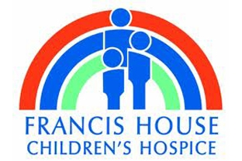***Francis House Appeal***

Dear Parents and Carers,

Francis House Children’s Hospice, in Didsbury could really, really do with your help this Christmas time. 2020 has been a tough year for all of us and with the lack of fundraising and donations, Francis House have encountered a massive shortfall of income needed for their running costs. These are difficult times financially and we rely on people like you to keep the doors of Francis House open.

So to help, Urmston Primary School have decided to have a **‘Christmas Movie Day’** with all donations going to Francis House.

This day will be on **Friday 11th December.** On this day you can come into school **dressed in your comfy clothes all ready for a movie day**. Your class will watch a Christmas movie (time and movie to be decided by your teacher). All we ask is that you please, please bring at least **£1 for Francis House!**

Thank you so much for all your support,

Mrs Tuckey

**PLEASE NOTE: *Infant Classes 1 & 7*** *(Mrs Cunningham and Mrs Saint/Mrs Coupe):*

*This date is also the date that the Nativity is being filmed in these classes. Therefore, just these classes will need to wear the clothes specified in their class letter about the Nativity on the 11th.*