

Nursery Update
Friday 21st March 2025

Hi everyone.
It’s been lovely to see some of you at Parent conferences this week and I look forward to seeing the rest of you next Tuesday. Apologies if I run late- so much to say in 10 minutes. Please don’t forget that if you need me, you can always contact me on Seesaw or, in an emergency, ring the main school office and they’ll put you through to Nursery.
Thanks for your donations to Nursery Fund. Please keep them coming if you can.
This week we have been talking about our trip to the farm last Friday, sharing our experiences and looking at the photos that we took. We’ve also been learning about the lifecycle of a chicken and reading Handa’s Hen and making a story map to help us to retell the story.  We have learned about the photographer Tin Man-Lee who takes the most amazing wildlife photos. The children will be practicing zooming in using the ipads to take some photographs of our own.  In maths we have been using unifix towers to help us have a better understanding of more, less and the same. The children have also been practicing holding their whiteboard pens and writing numbers 0 and 1 correctly.  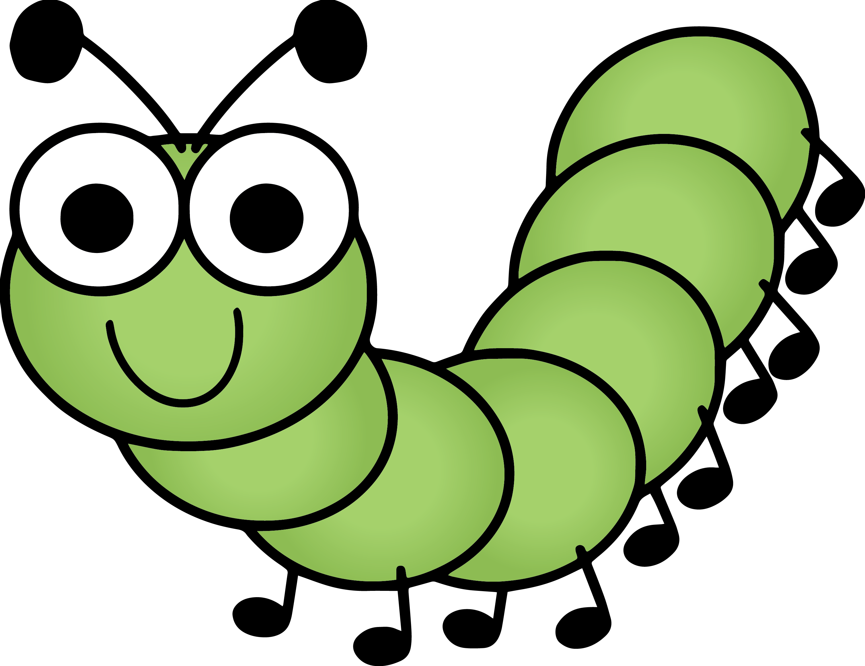  We also made mini pizzas which was  great fun as well as yummy! | Next week, our chicken eggs will arrive and we’re all very excited about watching them hatch. We will be having a go at milking a cow, using a rubber glove as a pretend udder! It’s a great deal trickier than it looks, but it’s great fun. We will be reading poems from “Farmyard Hullaballoo”, spotting lots of rhyming words and the children have also been sorting animals by where they live-as pets or on a farm.  We’ll be going for a walk to look for signs of Spring, collecting things we find along the way to create Journey Sticks and making cakes to sell at our special Pink Day.  In maths we have looked at ordinal number talking about 1st, 2nd and 3rd, first and last, number recognition and subitizing. The children are getting so good at it!  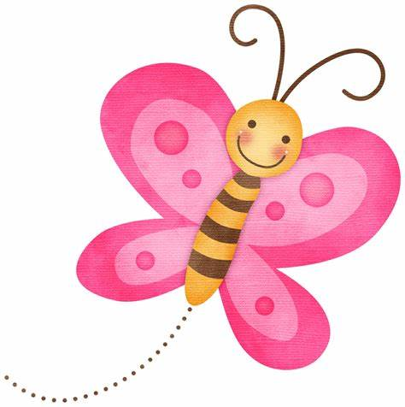  We’re also working on a secret project… to be revealed at a later date!
The farm trip was a massive success. We all had a wonderful day. Thank you to all the helpers who came with us. We couldn’t do it without you. I have made a book of our day that will come home with each child at some point. Please return it after one night so we can all have a turn as soon as quickly as possible.
Don’t forget to out “Paint the Nursery Pink Day” /Grandparent’s Day on Thursday. We’re looking forward to meeting our special older visitors, whilst making lots of money for a very worthy charity.
Caroline from Prevent Breast Cancer will also be visiting our event in the morning.
Pin badges, key rings and raffle tickets will be available for sale before and after school on the day.
A big thank you to John [our Urmston Aldi Manager] for the raffle donations- so generous!
If the children have pink clothes to wear, that would be lovely, but please don’t buy them especially.
I’ve got pink ribbons for them all to wear.
Also, get creating those Easter Bonnets for our parade on Monday 7th April at 10am in the Infant playground. Everyone is welcome to come and watch.
Back to the 80’s!!
We had so much fun dressing up and listening and dancing to music from 1985 [some of us remember it well!!] Thanks for your donations and for your effort with costumes. We discussed the reason we were dressing up.
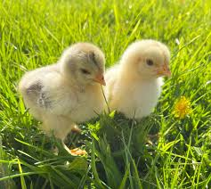Creme egg chicks in aid of Francis House are available for £2 each.

