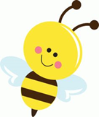

Nursery Update
Friday 25th April 2025

Welcome back everyone.
We hope you had a lovely Easter break. Thanks to everyone who sent in Seesaw posts for their children to share. So great to see what you have been up to and the children love sharing them.
We all had great fun doing our Sponsored Bounce. Thanks go to the PTA for organising it and to everyone who has kindly donated. Please pop any donations into book bags or across to the main office as soon as possible.

This week we started our new topic- Traditional Tales with a firm favourite- “The Three Little Pigs.” The children really enjoyed joining in with the refrains in the story and we had fun pretending to blow the houses down with a hairdryer and straw, sticks and a real house brick! Not sure that our cleaning lady was pleased though with straw blown all over the carpet! We have used our collage skills to create a new display and have had fun acting out the story with puppets.  Our phonics focus this half term is alliteration and so we are looking out for things that begin with the same initial sound, including lots of “Eyespy.”  In maths, we have continued to practice our subitizing and number bonds as well as introducing the children to 3d shape with sphere and cube, looking at their properties. | Next week we will be reading the story of “Jasper’s Beanstalk”, looking at the sequence of the story and using it to help us make our own instructions for planting a seed. We will be growing our own bean seed, thinking about what it will needs to grow. The story will also lead us to talking about the days of the week and what we do on different days. We will also read Jack and the Beanstalk and create a story map to help us retell it ourselves, in our own words.  In maths we will be practicing some number formations and looking at cuboids and pyramids.  In phonics we will be sorting objects based on their initial sound.  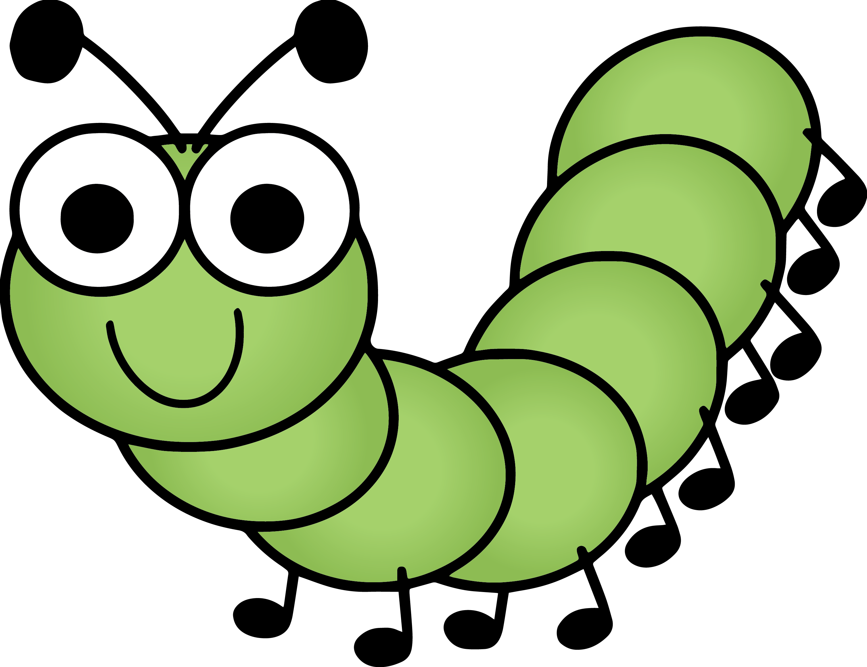  Our caterpillar eggs should also be delivered next week and we will be learning about the lifecycle of a butterfly and, hopefully watching our caterpillars hatch and then emerge later from their chrysalises.
Please can you return any Nursery clothes that you may have at home- especially socks- we bought 24 pairs of new socks in January and we’re now down to 6 so we’d be grateful if you could look out for them.
Please can you ensure that your child has a coat every day as the weather is still changeable. We have sunhats available here for the children to wear but please apply “Once a Day “ suncream in the morning.
On Monday, we will be celebrating our special World on Earth Day. We will be talking about plastic pollution and the importance of looking after our environment, including the importance of bees to our planet by looking at the picture book “Bee and Me.” You can watch this beautiful story on https://www.youtube.com/watch?v=DO215UAi4i4
Thanks again for Nursery fund donations. Please keep them coming if you’re able to contribute.
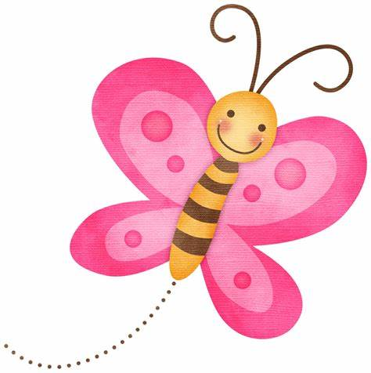
They really make a difference. Unfortunately this may be our last week for baking as funds are getting low.

