

Nursery Update
Friday 22nd November 2024

Hello there.
Thanks so much for attending Parent Conferences over the past couple of weeks. It’s been lovely to catch up and to be able to fill you in on the progress your child is making. Apologies if I was running late. Thanks for your patience.
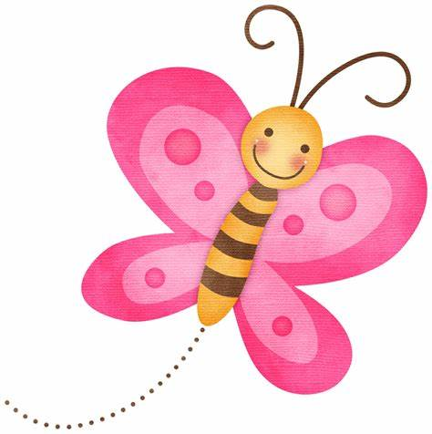
Thanks for your donations to Andy’s Man Club on International Men’s day on Tuesday and for showing your support by finding yellow and black clothes for the children to wear. We had a lovely chat and a few giggles about the men that the children have around them and thought about what makes them special to us.

This week we have been reading Julia Donaldson stories. The children are really enjoying as joining in with the refrains and listening out carefully for the rhyming words.  We have had fun decorating our divas with paint and sparkles, reminding us of the story of Rama and Sita and Diwali.  It’s also been Road Safety Week and so we have been talking about being safe outside, always holding hands with a grown up in car parks and near roads, finding safe places to cross, and always thinking, listening and looking.  We also talked again about people who help us and the Emergency Services and how to contact them. It would be great if you could practice your child’s address with them, just in case.  In maths, we’ve finding out about heavier and lighter, using our clever hands and brains to work it out and being introduced to a bucket balance. Jack Hartmann continues to help us with our subitizing with his catchy YouTube videos and we have also been practicing counting and number recognition. | Next week we will begin having fun with our dark investigation, looking at reflective materials, using torches and things that glow in the dark in our blackout tent.  The children will be writing their letters to Santa which will be sent home for you to post. I won’t seal the envelope so you can have a sneaky peek. Pop it in the post asap as Santa said in his letter to us that he will reply.  In maths we will be thinking about the language of size comparison, using words like long and short, thin and thick, tall and small as well as ordering numbers and flashing our fingers.  We will also be learning the story of the First Christmas, finding out about Mary, Joseph and the Donkey and the birth of Baby Jesus in preparation for our Nativity as well as continuing to practice the songs for our show.  The children have been enjoying their first baking experiences with Mrs McGuirk, making chocolate chip buns.  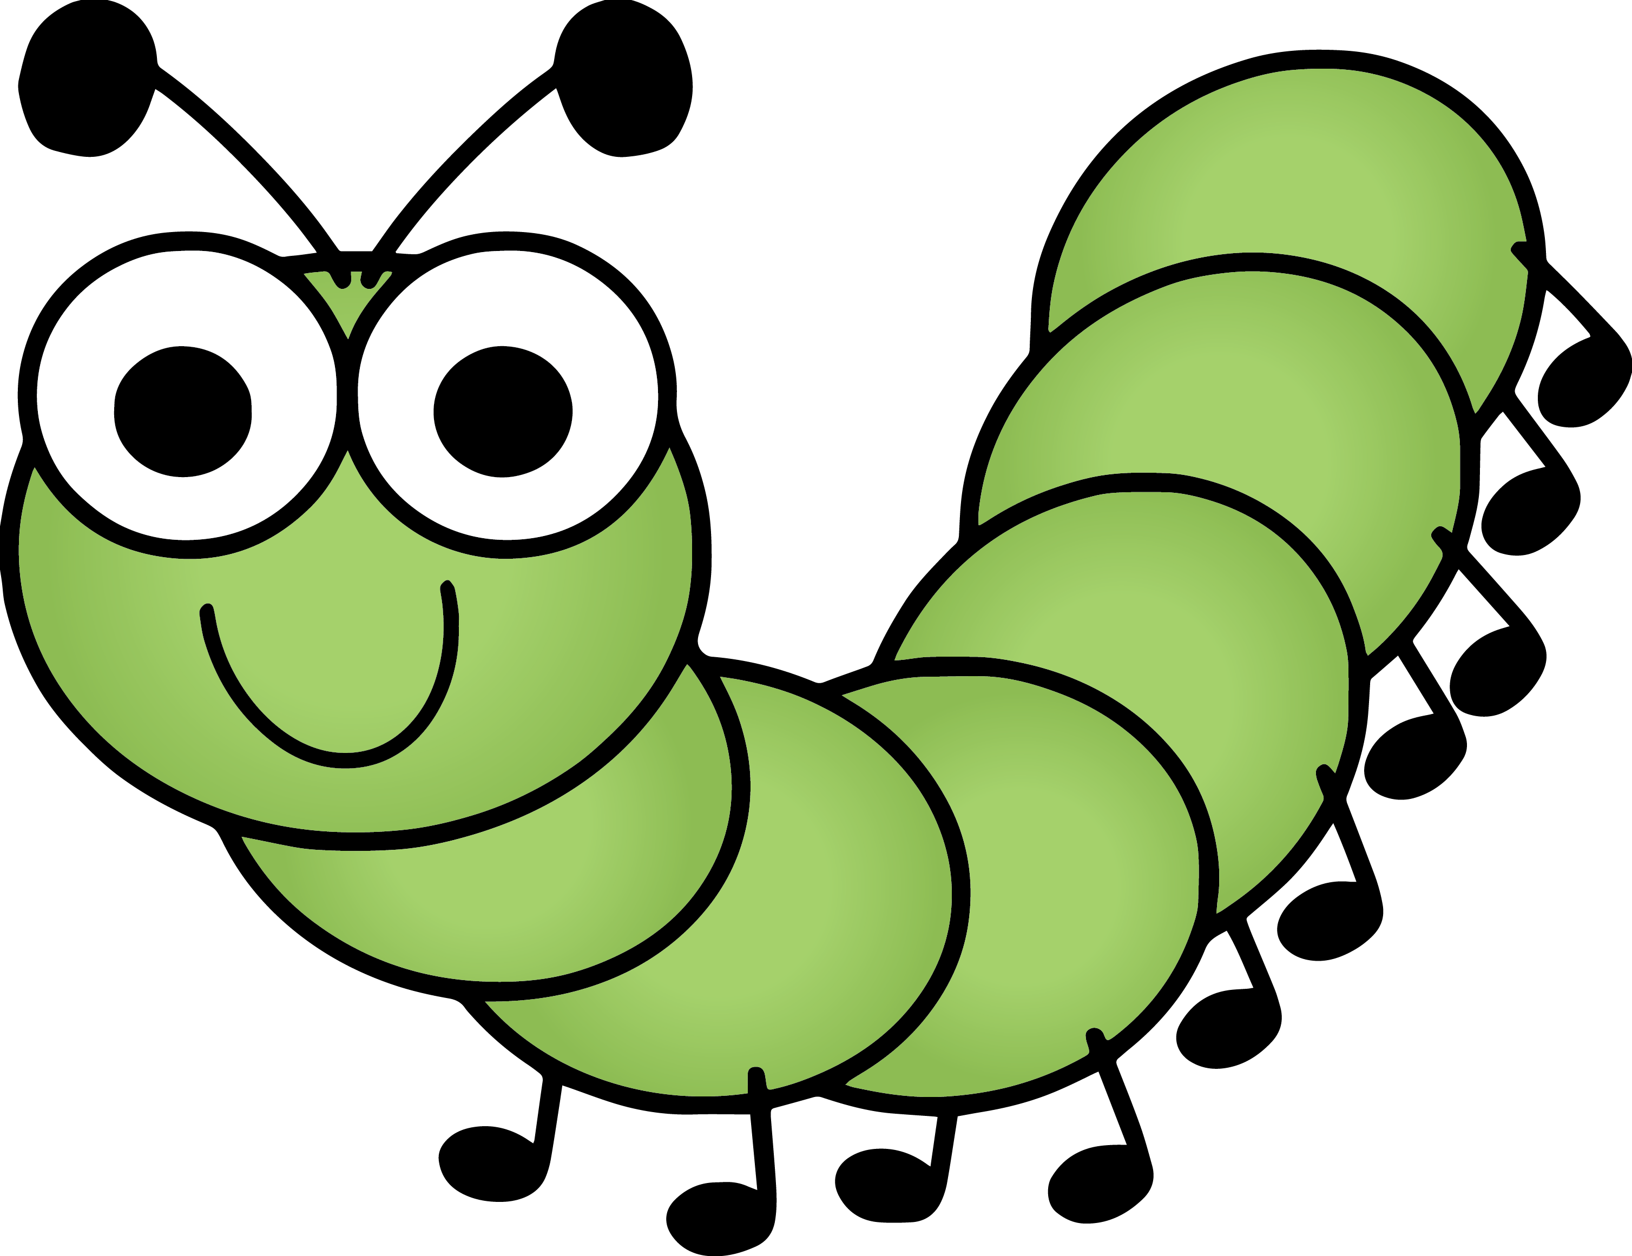  They bake in two groups of 5, one group in the morning and another in the afternoon and Mrs McGuirk has a special list so everyone gets a turn.
Drop off. Our session starts at 8.45am. Please arrive promptly. The door will be closed at 8.50am so we can settle the children and begin our learning with our morning dance and register, all together on the carpet.
Naming items. Please can you make sure that your child’s name or initials are in hats, scarves, gloves and coats. I’m sure you can imagine what it’s like at the end of a day with tonnes of items to give out and keep track of. Chaos!!
We’ve shown the children how to store hats and scarves up their coat sleeves and gloves in pockets, but things are still being dropped and misplaced which can cause upset. Thanks for your support.
Christmas show- As you know, it’s happening on Friday 6th December at 2.15pm in the Nursery. We will not be issuing tickets but due to limited space, we ask that a maximum of 2 family members attend. We are providing costumes, we will just need the children to wear black or neutral leggings or trousers on the performance day and on Thursday 5th which is our dress rehearsal for our Reception friends. Looking forward to seeing you. Get practicing those Christmas songs- you’ll be joining in!!

