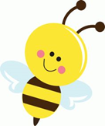
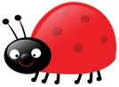
Nursery Update
Friday 10th January 2025

Hello and welcome back.
Hope you are all well and had a restful Christmas break.
Thank you for all the Seesaw posts. It’s been lovely to see all the things that you’ve been doing and the children have loved sharing them with their friends.
Unfortunately, some of us have had a poorly Christmas- Chicken Pox and tummy bugs are doing the rounds, so please be aware.
This week we have started our new topic- Hot and Cold funnily enough focussing on cold this week! We’ve done a mini snowman topic, making sock and printed snowmen, rolling white playdough to make them in the playdough area, adding stick arms, carrot noses, buttons and eyes. The children have also done some freezing experiments.  We have also been thinking about people who are special to us and the importance of saying thank you, especially after all our treats at Christmas.  Our Phonics focus this half term is body percussion and we will be thinking of sounds we can make with our voices and bodies.  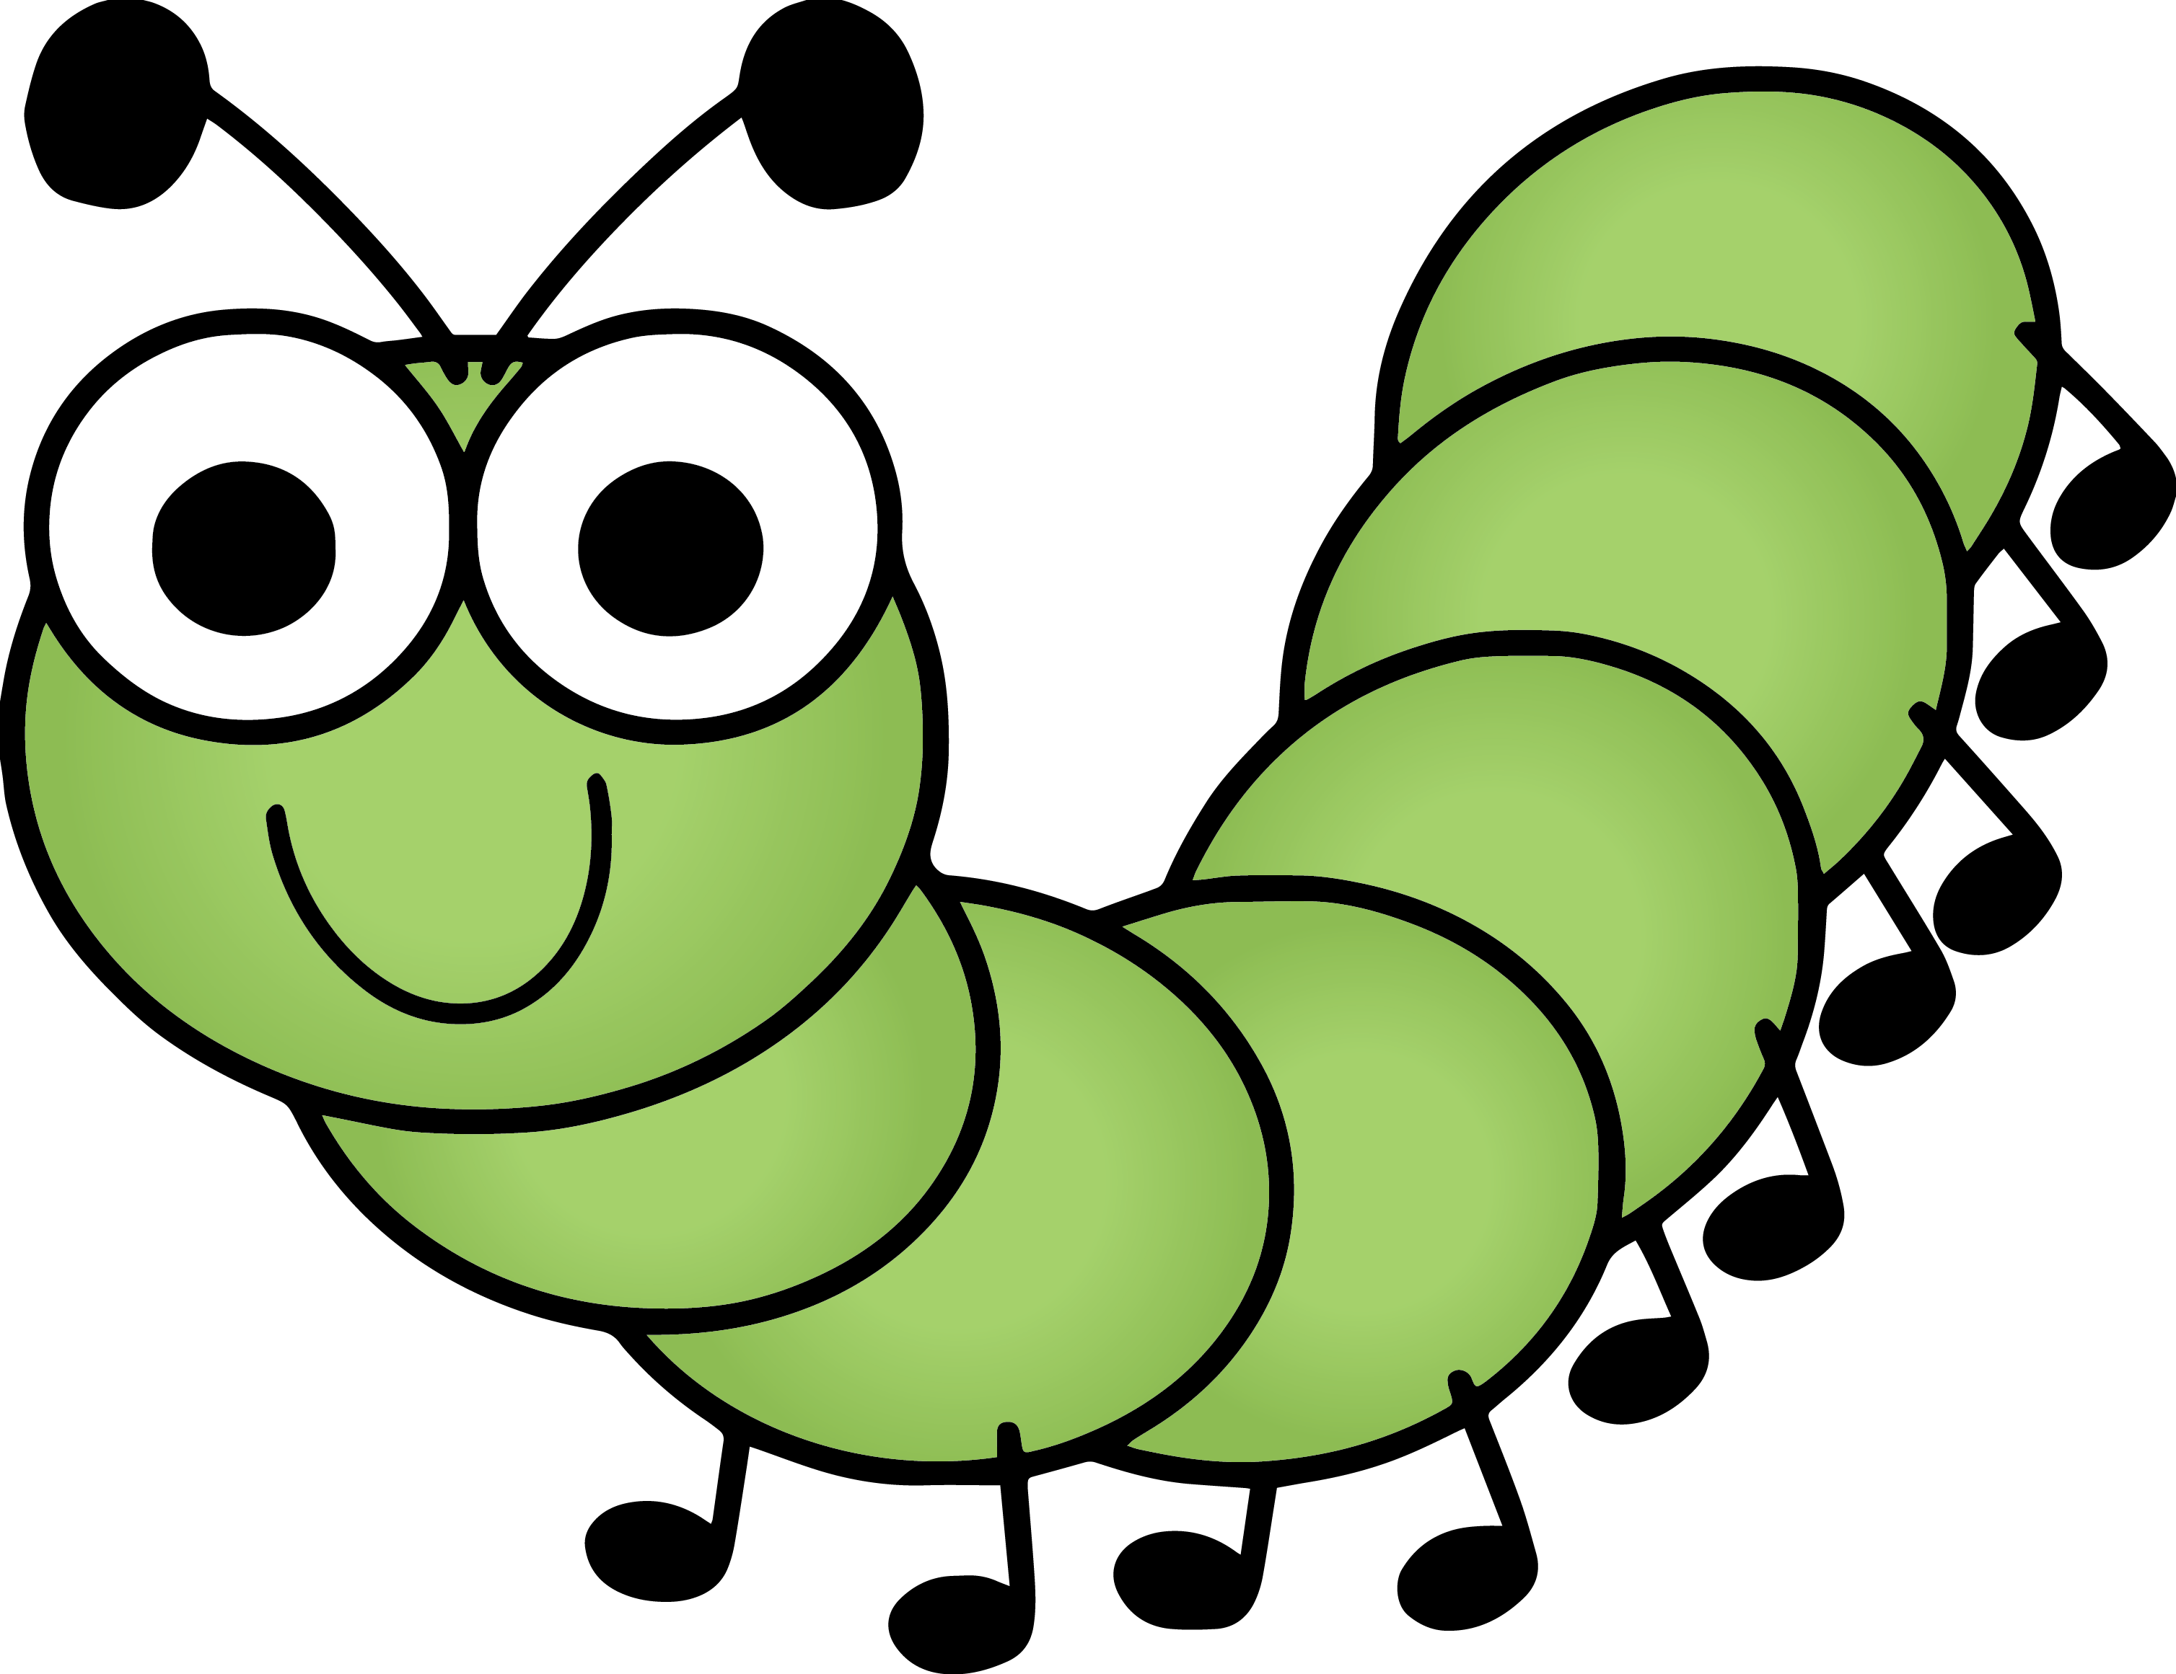  In maths we have been subitizing and looking again at number facts and Numicon. We have also been passing the magic microphone round, taking it in turns to say consecutive numbers 0-10. Lots of the children are still finding this tricky so if you practice, taking it in turns to say a number, that would help.  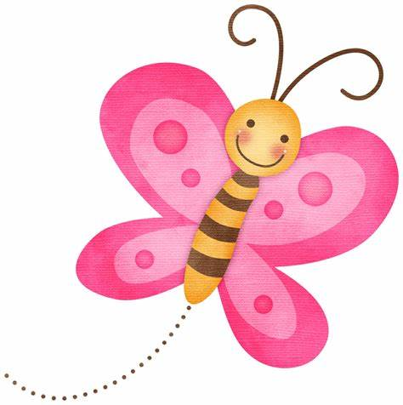 | Next week we will begin to think of things that are hot and cold, talking about places in the World, focusing on the Arctic and the animals that live there. We will be finding out fun facts about polar bears, talking about the difference between fact and non-fiction books. The children have been enjoying playing in the Hot and Cold clothes shop and we will be doing lots of sorting jobs thinking about clothes that we wear in different climates.  Our construction area inside has had a mini makeover with white carpet to help us set the scene for making dens for the polar bears and outside we have been building ice castles for Ana, Elsa and Olaf.  We will also become scientists again, investigating melting and freezing, doing some more experiments.  The children will also be talking about the things that make a good friend, thinking about being kind and respectful to each other.  In maths we will be looking at measuring things using our hands and some standard measures such as unifix cubes and basic rulers as well as using snowballs to help us with number recognition and counting
Lots of children have arrived back with lovely new coats, clothes, bottles and lunch bags. Please ensure they’re named so they don’t get misplaced as some of the children are not yet recognising them independently. Thank you.
Thanks to Nursery Fund, we’ve been able to buy some mittens for the children. They’re in a box outside. They’re black and blue and have a little stitch on the cuff so we can easily identify them as ours. We’ve also brought some socks as they are rarely returned. We have popped an “N” on them so if your child has different socks on than in the morning, please return them asap. Thanks.
Next week we will be introducing “Proud Poms” which are given to your child when they do something that makes us, or the child themselves, feel proud. They all have a little pot to collect them in and once they have collected 5 they can choose a prize.

