

Nursery Update
Friday 8th November 2024

Here we go again!!
This going to be such an exciting and busy half term. We’re going to have lots of fun together.
A big thank you to Miss Rollings who has kindly been covered Mrs McGuirk at the end of last half term and on Tuesday and Wednesday this week whilst she attended a Paediatric First Aid Course [something we both do very 3 years]
Please can we remind you to label gloves, hats and scarves.
Thank you for your Nursery Fund donations.
This week we started by sharing our holiday adventures, sharing our posts on Seesaw and talking about safety on Bonfire Night. We made our own sound picture, making firework sounds with our voices and the children made a firework collage for our new display- the glitter made its first appearance of the year!  In maths we’ve been practicing our repeating patterns and our number recognition and counting.  We looked at pictures produced by the artist Jackson Pollock and splashed and splatted paint to make our own interpretation of his work.  On Friday we celebrated Diwali with a candlelit pathway through Nursery and Bhangra dancing. Mrs Singh came in to paint Mehndi henna on our hands and we learned about the story of Rama and Sita.   | Next week we will be talking about Remembrance Day and watching a lovely little film on Cbeebies called “Poppies”. Take a look- https://www.bbc.co.uk/cbeebies/watch/poppies  We will be joining the rest of the school to observe the 2 minutes silence.  We will be learning to make thumb pot diva lamps from modelling clay which will be painted and decorated over the next few weeks.  In maths, we will be thinking about the language of weight and practicing our subitizing.  We will be celebrating Children in Need on Friday, making Pudsey Bear chocolate chip buns in our yellow fluffy ears.  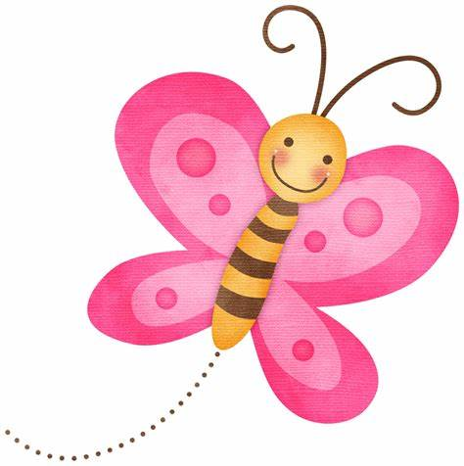  We will also be talking about Diabetes-what it is and how it affects people who live with it. Mrs May [our dinner lady] will be explaining about how her son and daughter live with the condition.  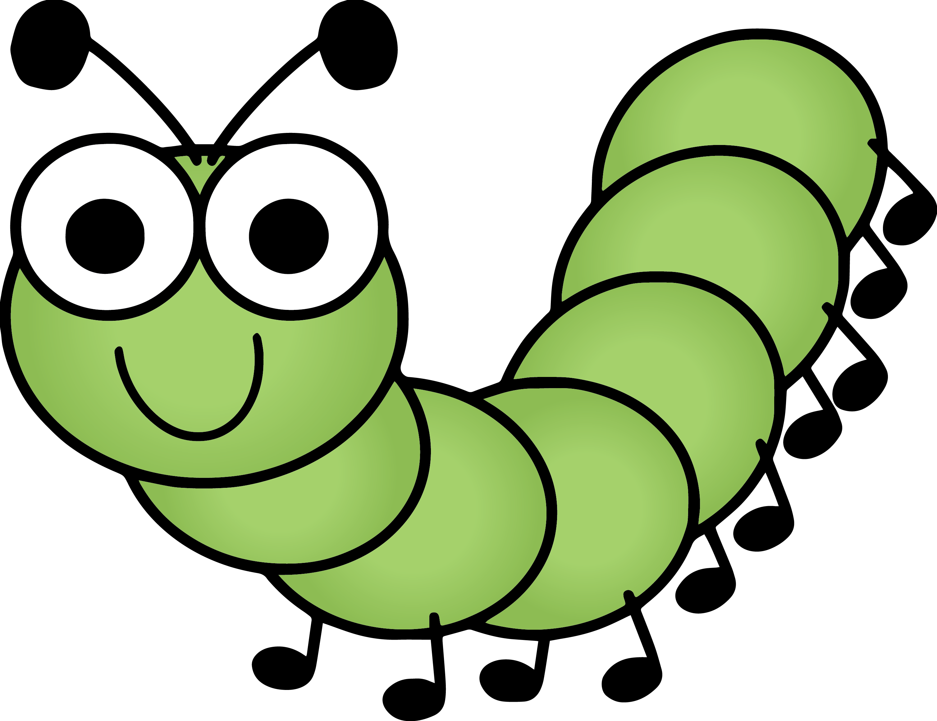  
Dates for your diary-
Tuesday 12th November- Wear odd socks to show support for Anti-Bullying Week
Tuesday !9th November- International Men’s Day- Wear black and yellow
We have popped a new toothbrush and some toothpaste in your child’s book bag for you to keep at home. We had some spares after signing up to an initiative from Colgate to clean teeth in school and promote better oral hygiene. The children clean their teeth with our dinner staff after their lunches.

