

Nursery Update
Friday 9th May 2025

Hi everyone,
Hope you are all well and enjoying the sunshine which has finally made an appearance. The children have been really excited to have the water tray back in use. They have loved practicing their pouring and filling skills and have been taking the watering of our bean seeds, bedding plants and herbs in the sensory garden very seriously.

There’s a form for you in your child’s book bag if you’d like to order a class photograph.
This week we’ve had a great time with the story of the Three Billy Goats Gruff. The children had lots of fun thinking of different character voices, building bridges and acting out the story on the Curiosity Table and on the carpet in small groups.  In maths we have been practicing our sequencing through printing with a variety of vegetables and it’s great to see how much the children have progressed- some of us can now do a sequence of three which is fantastic!  We have continued to look after our bean seeds getting them out into the sun and taking it in turns to spray them with water. We’re hoping they start to sprout soon.  The children enjoyed revisiting recycling this week with Mrs Cunnningham, reminding them of how important it is to help us look after our Planet. We have also been talking about saving paper, water and energy by turning off lights and taps whenever possible.    Our caterpillars arrived this week too and we’re watching them carefully, waiting for them to turn into chrysalis. | Next week out traditional tale will be Goldilocks and the Three Bears. We will be looking at the language of size, playing at making porridge for the bears and trying Mrs McGuirk’s real porridge, choosing a topping and making a pictogram to find out which was our class favourite.  In maths we will be ordering numbers and subitizing. Hopefully the shoots will appear from our bean seeds and then we will be able to begin to measure them in non-standard units.  Our artist of this half term is Picasso and we will be looking at some of his work and creating our own interpretation of a Picasso style face, using our cutting and gluing skills.  Fingers crossed our caterpillars will have continued to grow. We’re very exciting about seeing what will happen next.  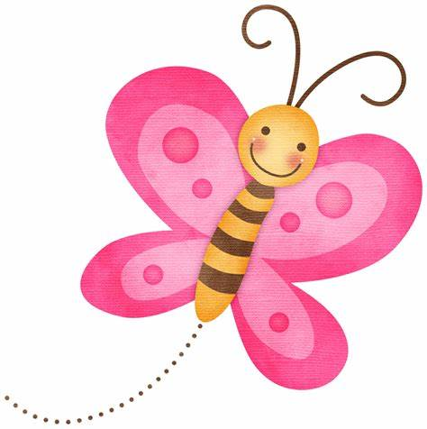  In Growth Mindset, we will be finding out about Dolly Parton, who not only makes great music bit also supports literacy in her home state by giving every child a book every year.
Dates for your diary
New Reception Parent’s Meeting in the Infant Hall at 9am and then repeated at 5pm on Thursday 19th June.
Mrs Steele and Mrs McGuirk out on new Nursery visits Monday 30th June, Tuesday 1st and Wednesday 2nd July all day.
New Reception Visits with parents to new classes- Tuesday 24th and Wednesday 25th June.
Sports Day- Monday 7th July in the morning in the Infant playground. Time TBC.
Nursery Open Day- Friday 4th July. Maximum of 2 adults per child are welcome at any point between 1.40-3pm. Access via the main gate. Children may go home early.
VE Day Celebrations.
We all had lots of fun having our afternoon tea party picnic even though it was a little chilly, listening to songs that were around 80 Years ago and finding out a little about what it would have been like to be a small child during the war- Shock horror….no bananas and sweet rations!

