*Wycliffe Road*

*Urmston M41 5AH*

*Tel: 0161 748 4362*

*Email:* [*admin@urmstonprimaryschool.com*](mailto:admin@urmstonprimaryschool.com)

*urmstonprimaryschool.com*

*****Headteacher: Mr S Parker* ***‘Growing Together. Empowered to be more’***

**Be part of our mission!**

Mission Christmas is back to make this Christmas Day different for local children living in poverty. Some families were already struggling to make ends meet, and the impact of COVID-19 has pushed even more into poverty. For so many this year Christmas is a luxury they just can’t afford.

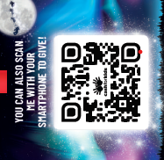This year is looking quite a lot different to other years and I hope you understand that we are so limited on space in regards to storing gifts. We are also unable to register as a drop off point as we usually would. With that in mind, you don’t just have to donate gifts this year, there are lots of other ways you can donate to this cause:

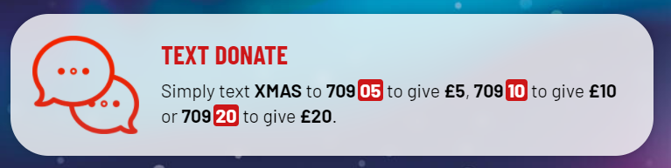**Donate money via the QR code**

**Text donate**

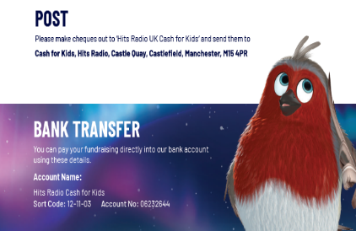

**Bank transfer or Post**

**There is even an Amazon Wishlist!**

**Alternatively, you can use the buckets we have by the school gates to donate cash and we will do the rest 😊**

Of course, if none of these options are viable we can, of course, still take your **new and unwrapped gifts** suitable for children and young people aged 0 to 18. You can bring your new and unwrapped gifts into school **(no later than the morning of Friday 11th December** **please**) and we will ensure your gifts are delivered to a drop off point! Alternatively, you can bring them to the Mission Christmas headquarters or one of the drop off points across the region (you can do this up until Friday 18th December). Gift ideas are listed below if needed.

Lots of information can be found on the website: <https://static.cashforkids.org.uk/faq/mission/?brand=Greater+Manchester>

As always, thank you so much for all your support,

Mrs Tuckey and the UPS Staff.

